Unit 3 Test Name: ______________________________
page 1
See instructions on pp. 126–127

 | Choose and write.
September sorry today week Yesterday your

Scott: What’s the date _________?

Jenny: It’s the 1st.________was my birthday.

Scott: Really? Oh, I’m _________. I forgot!

Jenny: That’s OK. When’s _________ birthday?

Scott: It’s on ________ 9th.

Jenny: That’s next _________.
Let’s have a party!
Scott: Good idea!
 | Listen and number.

1. ____ | 1. What’s the date today?  It’s the 3rd.
2. ____ | 2. When’s your birthday?  It’s on April 26th.
3. ____ | 3. When’s your birthday?  It’s on the 13th.
Unit 3 Test Name: ______________________________
page 2
See instructions on pp. 126–127

 | Read and connect.
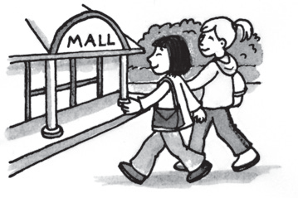
1. What did she do yesterday? ● | 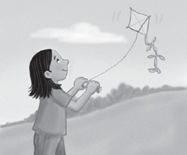  ● | A. They went to the mall.
2. What did they do yesterday? ● |   ● | B. She flew a kite.
3. What did he do yesterday? ● | ● | C. He won a race.

 | Look and write.
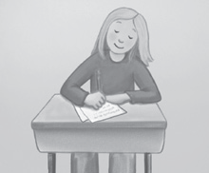
1. | What did she do yesterday?  __________________________________________.
  2. | What did he do yesterday?  __________________________________________.
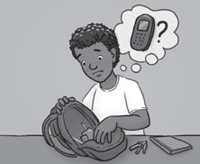  3. | What happened?  __________________________________________.
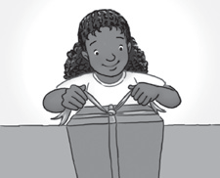  4. | What happened?  __________________________________________.

 | Does it have the th in thirty (1) or the  th in their (2)? Listen and circle 1 or 2.

1. mother | 2. thirteen | 3. they | 4. father | 5. thin
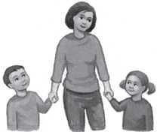 | 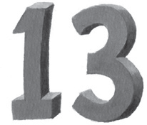 | 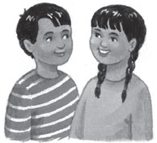 | 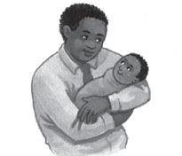 | 
1 2 | 1 2 | 1 2 | 1 2 | 1 2

