Unit 8 Test Name: ______________________________
page 1
See instructions on pp. 126–127

 | Choose and write.  blue What’s about favorite

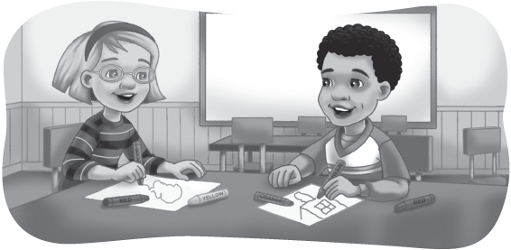
Kate: ____________ your ____________ color?

Andy: Red. What ____________ you?

Kate: I like ____________.

 | Connect.

1. a frog ● |   ● A. | 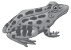  ● B.
2. rabbits ●
3. an elephant ● | 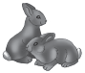  ● C. | 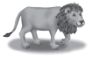  ● D.
4. monkeys ●
5. a lion ● | 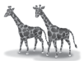  ● E. | 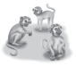  ● F.
6. giraffes ●

Unit 8 Test Name: ______________________________
page 2
See instructions on pp. 126–127

 | Listen and check.

1. | 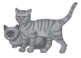 | Do you like cats? | A. Yes, I do. I like cats.  B. No, I don’t. I don’t like cats.
2. | 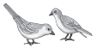 | Do you like birds? | A. Yes, I do. I like birds.  B. No, I don’t. I don’t like birds.
3. | 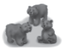 | Do you like bears? | A. Yes, I do. I like bears.  B. No, I don’t. I don’t like bears.
4. |  | Do you like dogs? | A. Yes, I do. I like dogs.  B. No, I don’t. I don’t like dogs.

 | Connect.

1. I feed a fish | 2. see a rabbit | 3. hear a lion | 4. pet a goat
•  • | •  • | •  • | •  •
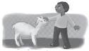  A. | 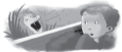  B. |   C. |   D.
 | Listen for u as in bug and check.

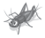  1. | bug | 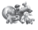  2. | toys |   3. | apple | 4. | cup
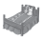 | bed |  | tub |  | umbrella |  | cap

