Name: | Class:

①Read, match and write. Mark / 10

out of round into in out of round
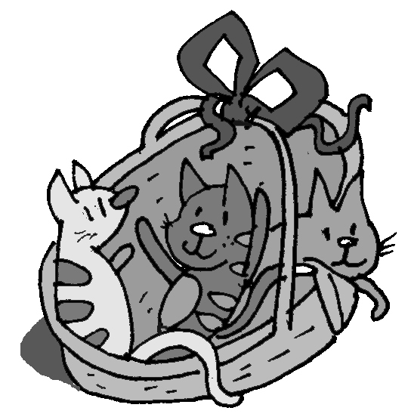
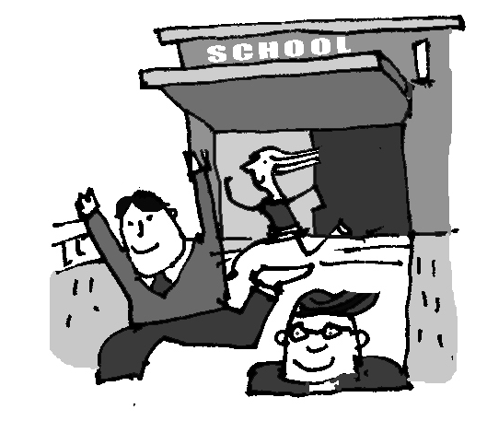

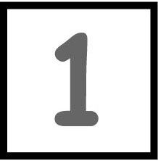

❶ The kittens played in the round basket.
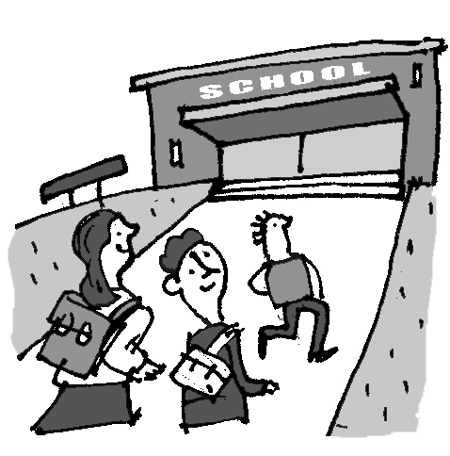
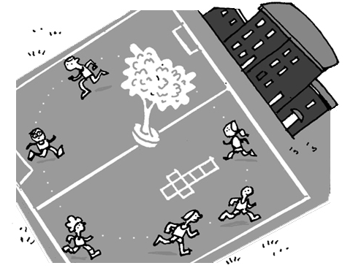
❷ The men came ________ the lift.
❸ The children ran ________ the playground.
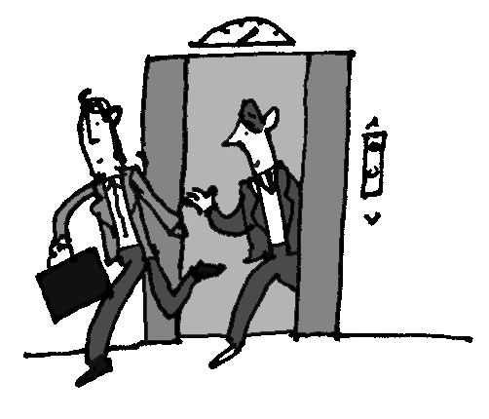
❹ The children walked ________ school.
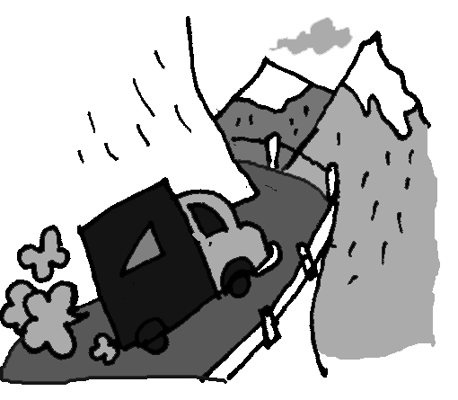
❺ The old lorry came ________ the mountain.

❻ The children ran ________ school.

②Read and complete the sentences. Mark / 5

slowly best loudly carefully worst quickly

❶ She’s shouting the most loudly. The teacher’s angry!
❷ He’s riding the most ________ . He wants to be first.
❸ I’m painting the most ________ . My picture’s the best!
❹ He’s running the most ________ . Yes, he came last!
❺ She’s playing the ________ . She loves basketball.
❻ He’s dancing the ________ ! His friends are laughing.

Total unit mark / 15

