Test Answer Key Play or download the test audio from the Test Center.

Unit 1 Test

A. Listen and ✓.
1. B Sit down.
2. B Stand up.
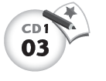
B. Listen and circle.
1. B It’s a bicycle.
2. A It’s a yo-yo.
3. B It’s a jump rope.
4. B It’s a teddy bear.

C. Match.
1. B
2. D
3. A
4. C

Unit 2 Test

A. Match.
1. B
2. A

B. ✓ or ✗.
1. A ✗ B ✓ C ✗
2. A ✗ B ✗ C ✓

C. Listen and color.
1. C What is it?
It’s a red bicycle.
2. D What is it?
It’s an orange train.

D. Listen and circle.
1. A It’s an A.
D It’s a D.
2. B It’s a B.
C It’s a C.

Unit 3 Test

A. Match.
1. B
2. A

B. ✓ or ✗.
1. A ✓ B ✗ C ✗
2. A ✗ B ✓ C ✗

C. Listen and ✓ or ✗.
1. B Is it a square? Yes, it is.
C Is it a circle? No, it isn’t. It’s a
diamond.
2. A Is it a star? Yes, it is.
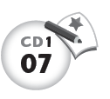
D Is it a square? No, it isn’t. It’s a
circle.

D. Listen and circle.
1. A It’s an E.
D It’s an H.
2. B It’s an F.
C It’s a G.

Unit 4 Test

A. Match.
1. B
2. A

B. ✓ or ✗.
1. A ✗ B ✗ C ✓
2. A ✗ B ✓ C ✗
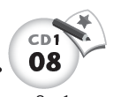
C. Listen and ✓ or ✗.
1. B, C How many? 5 yo-yos,
4 teddy bears.
2. D Is it a 10? No, it isn’t. It’s a 5.
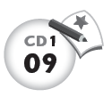
D. Listen and circle.
1. B It’s a J.
C It’s a K.
2. A It’s an I.
D It’s an L.

Midterm Test
Units 1–4

A. Match.
1. C
2. A
3. D
4. B

B. ✓ or ✗.
1. A ✗ B ✗ C ✓
2. A ✓ B ✗ C ✗
3. A ✗ B ✗ C ✓

4. A ✗ B ✓ C ✗

C. Listen and color.
1. C It’s a pink oval.
2. D It’s a black diamond.
3. B It’s a yellow triangle.
4. A It’s a purple star.
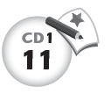
D. Listen and ✓ or ✗.
1. A It’s a G. It’s not an E.
D It’s a J. It’s not a B.
2. B It’s an A. It’s not a D.
D It’s an F. It’s not a D.
3. D It’s an H. It’s not an L.
C It’s a C. It’s not an L.

E. Count and write.
1. 10
2. 3
3. 5
4. 8
5. 4
6. 6

Unit 5 Test

A. Match.
1. A
2. B

B. ✓ or ✗.
1. A ✗ B ✓ C ✗
2. A ✗ B ✓ C ✗
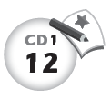
C. Listen and ✓ or ✗.
1. D How many dogs? 1 dog.
C How many birds? 8 birds.
2. A How many cats? 2 cats.
D How many dogs? 5 dogs.
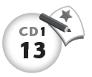
D. Listen and circle.
1. C It’s an O.
A It’s an M.
2. B It’s an N.
D It’s a P.

Unit 6 Test

A. Match.
1. A
2. B

B. ✓ or ✗.
1. A ✗ B ✓ C ✗
2. A ✓ B ✗ C ✗
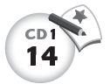
C. Listen and ✓ or ✗.
1. C Do you like rice? No, I don’t.
I like pizza.
D Do you like milk? No, I don’t. I
like ice cream.
2. D Do you like chicken? No, I don’t.
I like fish.
A Do you like bread? No, I don’t. I
like cake.
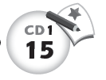
D. Listen and circle.
1. C It’s an S.
B It’s an R.
2. D It’s an T.
A It’s a Q.

Unit 7 Test

A. Match.
1. A
2. B

B. ✓ or ✗.
1. A ✗ B ✗ C ✓
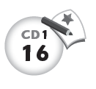
2. A ✗ B ✗ C ✓

C. Listen and ✓ or ✗.
1. C I can touch my toes.
D I can touch my mouth.
2. C I can touch my knees.
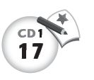
A I can touch my ears.

D. Listen and circle.
1. A It’s a U.
C It’s a W.
2. B It’s a V.
A It’s a U.

Unit 8 Test

A. Match.
1. A
2. B

B. ✓ or ✗.
1. A ✗ B ✓ C ✗
2. A ✓ B ✗ C ✗
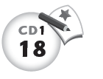
C. Listen and ✓ or ✗.
1. B Can you fly a kite? No, I can’t.
C Can you ride a bicycle? Yes,
I can.
2. A Can you bounce a ball? Yes,
I can.
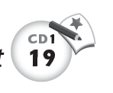
D Can you sing? No, I can’t.

D. Listen and circle.
1. C It’s a Z.
A It’s an X.
2. B It’s a Y.
C It’s a Z.

Final Test
Units 1–8

A. Match.
1. B
2. A
3. D
4. C

B. Match.
1. C
2. A
3. D
4. B

C. Connect
abcd efgh ijkl mnop qrst uvw xyz
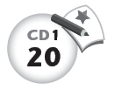
D. Listen and ✓ or ✗.
1. A I can’t sing.
D I can’t fly a kite.
2. A I can touch my shoulders.
C I can touch my head.
3 A I can ride a bike.
C I can’t bounce a ball.
4. B I can touch my ears.
C I can touch my eyes.
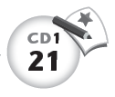
E. Listen and ✓ or ✗.
1. A ✓ B ✗ C ✗
2. A ✗ B ✗ C ✓
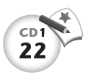
F. Listen and color.
1. It’s an orange yo-yo.
2. It’s a blue doll.
3. It’s a red train.
4. It’s a green jump rope.

