Unit 6 Test Name: ______________________________
page 1
See instructions on pp. 124–125

 | Match.

1. | 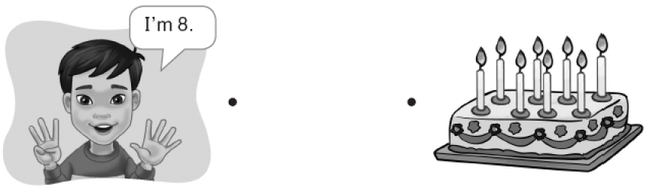  A.
2. | 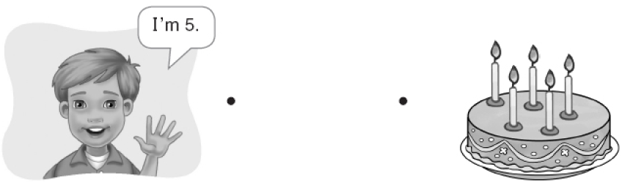  B.

 |   or .

1. | 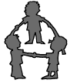 |  | 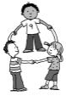 | 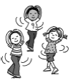
 | Make a circle. | A. | B. | C.
2. | 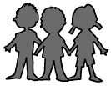 |  | 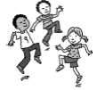 | 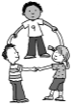
 | Make a line. | A. | B. | C.

Unit 6 Test Name: ______________________________
page 2
See instructions on pp. 124–125

 |   Listen and or .

1. | 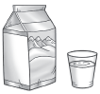 | 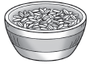 | 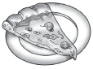 | 
 | A. | B. | C. | D.
2. | 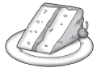 | 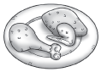 | 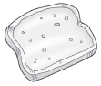 | 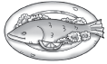
 | A. | B. | C. | D.

 |   Listen and circle.

1. |   A. |   B. |   C. |   D.
2. |   A. |   B. |   C. |   D.

