Final Test Name: ______________________________
page 1
See instructions on pp. 124–125

 | Match.

1. | 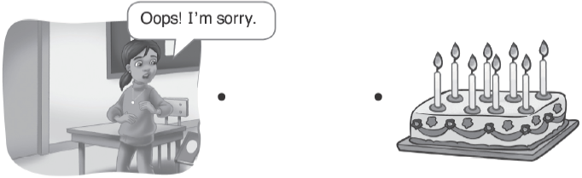  A.
2. | 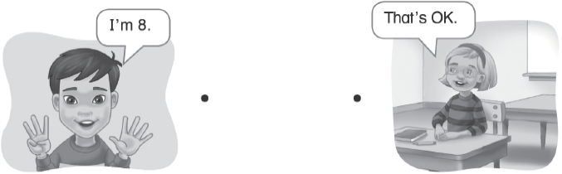  B.
3. | 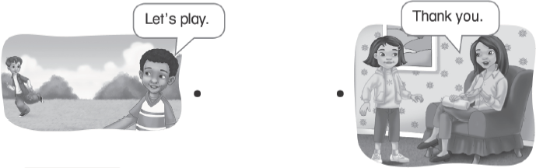  C.
4. | 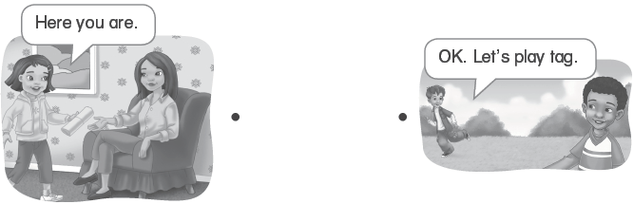  D.

Final Test Name: ______________________________
page 2
See instructions on pp. 124–125

 | Match.

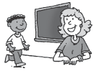  1. | 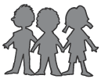  2. |   3. | 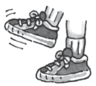  4.
Go to the board. | Make a line. | Jump. | Stamp your feet.
●  ● | ●  ● | ●  ● | ●  ●
  A. | 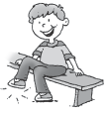  B. | 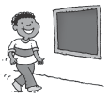  C. | 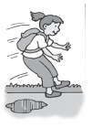  D.

 | Connect.

 |   ● |  | 
● |  |  | ●
 | ● |   ●
 |  |  | 
  ● |  |  | ●

Final Test Name: ______________________________
page 3

 |     Listen and or .

1. | 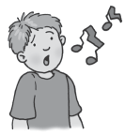 | 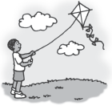 | 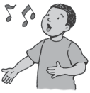 | 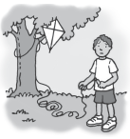
 | A. | B. | C. | D.
2. | 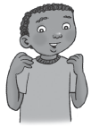 | 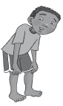 |  | 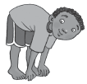
 | A. | B. | C. | D.
3. | 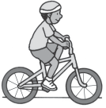 | 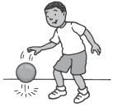 | 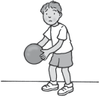 | 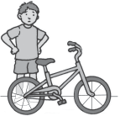
 | A. | B. | C. | D.
4. |  |  |  | 
 | A. | B. | C. | D.

Final Test Name: ______________________________
page 4
See instructions on pp. 124–125


Listen and or .

1. | 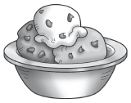 | 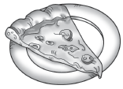 | 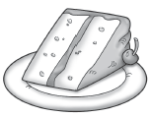
 | A. | B. | C.
2. | 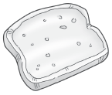 | 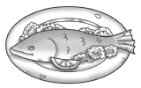 | 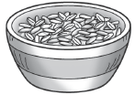
 | A. | B. | C.

Listen and color.

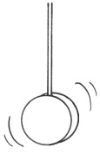  1. |  | 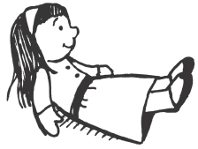  2.
 | 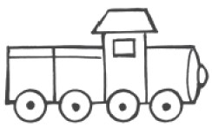  3. |  | 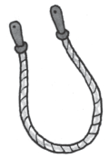  4.

