Unit 8 Test Name: ______________________________
page 1
See instructions on pp. 126–127

 | Choose and write.

been exciting love Guess summer twice visited

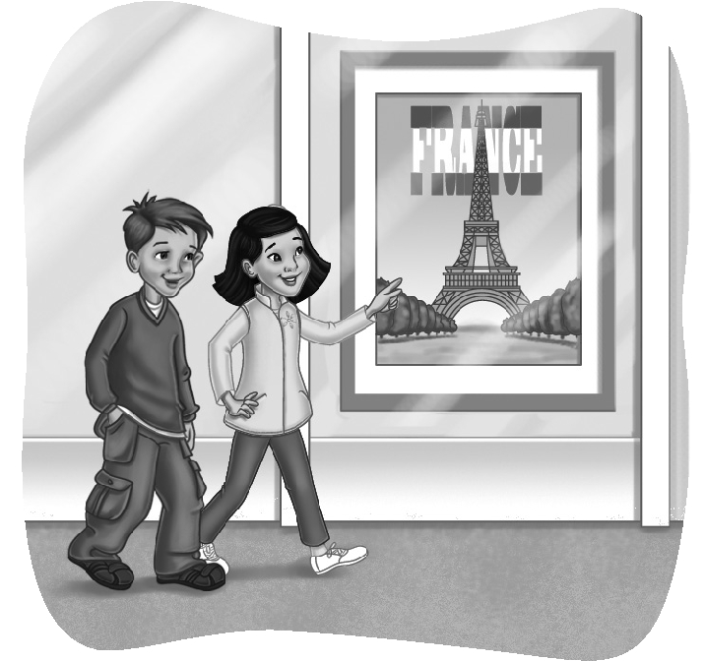
Jenny: ___________ what!

Scott: What?

Jenny: I’m going to go to France this ___________.

Scott: That’s ___________! Have you ___________ there
before?

Jenny: No. It’s my first time.

Scott: I’ve been there ___________. My uncle lives there.
I ___________ him last summer.

Jenny: Wow! You’re lucky! I don’t know anyone there.

Scott: You’ll ___________ France!

Jenny: There’s only one problem. I don’t speak French!

 | Listen and number.

1. ____  2. ____ | 1. | 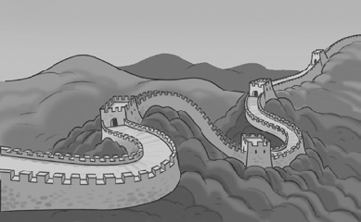  2.
3. ____  4. ____ | 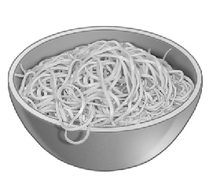  3. | 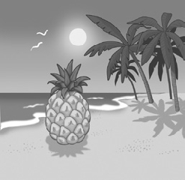  4.
Unit 8 Test Name: ______________________________
page 2
See instructions on pp. 126–127

 | Read and match.

1. Do you ever have _____ | A. a dream catcher?
2. Native Americans believe that a  dream catcher _____ | B. a spider’s web.
  3. Have you ever seen _____ | C. dream catcher.
4. It looks like _____ | D. dream catcher on the wall.
5. You can make a _____ | E. bad dreams at night?
6. Hang your _____ | F. can catch your unhappy dreams.

 | Look and write.
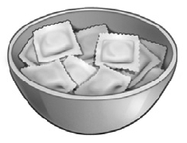
1.   | Have you ever eaten ___________?  Yes, I ___________.
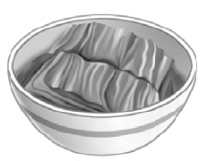  2. | Has she ever eaten ___________?  Yes, she ___________.
3. | _________ kimchi, but I’ve _________ eaten tacos.
  4. | Have you ever _________ a koala?  No, I _________.

 | Do you hear tch or t? Listen and check.

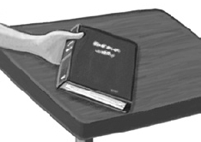 | 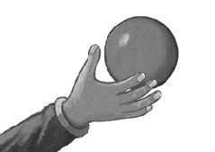 | 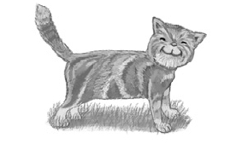 | 
1.  tch t | 2. tch t | 3. tch t | 4. tch t

