Unit 7 Test Name: ______________________________
page 1
See instructions on pp. 126–127

 | Choose and write.

cookies good happened How know look tastes

Scott: Something smells ____________. What are you doing?
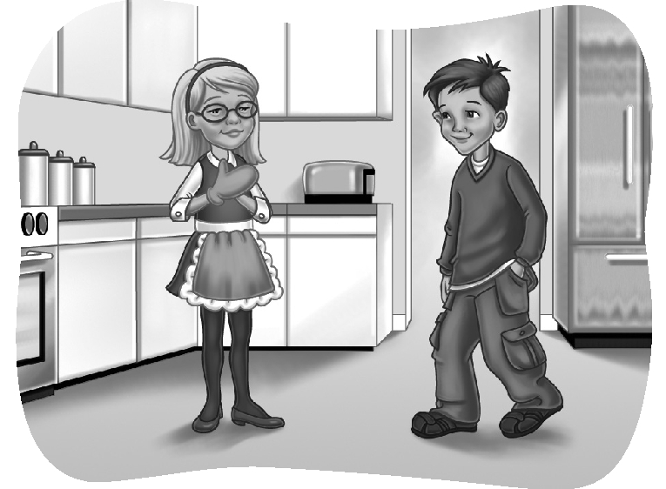
Kate: I’m baking ____________.

Scott: Are they done?

Kate: Almost. Oh, no.

Scott: What ____________?

Kate: I don’t ____________. They don’t ____________ good.

Scott: They smell good. I’ll try one.

Kate: ____________ is it?

Scott: It ____________ great!

 | Listen and number.

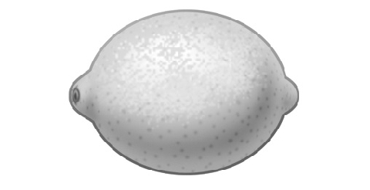
1. ____  2. ____ | 1. | 2.
3. ____  4. ____ | 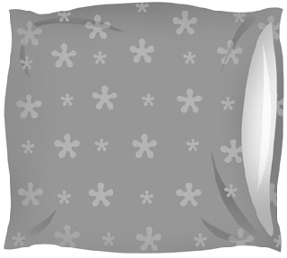  3. | 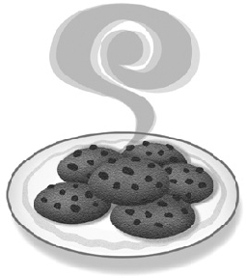  4.
Unit 7 Test Name: ______________________________
page 2
See instructions on pp. 126–127

 | Read and match.

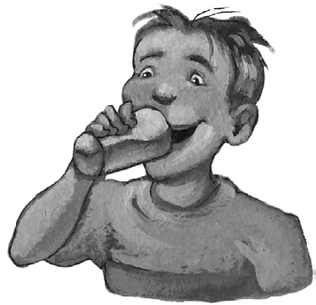  1. Taste buds _____ | A. is important, too.
2. They help you _____ | B. a glass of apple juice.
3. Your sense of smell _____ | C. your nose closed.
4. Drink _____ | D. are on your tongue.
5. Then pinch _____ | E. because you can’t smell it.
6. Now you can’t taste it _____ | F. taste each kind of flavor.

 | Look and write.

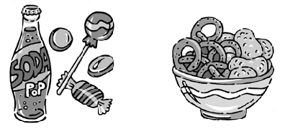  1. | Which do you like better, _____ food or _____ food?
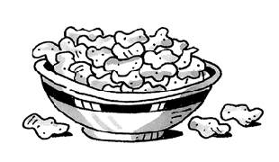  2. | I like ___________ because I like _____ food.
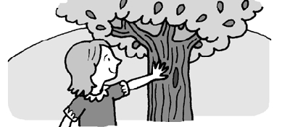  3. | Does it feel _____ or _____?
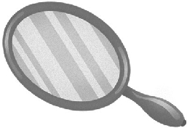  4. | It _____ _____.

 | Do you hear nch or ch? Listen and check.

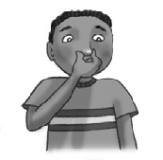 | 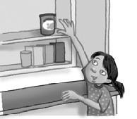 | 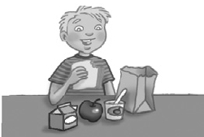 | 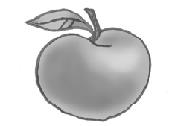
1.  nch ch | 2. nch ch | 3. nch ch | 4. nch ch

