Unit 6 Test Name: ______________________________
page 1
See instructions on pp. 126–127

 | Choose and write.

Because favorite fun Let’s like season Winter

Scott: Summer is my favorite _________.
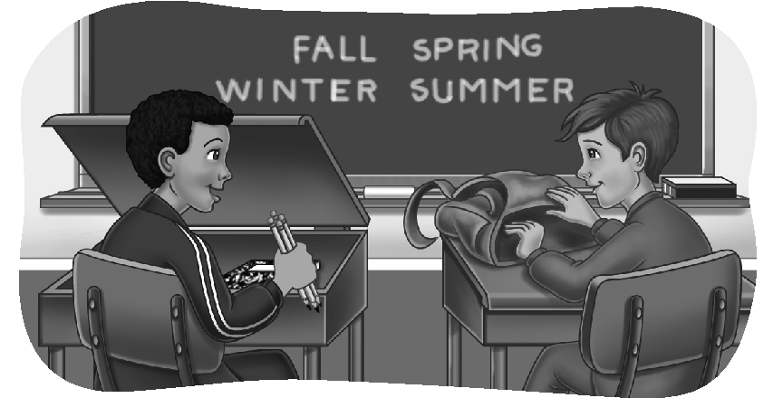
Andy: Why?

Scott: _________ it’s hot and there’s no school.
What’s your _________ season?

Andy: _________.

Scott: Why?

Andy: Because I _________ skiing.

Scott: I like skiing, too … waterskiing!

Andy: That sounds like _______. _______ go waterskiing this summer!

 | 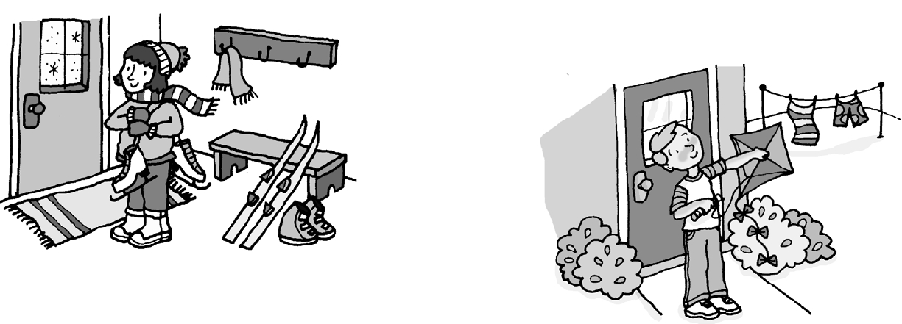  Listen and number.
1. ____  2. ____ | 1. | 2.  
3. ____  4. ____ | 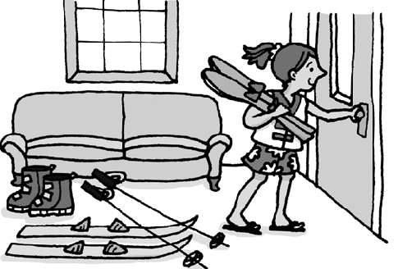  3. | 4.
Unit 6 Test Name: ______________________________
page 2
See instructions on pp. 126–127

 | Read and match.

1. The monarch butterflies are _____ | A. stop in California to rest.
2. They usually live in the north _____ | 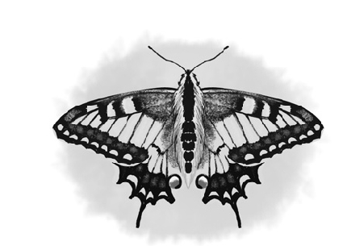  B. fly south to Mexico.
3. Every winter, they spread their wings and _____ | C. in the summer.  D. here in California!
4. Monarch butterflies _____ | E. are beautiful.
5. They fill the sky with _____ | F. orange and black spots when they fly.
6. In the fall, the butterflies _____

 | Look and write.

  1. | Last summer, he ____________________________.
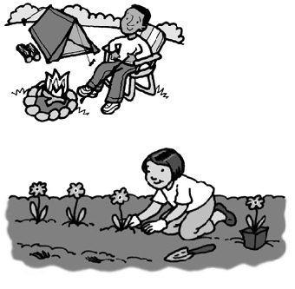  2. | Next summer, ______________________________.
  3. | What did she do last weekend?  __________________________________________.
4. | Why does he like summer?  __________________________________________.

 | Do you hear spr or sp? Listen and write.

 | 
1.  spr sp | 2. spr sp | 3. spr sp | 4. spr sp | 5. spr sp

