Unit 5 Test Name: ______________________________
page 1
See instructions on pp. 126–127

 | Choose and write.

drawing math Maybe right tennis player think What

Kate: What do you ____________ you’ll be when you grow up?

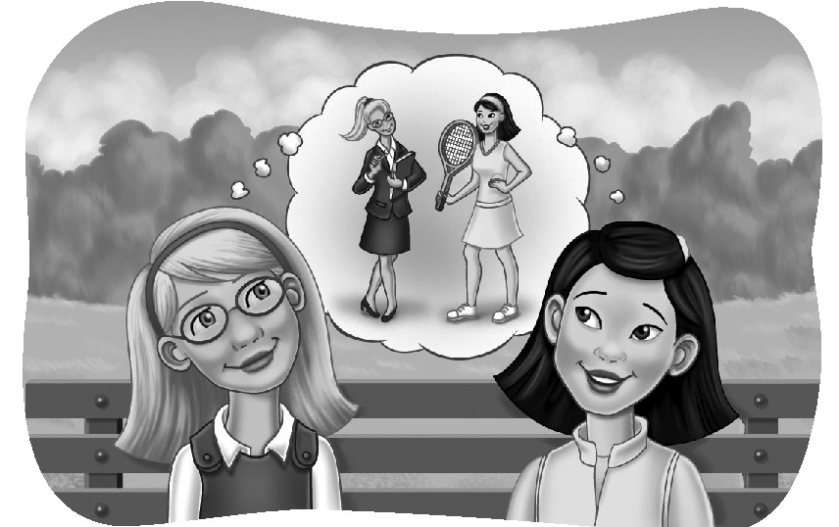
Jenny: I think I’ll be a ____________.

Kate: Good idea! You play tennis very well. What
about me? ____________ do you think I’ll be?

Jenny: Hmm. ____________ you’ll be an engineer.

Kate: Really? I don’t think so. I hate ____________.
I think I’ll be a designer.

Jenny: You’re probably ________. You’re really good at ___________.

Kate: Maybe I’ll make a tennis outfit for you.

Jenny: That’ll be great! Thanks.

 | Listen and check.


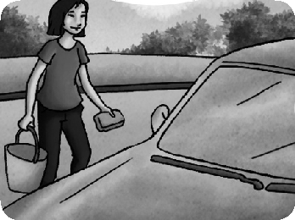
1. A. I think she’ll do the laundry. 1.
B. I think she’ll wash the car.
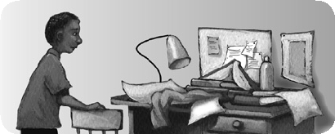
2.
2. A. Maybe he will.
B. Yes, he probably will.
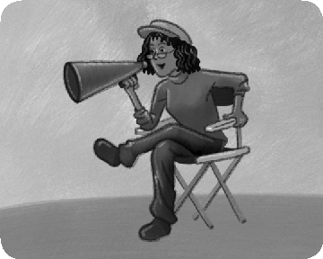
3.
3. A. I think she’ll be a movie director.
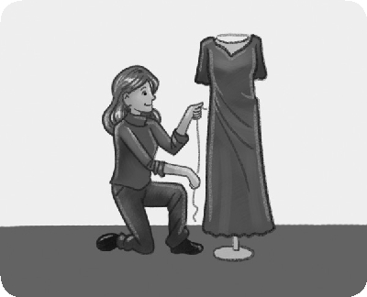
B. I think she’ll be a lawyer. 4.

4. A. I don’t think so.
B. I think so, too.
Unit 5 Test Name: ______________________________
page 2
See instructions on pp. 126–127

 | Read and match.

1. Today I went _____ | A. was painting a picture.
2. The elephants and their trainers _____ | B. to an elephant camp in Thailand.
3. The elephants can _____ | C. were playing soccer!
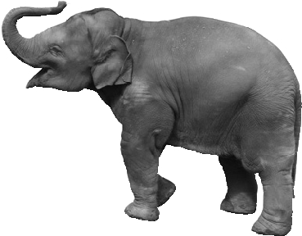  4. Another elephant _____ | D. a picture of a flower.
5. She painted _____ | E. were very cute.
6. The baby elephants _____ | F. play soccer better than I can!

 | Look and write.

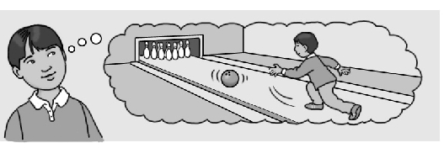  1. | 1. What will you do after class?  I think I’ll ____________.
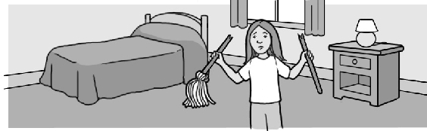  2. | 2. Will she mop the floor?  No, ____________.
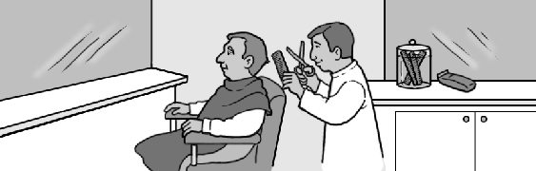  3. | 3. What do you think he’ll be?  I think he’ll be a ____________.
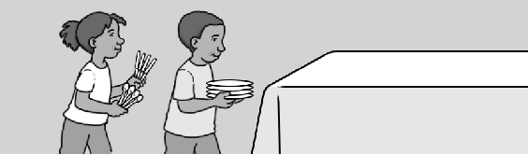  4. | 4. What will they do next?  They’ll ____________ set the table.
 | Do you hear wr or wh? Listen and check.

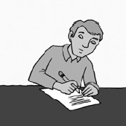 | 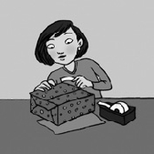 |  | 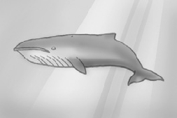
1. wr wh | 2. wr wh | 3. wr wh | 4. wr wh

