Unit 3 Test Name: ______________________________
page 1
See instructions on pp. 126–127

 | Choose and write.

bike fun great How like went What

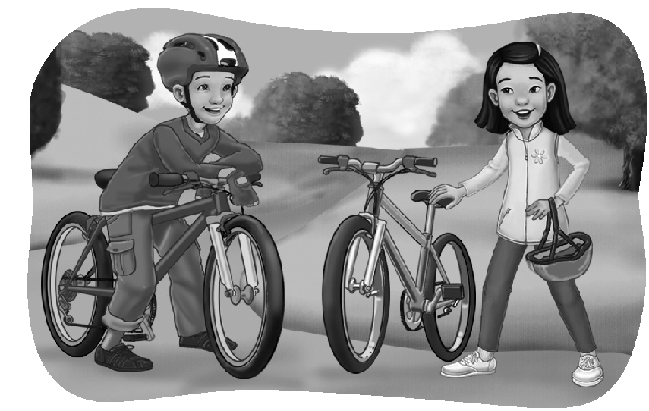
Jenny: _________ was your weekend?

Scott: It was _________. How was yours?

Jenny: It was pretty good.

Scott: _________ did you do?

Jenny: My brother and I went for a _________ ride.

Scott: That sounds like _________.

Jenny: What did you do last weekend?

Scott: I _________ shopping and bought this new bike.

Jenny: Wow! I _________ it.

Scott: Thanks.
 | Listen and check.

1. A. They went swimming.
B. They went skateboarding.

2. A. She was playing volleyball.
B. She was taking pictures.

3. A. Yes, she was.
B. No, she wasn’t.
Unit 3 Test Name: ______________________________
page 2
See instructions on pp. 126–127

 | Read and match.

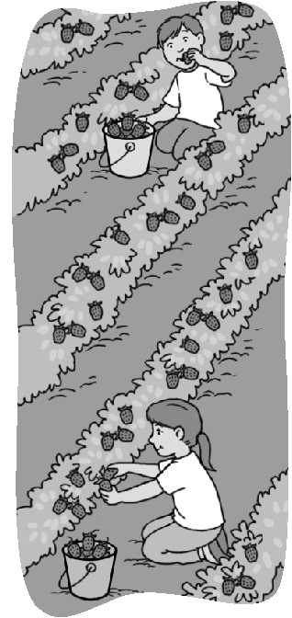  1. Last weekend, I went _____ |  | A. strawberries in one row.
2. I was picking _____ |  | B. eating them.
3. I was watching _____ |  | C. and made jam and ice cream.
4. Sometimes he was _____ |  | D. picking strawberries.
5. But usually he was _____ |  | E. my brother.
6. We took them home _____ |  | F. to a strawberry farm with my family.

 | Write the question or answer.

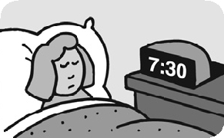  1. | What was she doing at 7:30 a.m.?  __________________________________________.
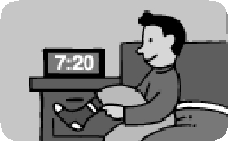  2. | What was he doing at 7:20 a.m.?  __________________________________________.
  3. | _______________________________ this afternoon?  She was at the post office.
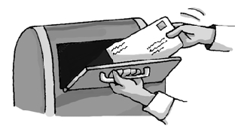  4. | __________________________________________?  He was mailing a package.

 | Do you hear st or str? Listen and check.

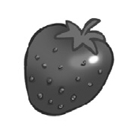 | 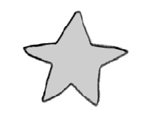 | 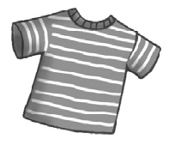 | 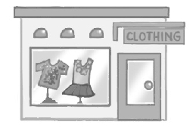 | 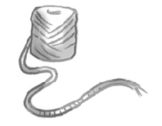
1. st str | 2. st str | 3. st str | 4. st str | 5. st str

