Unit 1 Test Name: ______________________________
page 1
See instructions on pp. 126–127

 | Choose and write.
Do don’t enough many ready so twelve

Kate: Is everything ____________ for the party? Are
there ____________ pretzels?

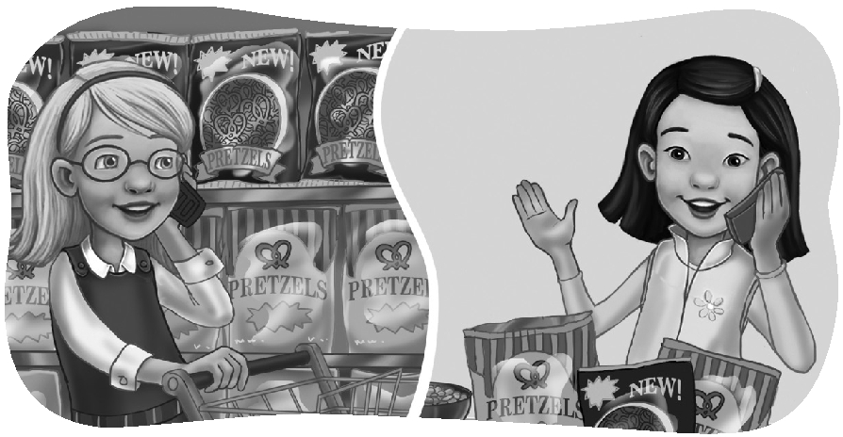
Jenny: I think ____________. There are three bags.

Kate: ____________ we have any soda?

Jenny: Yes, we do.

Kate: How ____________ cans of soda are there?

Jenny: There’s only one can. We ____________
have enough.

Kate: How many cans do we need?

Jenny: We need ____________ cans.

Kate: OK. See you soon!

 | Listen, look, and check.

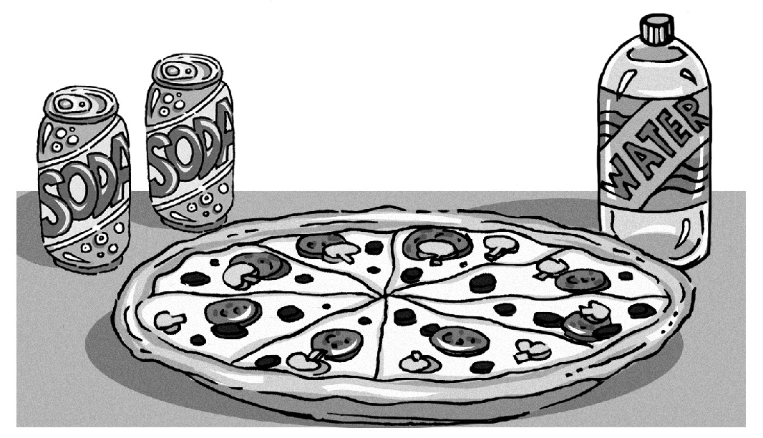1. A. There is one can of soda.
B. There are two cans of soda.

2. A. Yes, there is.
B. No, there isn’t.

3. A. Yes, there are.
B. No, there aren’t.
Unit 1 Test Name: ______________________________
page 2
See instructions on pp. 126–127

 | Read and match.
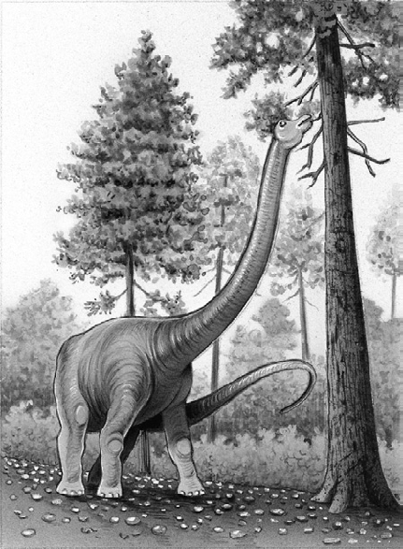
1. Dinosaurs lived _____ |  | A. climb trees.
2. What did dinosaurs _____ |  | B. dinosaur teeth and bones.
3. Scientists studied _____ |  | C. plants and meat.
4. Dinosaurs ate _____ |  | D. millions of years ago.
5. Tall dinosaurs could _____ |  | E. eat?
6. Dinosaurs with short bones could _____ |  | F. reach the leaves on trees.

 | Look and circle or write.

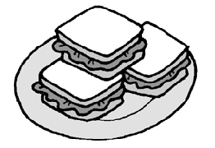    1. | a little  There are sandwiches.  a few
2. | a little  There is salad.  a few
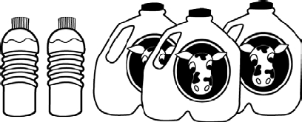  3. | There is a little ______ and a lot of ______.
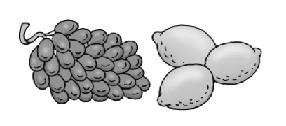  4. | There are a lot of ______ and only a few ______.
 | Do you hear mp or mb? Listen and check.

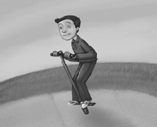 | 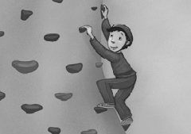 |  | 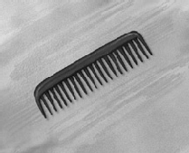
1. mp mb | 2. mp mb | 3. mp mb | 4. mp mb

