Midterm Test Name: ______________________________
(Units 1–4) Page 1
See instructions on pp. 126–127

 | Write.  animal on probably many forgot How yours There’s

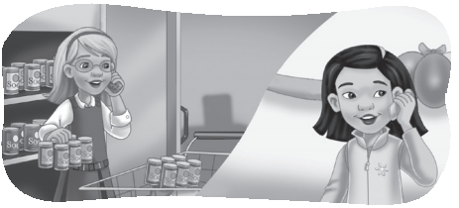
1. Kate: How _____ cans of soda are there?

Jenny: _____ only one can. We don’t have

enough.

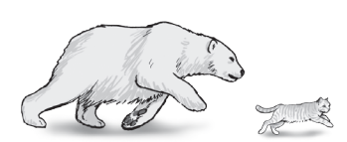
2. Andy: Which _____ is faster? A cat or a polar bear?

Scott: I’m not sure. I think a polar bear is _____

faster.

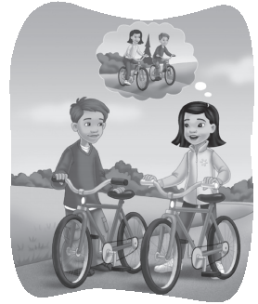
Andy: No! A cat is as fast as a polar bear.

3. Jenny: _______ was your weekend?

Scott: It was great. How was _____?

Jenny: It was pretty good.

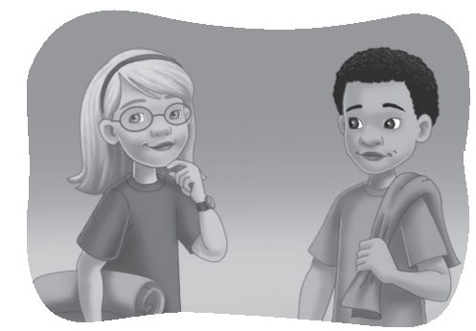
4. Kate: I think I _____ to do something.

Andy: Did you put _____ sunscreen?

Kate: Yes, I did. I put it on.
 | Listen and number.

1. _____ | 2. _____ | 3. _____ | 4. _____
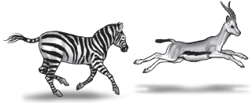 | 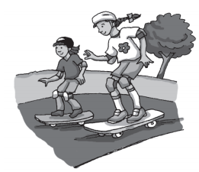 | 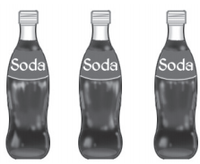 | 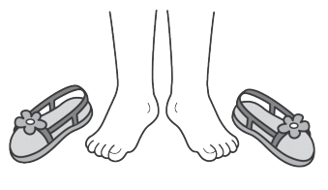
1. | 2. | 3. | 4.
Midterm Test Name: ______________________________
(Units 1–4) Page 2
See instructions on pp. 126–127

 | Look and connect.
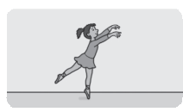
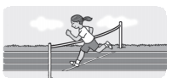
1.  ● | ● quickly ●  ● quietly ● | 4.  ●
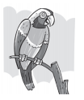  2.  ● | ● graceful ●  ● colorful ● |   5.  ●
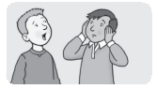  3.  ● | ● slowly ●  ● loudly ● | 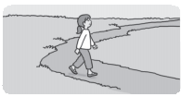  6.  ●
 | Listen, circle, and write.
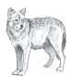

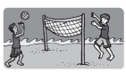  1. A. |  | 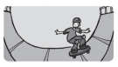  B. |   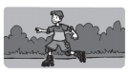  C. | __________
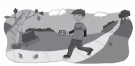  2. A. |  | B. | 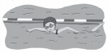  C. | __________
  3. A. |  | 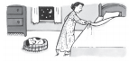    B. |   C. | __________
  4. A. |  | B. | 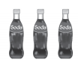  C. | __________
5. A. |  | 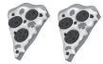  B. |   C. | __________
  6. A. |  |   B. | C. | __________

Midterm Test Name: ______________________________
(Units 1–4) Page 3
See instructions on pp. 126–127

Read and match.

1. Is an elephant as fast as a wolf? _____ | A. The frog is the most colorful.
2. What were they doing yesterday? _____ | B. There isn’t any soda.
3. Are there a lot of pretzels? _____ | C. No, there aren’t.
4. Does he usually speak loudly? _____ | D. Yes, I did.
5. Which animal is the most colorful? _____ | E. Yes, he does.
6. How many bottles of soda are there? _____ | F. No, it isn’t. It’s slower.
7. Did you turn down the music? _____ | G. They were skateboarding.

 | 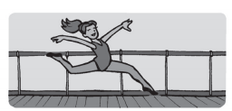  Look and write.

1. Is she _________?
Yes, she is. She dances _________.
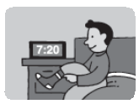
2. What was he _________ at 7:20 a.m.?
He was ________________________.


3. Are _________ a lot of grapes?
No, there aren’t. There are _________ grapes.
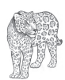
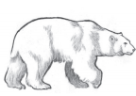
4. Which one is _________ colorful?
The _________ is less colorful.

Midterm Test Name: ______________________________
(Units 1–4) Page 4
See instructions on pp. 126–127

Read, connect, and write.

1. Did she turn on the TV? ●  ____________________________. |  | ● |   A.
2. What was she doing this afternoon? ●  ____________________________. |  | ● | 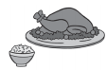  B.
3. Which is less expensive, a car or a bicycle? ●  ____________________________. |  | ● |   C.
4. Is there a lot of rice? ●  ____________________________. |  | ● |   D.
Listen and check.

1. | A. They were skateboarding.  B. They were running.
2. | A. Yes, she does. She plays the violin very well.  B. No, she doesn’t.
3. | A. Chicken is more delicious.  B. Pizza is more delicious.
4. | A. There are a lot of pancakes.  B. There are a few pancakes.

Which sound do you hear? Listen and check.
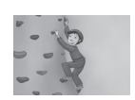

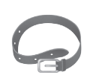
 |  | 
1. mp mb | 2. ar ir | 3. st str | 4. lt ld

