Date:

Speaking and Listening

Materials: Refer to the Speaking and Listening Picture Card

 | Question | Possible Answer | Score
1. | Hello. What’s your name? | My name is . . . | /1
2. | How old are you? | I am (seven) years old. | /1
3. | Can you show me a dog? (Picture 1) | (Pointing only). | /1
4. | What is it? (point to a rabbit in Picture 1) | It’s a rabbit. | /1
5. | How many birds can you see? (Picture 1) | Three birds. | /1
6. | Point to your arm/hand/foot/toe. | (Pointing only). | /1
7. | I like ice cream. What about you? | I do, too./I don’t. /I like (cake). | /1
8. | Can you see a chair? (Picture 2) | Yes, I can. | /1
9. | Where is the pen? (Picture 2) | It’s on the table. | /1
10. | Can you ride a bicycle? | Yes, I can./No, I can’t. | /1
11. | What can you see? (Look around the room) | I can see a . . . | /1
12. | What’s he wearing?  (point to child in Picture 3) | He’s wearing a (sweater)  and (sneakers). | /1
13. | What’s he doing?  (point to child reading in Picture 3) | He’s reading. | /1
14. | What is your favorite subject? | (English) | /1
15. | When do you eat lunch? | At (twelve o’clock). | /1
16. | What do you usually do on Saturdays? | I usually (visit my grandmother). | /2
17. | What chores do you always do at home? | I always (make my bed). | /2
18. | What is softer, a ball or a marble? | A ball is softer. | /2
19. | How is the weather today? | It’s (cloudy). | /2
20. | How was the weather yesterday? | It was (sunny). | /2

/25

Reading and Writing

A Write the letters.

A a B b C c D d E e

f | G g | h | I i | J
K k | L l | m | N | O o
P p | q | R r | S s
U u | V v | w | X x | Y | Z z
 |  |  |  |  |  | /10

B Read and match.

1. It’s a balloon.  •    • | 2. It’s a train.  •  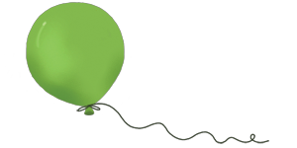  • | 3. I have a pencil.  •    •
4. I can run.  •    • | 5. Can you swim?  •  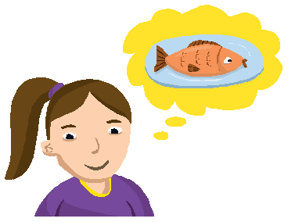  • | 6. Do you like fish?  •  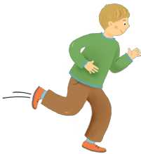  •  /5

C Circle. Write the letter.

1. B  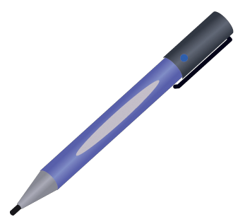 | (A) pencil  (B) pen  (C) eraser  (D) ruler | 2.  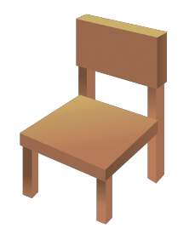 | (A) book  (B) notebook  (C) desk  (D) chair
3.   | (A) fish  (B) juice  (C) chicken  (D) ice cream | 4.  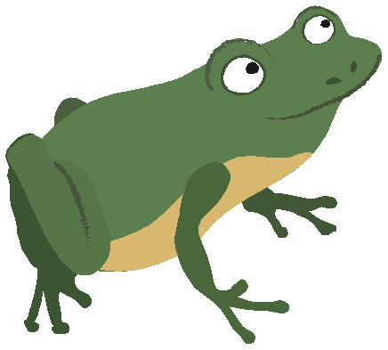 | (A) spider  (B) turtle  (C) frog  (D) ant
5.  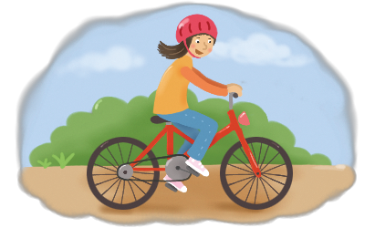 | (A) ride a bike  (B) fly a kite  (C) play soccer  (D) jump rope | 6.  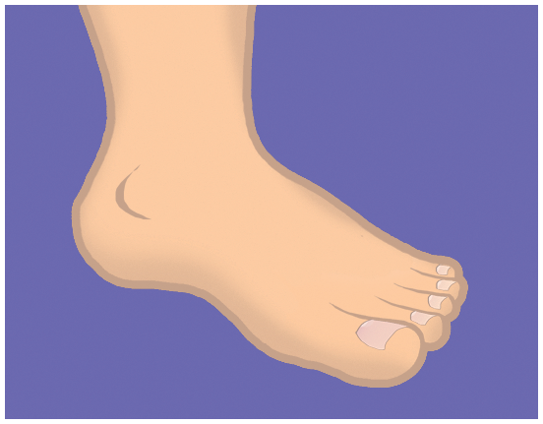 | (A) finger  (B) leg  (C) foot  (D) toe  /10

D Write.

it’s can where what’s isn’t

1. is the monkey? It’s on the rock.

2. What is it? a book.

3. this? It’s my hand.

4. Is that a fast car? No, it .
/10
5. I fly a kite.

E Look and write.

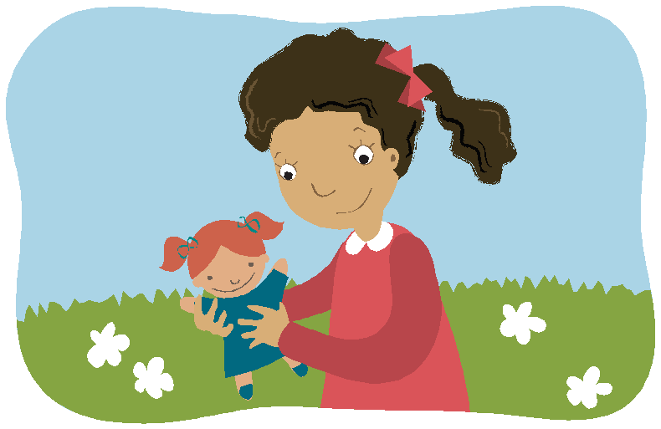 | 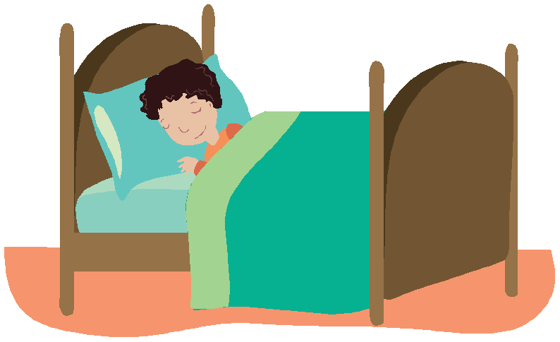 |  |  | 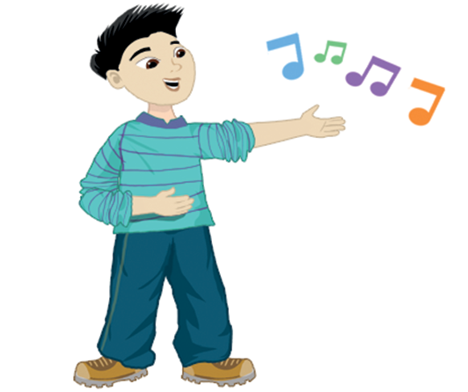
1. She’s playing . | 2. He’s . |  |  | 3. He’s .
 |  | 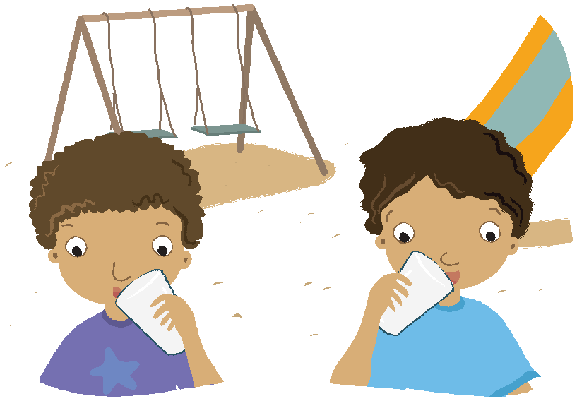
4. They’re . |  |  | 5. They’re .

/8

F Circle. Write the letter.

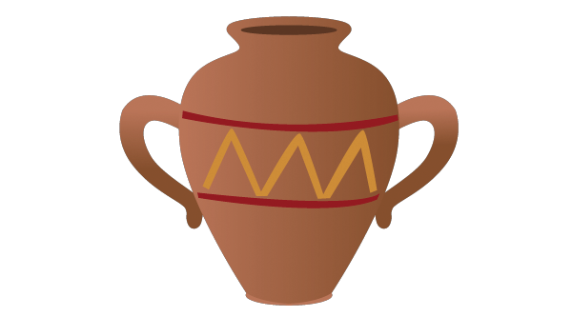  1. | l  m  j  h | 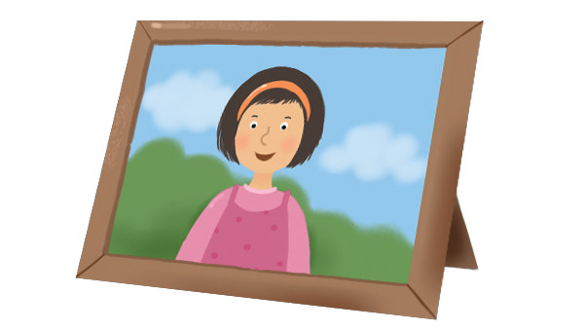  2. | f  sh  s  ph | 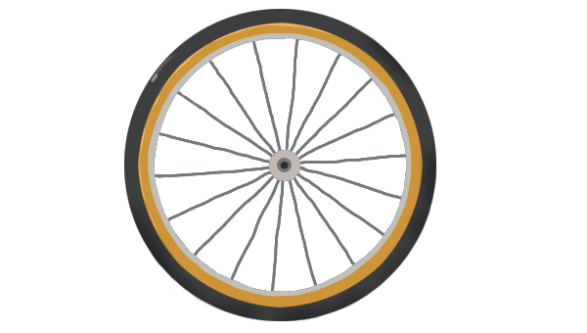  3. | wh  ph  th  ch | 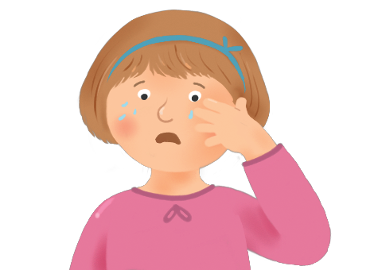  4. | i  ai  y  ei
ug |  | oto |  | eel |  | cr

/4

G Look. Read and write.

karate class swimming class English class dance class

Mary | Rob | Tony | Jenny
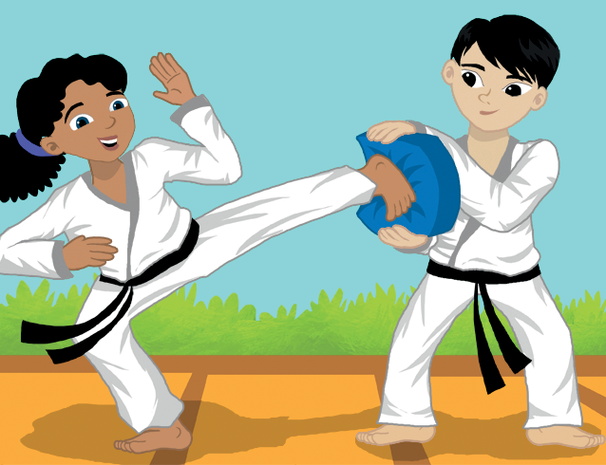 | 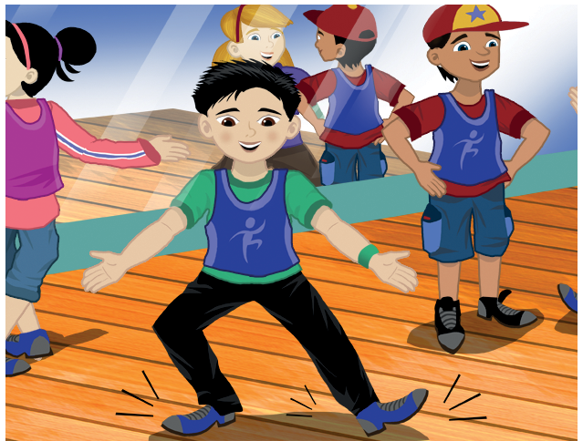 | 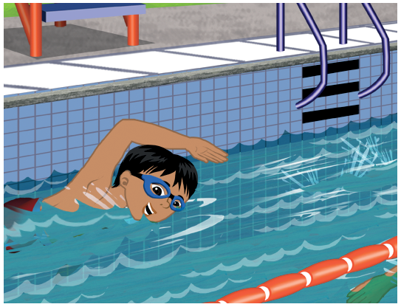 | 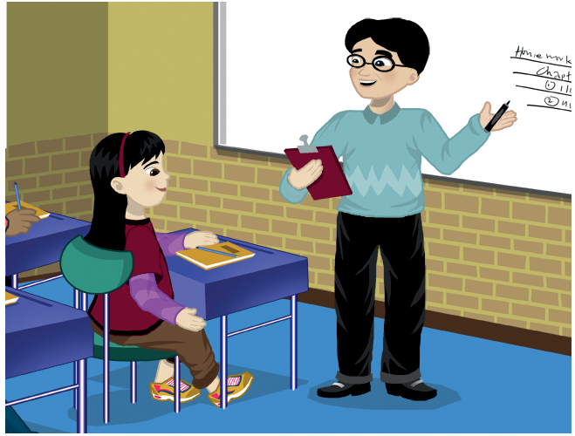
Monday | Tuesday | Wednesday | Thursday

1. Mary goes to on .

2. Rob on .

3. on Wednesdays.

4. .

/8

H Unscramble.

1. carrots / Do / need / you / any 2. I / milkshake / a / want / make / to
Do you need any carrots
? .

3. at / the / They / were / drug store 4. doesn’t / He / any / tomatoes / want

. .

5. post office / he / doing / What’s / at / the

?
/4

I Check the word.

1. Where was the book?  It on the table.  A is  B were  C was  D isn’t | 2. What does the cook do?  The cook food. A eat  B makes  C sells  D make
3. How was the weather ?  A yesterday  B tomorrow  C Friday  D today | 4. Whose plate is this?  It’s . A my  B her  C she  D mine
/4
J Read and write.

Hi Mom,
I’m having a good time. I’m at the park with my friends.
It’s sunny today. Yesterday, it was rainy. We were at the aquarium. I’m happy and tired. It’s one fifteen. It’s time to go. Bye,
Joy

1. Where is Joy? .
She’s at
2. How’s the weather today? .
It’s
3. How was the weather yesterday? .
4. Where was she yesterday? .
5. How does she feel? .
6. What time is it? .
/12

