Unit 6 Test Name: ______________________________
page 1
See instructions on pp. 126–127

 | Choose and write.  windy sunny rainy cloudy snowy

 | 1. How’s the weather? | It’s _____________.
 | 2. How’s the weather? | It’s _____________.
 | 3. How’s the weather? | It’s _____________.
 | 4. How’s the weather? | It’s _____________.
 | 5. How’s the weather? | It’s _____________.
one three five one
 | Read, circle, and write.

  1. | How many flowers are there?  There’s / There are _______ flowers.
  2. | How many trees are there?  There’s / There are _______ tree.
  3. | How many clouds are there?  There’s / There are _______ clouds.
  4. | How many puddles are there?  There’s / There are _______ puddle.

Unit 6 Test Name: ______________________________
page 2
See instructions on pp. 126–127

   | Listen and check

1. Where’s the bat? |  | 2. Where’s the baseball?
 | 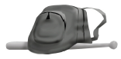 | 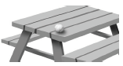 | 
A. | B. | A. | B.
3. Where are the bugs? |  | 4. Where are the puddles?
 |  |  | 
A. | B. | A. | B.

 | Choose and write.  play big This snowy

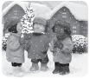  1. | It’s __________.  Let’s make an igloo. | 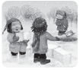  2. | These are _______ squares. This is a big pit.
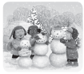  3. | ________ is the baby. This is the bib. | 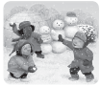  4. | Let’s _________!

 | Listen for i as in pit and check.

  1. | peg |   2. | egg | 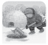  3. | dig | 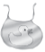  4. | bib
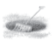 | pit | 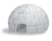 | igloo |  | bag | 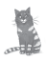 | pet

