Unit 5 Test Name: ______________________________
page 1
See instructions on pp. 126–127

 | Choose and write.  years old Happy This

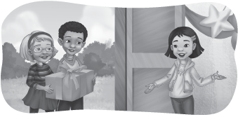 | 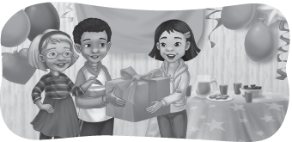

Kate: _______ birthday, Jenny! | Andy: _______ is for you.
Andy: How _______ are you? | Jenny: Thank you!
Jenny: I’m seven _______ old.

 | Read and check.

1. What is it? | It’s a little robot. | 2. What is it? | It’s a new car.
 | 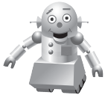 |  | 
A. | B. | A. | B.
3. What is it? | It’s a long jump rope. | 4. What is it? | It’s a round yo-yo.
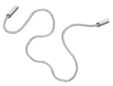 | 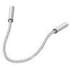 |  | 
A. | B. | A. | B.

Unit 5 Test Name: ______________________________
page 2
See instructions on pp. 126–127

   | Listen and write A, B, C, or D.

1. ____ | 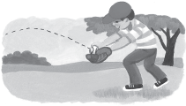 |  | 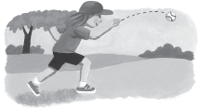
2. ____
 | A. catch a ball |  | B. throw a ball
 | 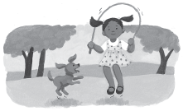
3. ____ |  |  | 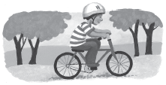
4. ____ | C. jump rope |  | D. ride a bicycle


 | Listen for e as in bed and check.

1. |  | 2.
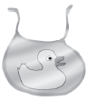 |  | 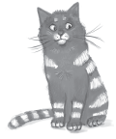 | 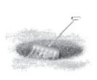
bib | bed | pet | pit
3. |  | 4.
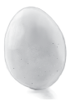 |  | 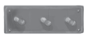 | 
egg | bag | peg | cap

