Unit 4 Test Name: ______________________________
page 1
See instructions on pp. 126–127

 | Choose and write.
meet friend nice you

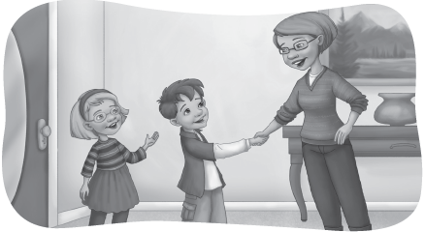
Kate: Hi, Mom! This is my ____________, Scott.

Kate’s mom: It’s ____________ to meet ____________, Scott.

Scott: It’s nice to ____________ you, too.

 | Read and circle.  is isn’t

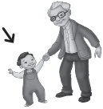  1. | Is he old?  No, he ______. |   2. | Is she pretty?  Yes, she _____.
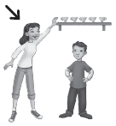  3. | Is she short?  No, she ______. | 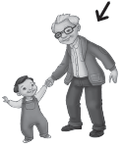  4. | Is he young?  No, he ______.

Unit 4 Test Name: ______________________________
page 2
See instructions on pp. 126–127

 |   Listen and circle.

1. Who’s he? He’s my brother / father. | 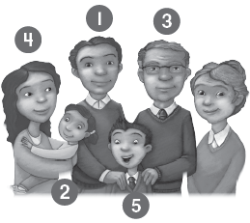
2. Who’s she? She’s my grandmother / baby sister.
3. Who’s he? He’s my grandfather / mother.
4. Who’s she? She’s my mother / baby sister.
5. Who’s he? He’s my father / brother.

 | Connect.

1. Say the alphabet. | 2. Count to ten. | 3. Read a book. | 4. Write the word.
•  • | •  • | •  • | •  •
  A. | 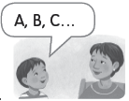  B. |   C. | 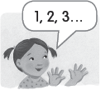  D.

 |   Listen for a as in bag and check.

  1. | cow |   2. | apple |   3. | duck |   4. | bag
 | cat |  | tiger |  | cap |  | boy

