Unit 3 Test Name: ______________________________
page 1
See instructions on pp. 126–127

 | Choose and write.
Hello friend

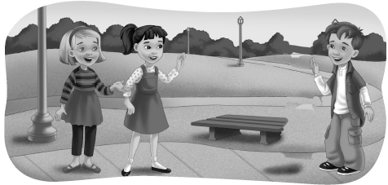
Kate: Hi Scott. This is my ____________, Sarah.

Sarah: ____________, Scott.

Scott: Hi, Sarah.

 | Read and circle.

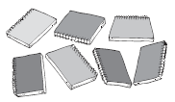  1. | 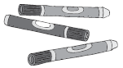  2.
How many notebooks?  four / seven notebooks | How many markers?  six / three markers
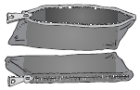  3. |   4.
How many pencil cases?  two / four pencil cases | How many crayons?  ten / eight crayons

Unit 3 Test Name: ______________________________
page 2
See instructions on pp. 126–127

 |   Listen and write A, B, C, or D.

1. _____ |  |  | 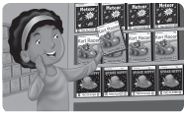
2. _____
 | A. Point to the computer. |  | B. Find the video games.
3. _____  4. _____ |  |  | 
 | C. Count the video games. |  | D. Count the books.

 | Connect.

1. What’s this?  It’s a cell phone | 2. What are these? They’re CDs | 3. What are these? They’re video games | 4. What’s this? It’s a computer
•  • | •  • | •  • | •  •
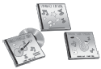  A. |   B. |   C. | 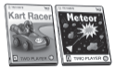  D.

 |   Does it have d or t? Listen and write.

 |  |  |  | 
1. ___ oys | 2. ___ iger | 3. ___ oor | 4. ___ esk | 5. ___ uck

