Unit 2 Test Name: ______________________________
page 1
See instructions on pp. 126–127

 | Choose and write.
Thank fine Hi are

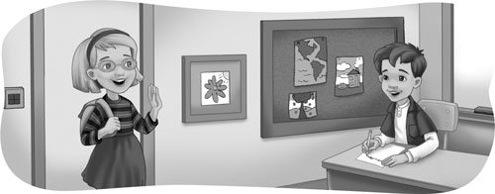
Kate: ____________, Scott. How are you?

Scott: I’m ____________. How ____________ you?

Kate: I’m fine. ____________ you.

 | Unscramble and write.
purple blue red green

1. What color is this? It’s __________. dre
2. What color is this? It’s __________. lbeu
3. What color is this? It’s __________. plurep
4. What color is this? It’s __________. egern
Unit 2 Test Name: ______________________________
page 2
See instructions on pp. 126–127

 |   Listen and write A, B, C, or D.

1. _____ | 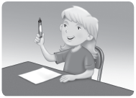 |  | 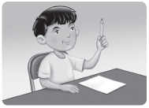
2. _____
 | A. Pick up a red marker. |  | B. Pick up your pencil.
3. _____  4. _____ |  |  | 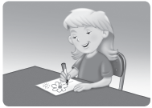
 | C. Draw a triangle. |  | D. Draw a picture.

 | Choose and write.
it isn’t it is

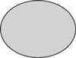  1. |   2. |   3. |   4.
Is this an oval? | Is this a square? | Is this a diamond? | Is this a star?
Yes, ______. | No, ______. | No, ______. | Yes, ______.

 |   Does it have c or g? Listen and write.

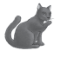 |  | 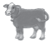 | 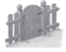
1. ___ at | 2. ___ irl | 3. ___ ow | 4. ___ ate

