Unit 1 Test Name: ______________________________
page 1
See instructions on pp. 126–127

 | Choose and write.

What’s is Hello My

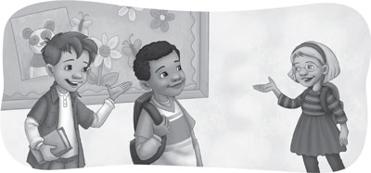
Scott: ____________ ! I’m Scott. ____________ your name?

Kate: ____________ name ____________ Kate.

 | Read and Circle.

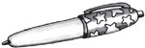  1. What’s this?  It’s a pen / a pencil. | 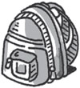  2. What’s this?  It’s a bag / a book.
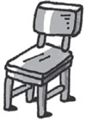  3. What’s this?  It’s a desk / a chair. | 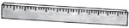  4. What’s this?  It’s a ruler / an eraser.
Unit 1 Test Name: ______________________________
page 2
See instructions on pp. 126–127

 |   Listen and check.

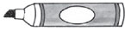  1. |  | 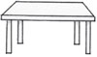  2. | 
A. | B. | A. | B.
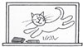  3. |  | 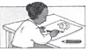  4. | 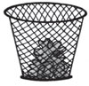
A. | B. | A. | B.

 | Connect.

1. Take out your book. • |  | • A. | 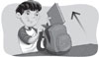
2. Open your book. • |  | • B. | 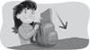
3. Close your book. • |  | • C. | 
4. Put away your book. • |  | • D. | 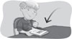

 |   Does it have b or p? Listen and write.

 | 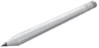 | 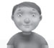 | 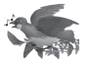 | 
1. ___ all | 2. ___ encil | 3. ___ oy | 4. ___ ird | 5. ___ ink

