Midterm Test Name: ______________________________
(Units 1–4) page 1
See instructions on pp. 126–127

 | Choose and write.
nice How friend What’s fine name meet

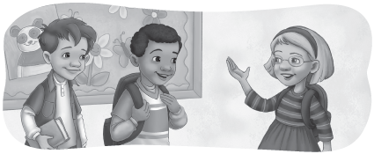
Scott: Hello. I’m Scott. _____ your name?  Kate: My ________ is Kate.  Scott: ________ are you?  Kate: I’m ________, thank you. | Scott: This is my ______, Andy.  Kate: Hi, Andy. It’s ______to meet you.  Andy: It’s nice to ______ you, too.


 | Listen and circle.

  1. |   2.
It’s a book /cell phone. | It’s a globe / pencil.
  3. |   4.
It’s an eraser /marker. | It’s a bag /ruler.

Midterm Test Name: ______________________________
(Units 1–4) page 2
See instructions on pp. 126–127


 | Connect.

1. Open your book. | ● | ● A | 
2. Count the video games. | ● | ● B | 
3. Pick up a red marker. | ● | ● C | 
4. Write the word. | ● | ● D | 


 | Does it have b or p? Listen and write.

 |  |  |  |  | 
1. __ ird | 2. __ each | 3. __ oy | 4. __ all | 5. __ ink | 6. __ encil


 | Does it have c or g? Listen and check.

  1. | c | g |  |   2. | c | g
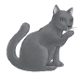  3. | c | g |  | 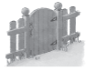  4. | c | g
  5. | c | g |  | 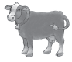  6. | c | g

Midterm Test Name: ______________________________
(Units 1–4) page 3
See instructions on pp. 126–127


 | Listen, read and connect.

1. What color is this? | ● |  | ● | A. No, she isn’t. She’s tall.
2. What’s this? | ● |  | ● | B. They’re video games.
3. Is it a diamond? | ● |  | ● | C. It’s blue.
4. How many markers? | ● |  | ● | D. No, he isn’t. He’s old.
5. What are these? | ● |  | ● | E. Five markers.
6. Who’s she? | ● |  | ● | F. It’s a desk.
7. Is she short? | ● |  | ● | G. She’s my mother.
8. Is he young? | ● |  | ● | H. No, it isn’t. It’s a star.

Choose and write.
my grandfather a ruler it isn’t computers an oval

  1. | What are these? | They’re _________________.
  2. | Is this a circle? | No, __________. It’s _______.
  3. | What’s this? | It’s _____________________.
  4. | Who’s he? | He’s ____________________.

Midterm Test Name: ______________________________
(Units 1–4) page 4
See instructions on pp. 126–127

Choose and write.

four two seven three

1. How many pens? __________ | 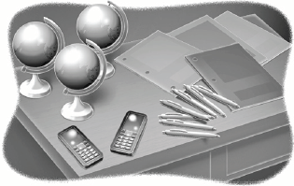
2. How many globes? __________
3. How many notebooks? __________
4. How many cell phones? __________

Listen and write A, B, C, or D.

1. _____ |  | A. This is my father. He’s tall.
2. _____ |  | B. This is my brother. He’s handsome.
3. _____ |  | C. This is my baby sister. She’s short.
4. _____ |  | D. This is my grandmother. She’s pretty.

 | Does it have d, t, or a? Listen and write.

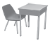 |  |  |  | 
1. ___ esk | 2. ___ oys | 3. c ___ p | 4. ___ iger | 5. b ___ g
 |  |  |  | 
6. ___ pple | 7. ___ uck | 8. ___ wo | 9. c ___ t | 10. ___ oor

