Final Test Name: ______________________________
(Units 1–8) Page 1
See instructions on pp. 126–127

 | Choose and write.  name Hello What’s

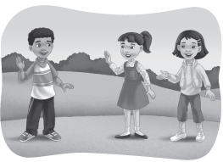
1. ______. I’m Jenny. ______ your name?
My ______ is Andy.
Thank fine Andy
2. Hi, ______. How are you?
I’m ______. ______ you.
This Hello friend
3. Hi, Andy! ______ is my ______, Sarah.
______, Sarah.
meet too nice
4. It’s ______ to meet you, Andy. | 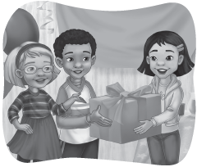
It’s nice to ______ you, ______.
years old birthday
5. Happy ____, Jenny! How ___ are you?
I’m seven ______ old.
sunny How’s weather
6. ______ the ______?
It’s ______.
thirsty hungry want
 | 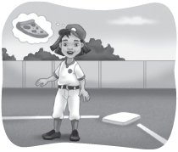
7. I’m ______. I want pizza.
I’m ______. I ______ juice.
about color What’s
8. ______ your favorite ______.
Red. What ______ you?

Final Test Name: ______________________________
(Units 1–8) Page 2
See instructions on pp. 126–127

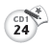
 | Listen and check.

 | Do you want _______?
 | 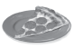  1. | 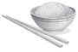  2. |   3. |   4. |   5. |   6.
Yes I do.
No, I don’t


 | Listen, read and connect.

1. Do you like frogs? ● | ● A. I want ice cream. I don’t want fish
2. What is it? ● | ● B. It’s a little blue robot.
3. How many flowers are there? ● | ● C. No, I don’t. I like turtles.
4. Where’s the bat? ● | ● D. There are five flowers.
5. How’s the weather? ● | ● E. You’re welcome.
6. What do you want? ● | ● F. It’s under the table.
7. What’s your favorite color? ● | ● G. It’s rainy.
8. Thank you. ● | ● H. I like purple.

Final Test Name: ______________________________
(Units 1–8) Page 3
See instructions on pp. 126–127

 | Connect.

1. jump rope ● | 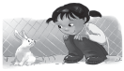  ● A. | 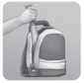  ● B.
2. ride a bicycle ●
3. Put the baseball by the bat. ● | 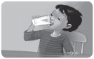  ● C. | 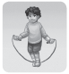  ● D.
4. Put the bat in the bag. ●
5. brush my teeth ● | 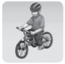  ● E. | 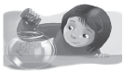  ● F.
6. drink milk ●
7. see a rabbit ● | 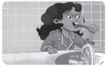  ● G. | 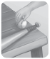  ● H.
8. feed a fish ●

 | Choose and write.

like
want
It’s
don’t
How’s
do
is it
It’s
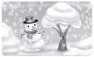 | 1. _______ the weather?  _______ snowy.
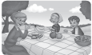 | 2. What ____ you want?  I _____ an orange.
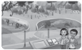 | 3. I ______ monkeys.  I _______ like bears.
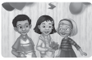 | 4. What _______?  I don’t know. ____ square.

Final Test Name: ______________________________
(Units 1–8) Page 4
See instructions on pp. 126–127

 | Choose and write.
mother father little pretty tall round robot yo-yo

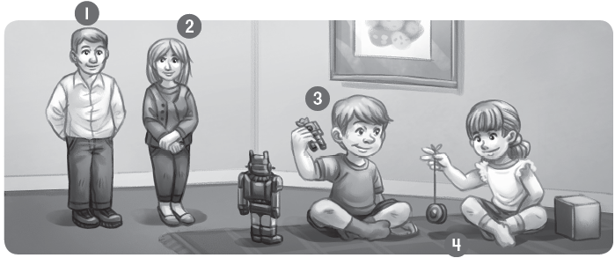
1. My ________ is ________.
2. My ________ is ________.
3. The ________ is ________.
4. The ________ is ________.


Does it have a, e, i, o, or u? Listen and write.

 |  |  | 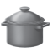 | 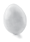
1. c ___ p | 2. ___ mbrella | 3. ___ ctopus | 4. p ___ t | 5. ___ gg
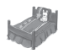 | 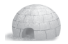 | 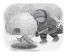 |  | 
6. b ___ d | 7. ___ gloo | 8. d ___ g | 9. b ___ g | 10. ___ pple

