

1 Cross out the wrong words. (10 marks)
2 sing, breathe fire, fur, scales, 3 ugly, lion’s tail, horn, feathers, 4 tail, half man, wings, half-eagle,
5 sing, breathe fire, ugly, live near water, 6 fur, half bird, scales, half fish

2 Look at Dan’s diary. Complete the questions. (5 marks)
2 Who is he going to see, 3 When is he going to call, 4 Where is he going to go, 5 Who is he going to watch, 6 When is he going to make



1 Listen and circle. (10 marks)
2 space, 3 five, 4 vegetables, 5 read or take photos, 6 won’t

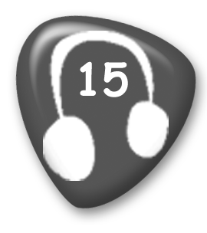
Assistant: Good morning. Can I help you?
Woman: Yes, I’d like some information about your space trips.
Assistant: Of course.
Woman: What planets will we be able to see?
Assistant: The first planet you will see is the Earth. It will look amazing! After that we’ll see Venus.
Woman: And Mars?
Assistant: No, we won’t be able to see Mars.
Woman: Will I be comfortable on the trip?
Assistant: Yes, our rockets have a lot of space!
Woman: Good. How long will the flight be?
Assistant: Just five hours. We will arrive before we have dinner.
Woman: What will we eat?
Assistant: We have delicious space meals made of vegetables.
Woman: What will we do in the evening?
Assistant: There aren’t a lot of things to do. You should bring a book. You can take photos too.
Woman: OK. And how much will the trip cost?
Assistant: It’s one million pounds.
Woman: One million pounds! Oh no! I think I’ll have to find a different trip here on Earth.

2 Read and match. (5 marks)
2 d, 3 a, 4 c, 5 b, 6 a



1 Listen and complete. (10 marks)
2 wings, 3 a cave, 4 animals, 5 twelve, 6 B

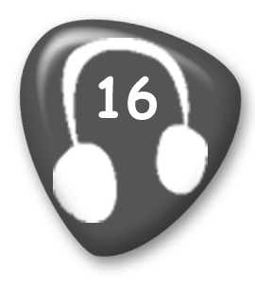
Boy: I read a good story last night.
Woman: Can you tell me about it?
Boy: Yes. The name of the story was The Helper
Woman: How do you spell helper?
Boy: H-E-L-P-E-R.
Woman: Oh, helper. And was the story about a person who helped people?
Boy: No, not a person. It was a creature with big wings.
Woman: Oh. That’s interesting. Did it live near the sea?
Boy: No, it lived in a cave.
Woman: Was it a dragon?
Boy: No, it wasn’t. But it could fly. It helped animals. It flew around to tell them when there was danger.
Woman: Did it help a lot of animals?
Boy: Yes, it did.
Woman: Was it a long story?
Boy: No. It was only twelve pages. I read it all last night.

2 Read and match. (5 marks)
2 a, 3 e, 4 f, 5 b, 6 d



1 Read and tick the correct sentence. (5 marks)
2 a, 3 b, 4 b, 5 b, 6 a

2 Read and complete. (10 marks)
2 torch, 3 rucksack, 4 sleep, 5 behind, 6 countryside



1 Read and write yes or no. (10 marks)
1 no, 2 yes, 3 no, 4 no, 5 yes, 6 yes, 7 no, 8 no, 9 no, 10 no, 11 yes

2 Listen and match. (5 marks)
vegetables − 5, biscuits − 6, cheese − 4, popcorn − 3, soup − 2

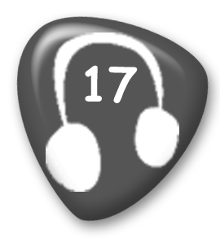
1 My favourite snack is very healthy. There are lots of different things you can choose to eat. Some are long and yellow and some are round and orange, green or red. They taste very different too. But they are all sweet. I always eat some after lunch.
2 My favourite food is hot. It can be made of tomatoes, potatoes or other vegetables. Sometimes it has got meat in it too. I eat this food in autumn and winter. You can’t eat this food for breakfast. It’s a food for lunch or dinner. You always eat it with a spoon.
3 I don’t eat my favourite snack at home, but when I go to the cinema I eat a lot! It’s small but you can buy a big bag. It’s not very healthy but I love it!
4 I put my favourite food in sandwiches. It’s yellow and sometimes it smells strong. It’s the most important topping on a pizza.
5 You should eat my favourite food every day. I do. They can be green, red, purple or orange. You can use my favourite food to make salad or soup. People put this food on pizzas too.
6 My favourite snack is sweet. I eat them in the afternoon with a cup of tea. You can have them in the morning with a glass of milk too. You shouldn't eat a lot of my favourite snack because they’ve got a lot of sugar in them.

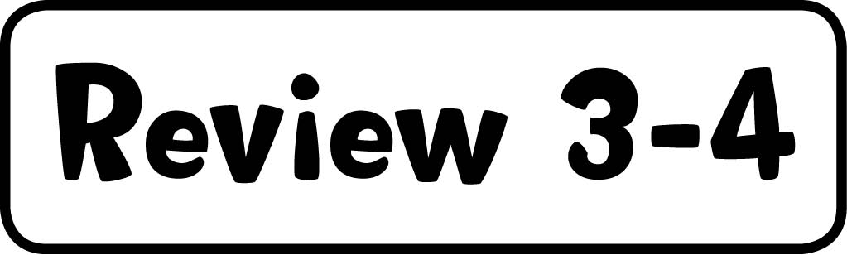

1 Complete the table. (10 marks)
Snacks: biscuits, popcorn
Things we cook with: tray, oven pan
Things we eat with: chopsticks, knife, fork
Cooking instructions: mix, heat, cut

2 Listen and write the number. (5 marks)
2 spaghetti and tomato sauce, 3 fruit, 4 popcorn, 5 jam, 6 biscuits

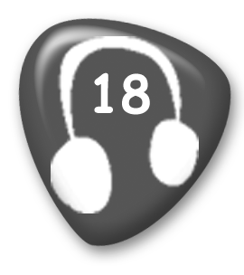
1 Girl: Did you enjoy lunch today?
Boy: Yes. I had cheese sandwiches.
Girl: Boring!
Boy: Not for me. I love cheese!
2 Boy: Were you hungry when you were playing volleyball?
Girl: No. I had a big plate of spaghetti and tomato sauce last night.
3 Girl: How long were you playing guitar this afternoon?
Boy: Mmm … about two hours.
Girl: Wow!

Boy: I stopped to have a banana and an apple after an hour. But I was playing all afternoon.
4 Boy: Why were you brushing your teeth for ten minutes this morning?
Girl: I was eating popcorn before breakfast so I needed to clean my teeth well.
Boy: Why were you eating popcorn in the morning?
Girl: It’s my favourite snack. Don’t tell Mum, OK?
5 Girl: I was so tired when we were doing our homework last night.
Boy: Me too. It was a good idea to have some bread and jam when we were working.
6 Boy: That film we were watching last night wasn’t very good.
Girl: I wasn’t watching carefully.
Boy: No. You were busy eating all the biscuits!
Girl: No I wasn’t!
Boy: Yes you were!



1 Complete the table. (10 marks)
for: three hours, six years, four months, two weeks, years
since: 21st April, 2011, Tuesday, this morning, Sunday

2 Read and tick or cross. (5 marks)
2 , 3 , 4 , 5 , 6 



1 Listen and number. (5 marks)
b free running − 2, board games − 6, clothes design − 5, skate boarding − 3, chess − 4

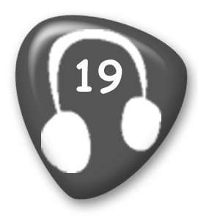
1 It’s something you do in the mountains or hills. You need to have strong legs. You should wear a helmet.
2 This hobby has been popular since the 1990’s. People who do this are very fit. You have to run a lot, jump and climb walls. You can do it anywhere in the city, but you should be careful, because it’s dangerous.
3 This hobby started in the 1970’s. It is still very popular with young people. They learn tricks and go to special parks to practise. You shouldn’t do this hobby near the road. And you should wear a helmet and knee pads.
4 This game has been popular for hundreds of years. It is difficult. You have to think carefully before you move. The board has got black and white squares. Sometimes schools have a club for this hobby where students practise for competitions.
5 People who do this hobby draw new clothes. Sometimes they paint and sew T-shirts too. If you like clothes and making things, this is a good hobby for you.

6 This can be fun for all the family on rainy days and on holidays. There are lots of different games to play.

2 Circle the music words. (10 marks)
Students should circle: tempo, melody, opera, tune, rhythm, bass guitar, improvisation, notes, harmony, rhyme

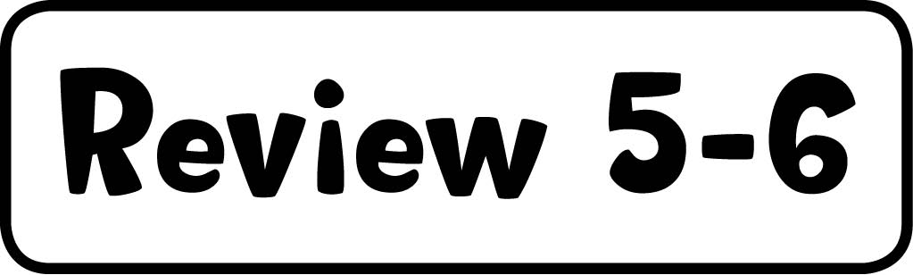

1 Read and tick or cross. (5 marks)
2 , 3 , 4 , 5 , 6 

2 Write the sentences. (10 marks)
2 He’s done free running since he was thirteen. 3 They haven’t got anything to do. 4 She hasn’t got anyone to play football with. 5 Crabs have lived for millions of years. 6 No one has gone fishing with him.

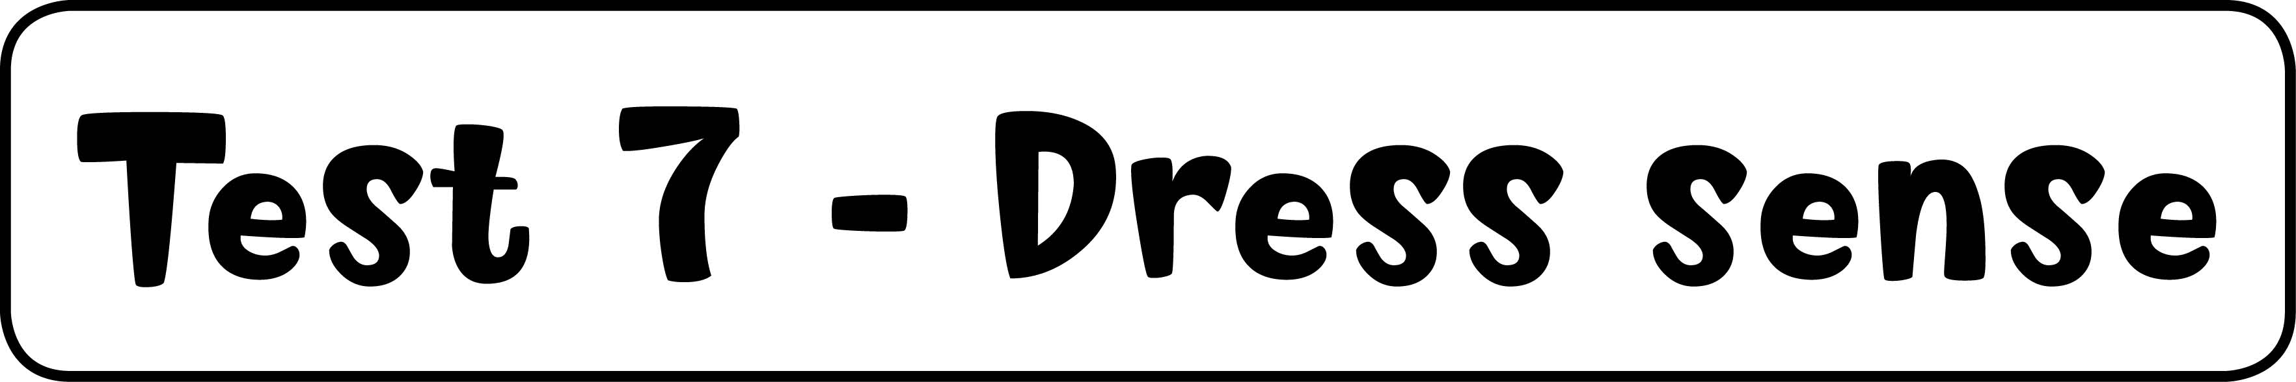

1 Read and match. (5 marks)
2 c, 3 d, 4 b, 5 f, 6 e

2 Listen and tick or cross. (10 marks)
2 , 3 , 4 , 5 , 6 


1 Hello? Who’s there? Mum!
2 Brr! My hands are so cold.
3 Wow, thanks Dad! I love my new bike. This is the best present I’ve ever had.
4 Hello, my name’s Daniel. What’s yours?
5 Uff! It’s so hot today. Did you put some water in the rucksack?
6 Sorry, what did you say?



1 Listen and tick the things Jenny has already done. (5 marks)
2 (not ticked), 3 , 4 , 5 (not ticked), 6 (not ticked)


Girl: Hello?
Boy: Hi Jenny. Are you having a good holiday?
Girl: Yes, thanks Tim. We’ve already done a lot of things. This morning we went to the
History museum.
Boy: Is the museum next to the river?
Girl: No, it’s up the big hill in the city centre. I haven’t been to the river yet. Tomorrow,
we’re going to take a boat along the river and take photos of the city.
Boy: Brilliant! I’m sure you’ve already been to the university.
Girl: Yes, we went there yesterday. I think I’ll study there in the future.
Boy: So what are you doing now?
Girl: Well, I’ve just been to the castle. I think we’re going to have something to eat now.
Boy: It’s a very busy holiday Jenny. Are you feeling tired?
Girl: No! After lunch we’re going to walk on the Roman walls and then go shopping.
Boy: So you haven’t been shopping yet.
Girl: No, not yet. But I might buy you a little present this afternoon.
Boy: Great! Have a good day!

2 Read and complete. (10 marks)
2 took, 3 put, 4 bought, 5 lost, 6 shouted, 7 looked, 8 found, 9 heard, 10 felt, 11 tidied

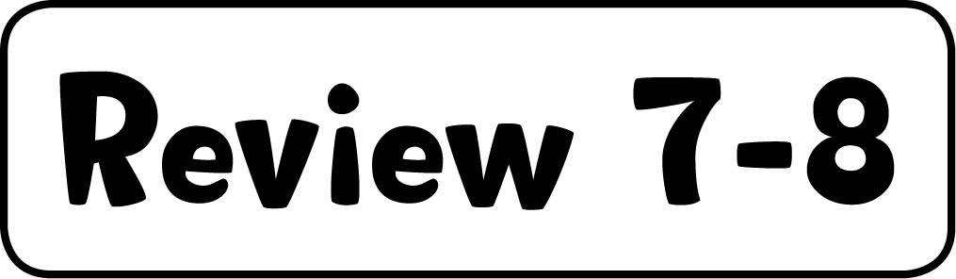

1 Read and tick or cross. (10 marks)
3 , 4 , 5 , 6 , 7 , 8 , 9 , 10 , 11 , 12 

2 Match the letters to make words. (5 marks)
cities: Sydney, countries: India, Germany, nationalities: French, Portuguese



1 Complete the story. (10 marks)
2 already, 3 everywhere, 4 was, 5 bought, 6 Nothing

2 Complete the tables. (10 marks)
under the sea: jellyfish, coral, plankton, beasts: griffin, centaur, space: engineer, satellite,
food: chopsticks, peanut butter, recipe

3 Read and match. (10 marks)
2 D, 3 F, 4 C, 5 E, 6 B

4 Listen and circle. (5 marks)
2 sauce, 3 someone, 4 will, 5 might not, 6 is


Girl: What are you cooking for dinner?
Boy: Spaghetti. I found this exciting recipe. It’s got squid and octopus in it!
Girl: Mmm.
Boy: I’ve just started the sauce. Do you want to taste it?
Girl: OK, thanks. Ow! I’ve burnt my mouth!
Boy: Sorry. I’ll get you a glass of water.
Girl: Thanks. We should invite someone for dinner.
Boy: Good idea.
Girl: I might call Daisy.
Boy: She’ll be busy. She’s working this evening.
Girl: Oh, I remember.
Boy: But Tony won’t be busy. We can invite him.
Girl: Um. Tony might not like squid.
Boy: Of course. Tony doesn’t like anything!
Girl: We could invite Mary.
Boy: But Mary’s still on holiday in India.
Girl: Oh, yes. Well, we don’t have to invite anyone.
Boy: No. And we can eat everything!

