Name: | Class:

①Read and tick () or cross (). Mark / 10

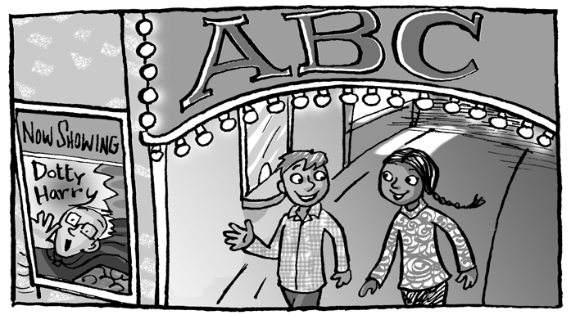
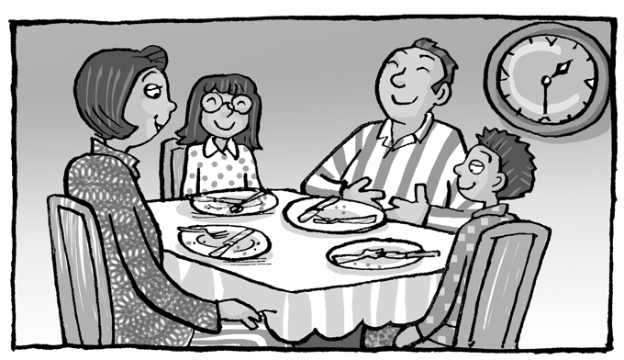
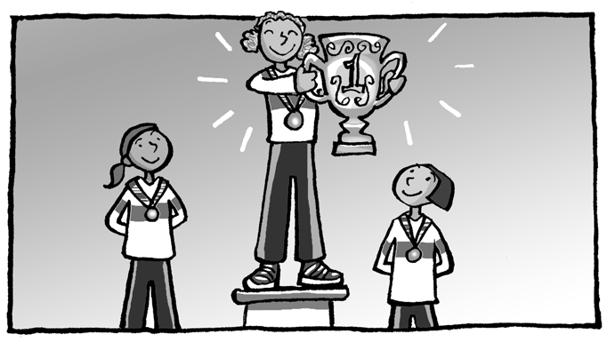
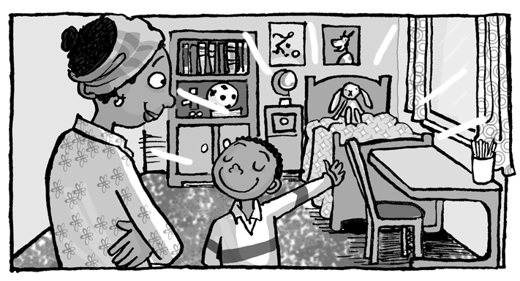

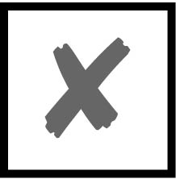

❶ They’re wearing scarves and gloves. ❸ They might be hungry.

❷ They’ve just seen a film. ❹ They’ve just finished
dinner.
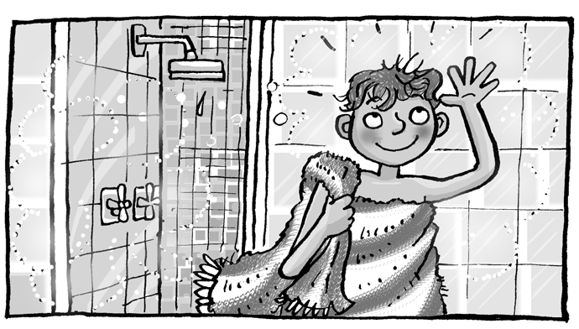

❺ He has already tidied his room. ❼ He’s wearing a helmet.
❻ His mum may be angry. ❽ He’s just washed his hair.
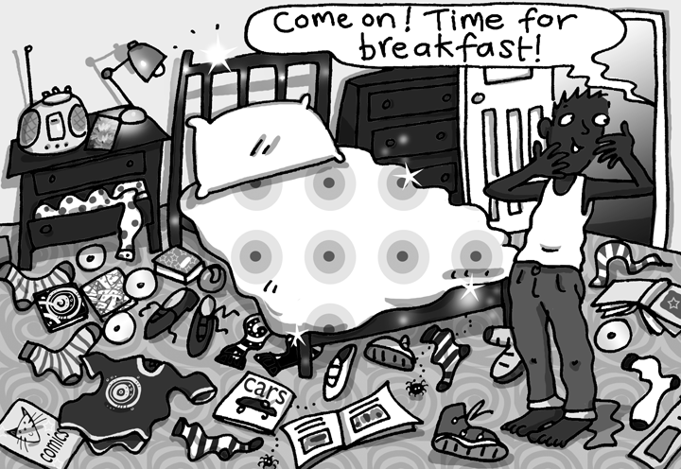

❾ She might be bored.  He might not be happy.
❿ She’s feeling excited.  There are umbrellas everywhere.

②Match the letters to make words. Mark / 5

Liver-
In-
Fr-
Portu-
Syd-
Ger-
-many
-pool
-guese
-ney
-ench
-dia

cities
Liverpool
________________

countries
________________
________________

nationalities
________________
________________

Total unit mark / 15

