Name: | Class:

①Cross out the wrong words. Mark / 10
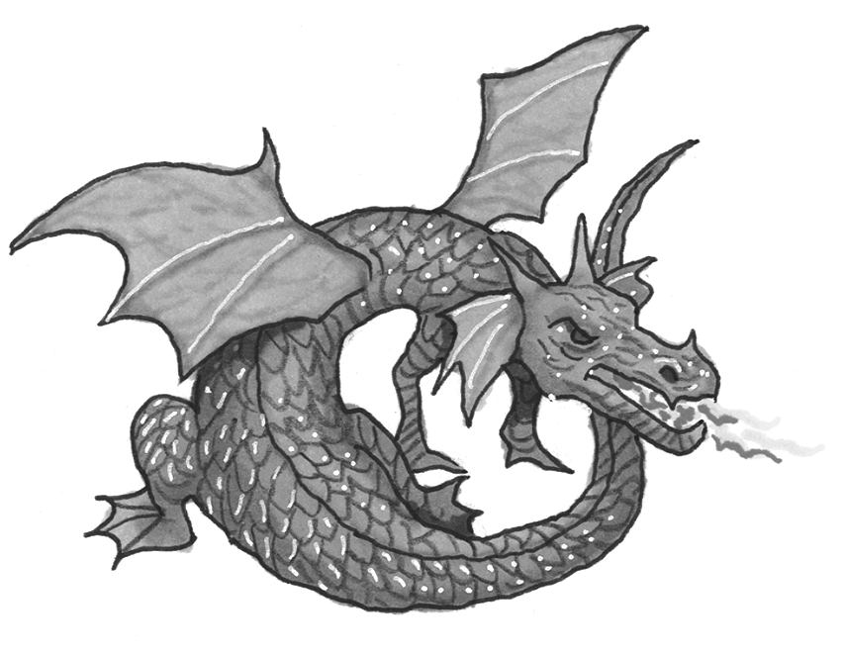
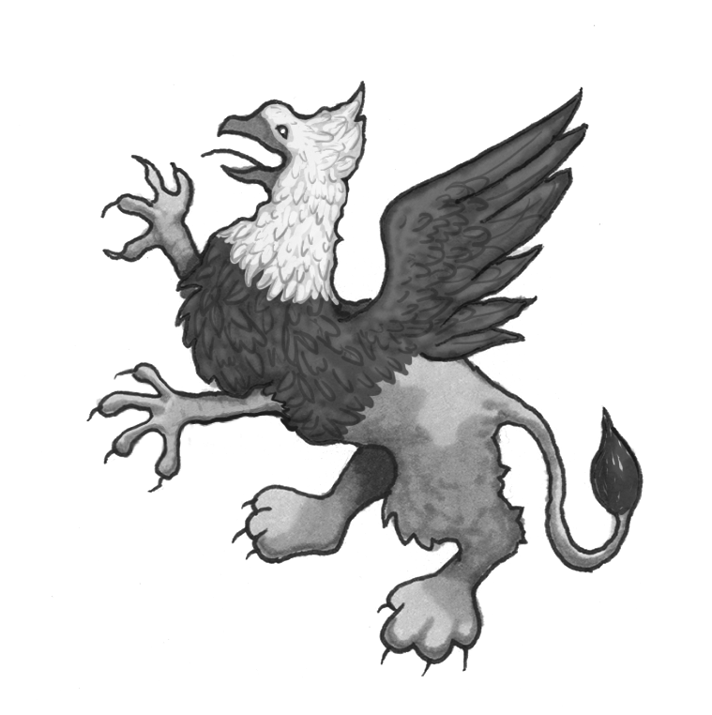
❶ |  | claws | horn |  | ❷ |  | sing | breathe fire
 |  | sing | make nests |  |  |  | fur | scales

❸ | 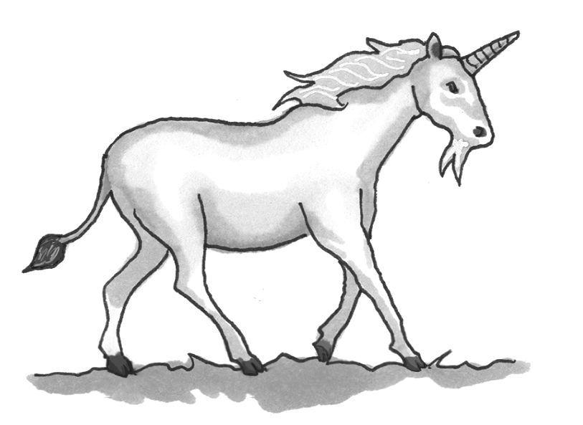 | ugly | lion’s tail |  | 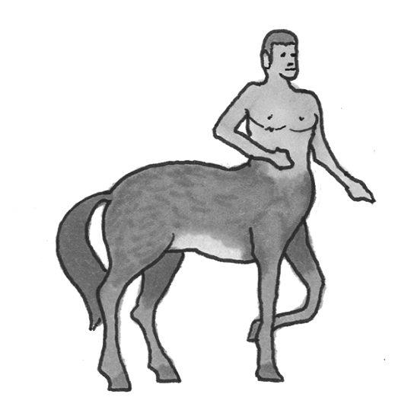  ❹ |  | tail | half man
 |  | horn | feathers |  |  |  | wings | half eagle

❺ | 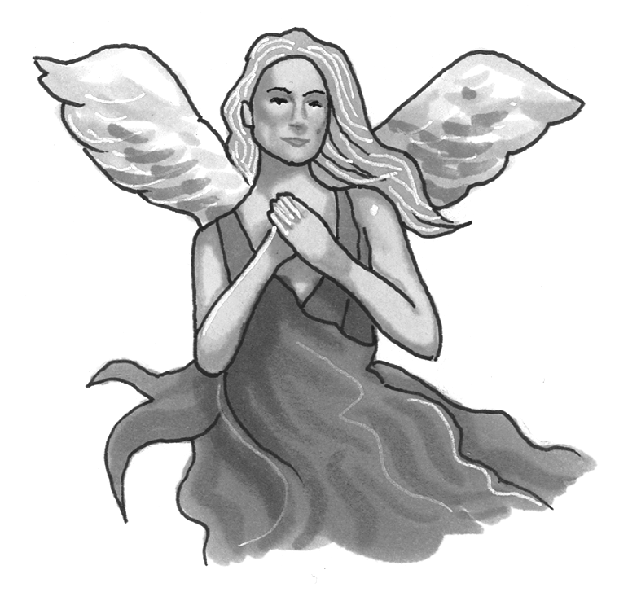 | sing | breathe fire |  | ❻ | 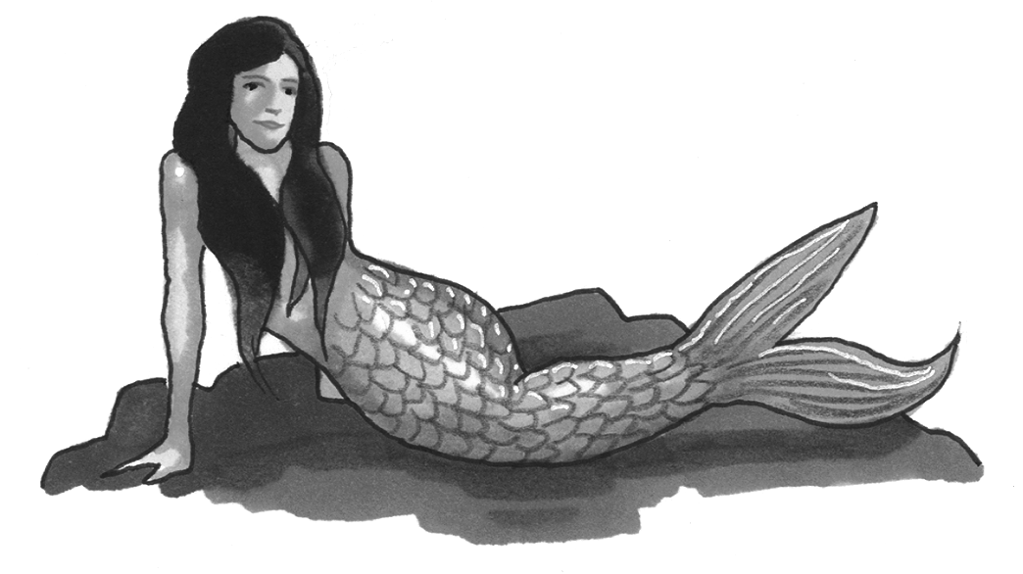 | fur | half bird
 |  | ugly | live near water |  |  |  | scales | half fish

②Look at Dan’s diary. Complete the questions. Mark / 5
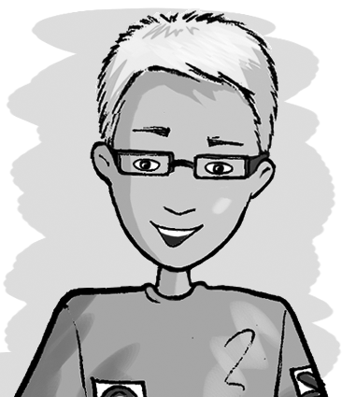
Saturday | Sunday
9am – buy fish | 11am – go to the gym
10am – see doctor | 3pm – watch football with Shari
1pm – call Alvin | 8pm – make pizza

When What Who Where When Who

❶ What is he going to buy at 9 o’clock on Saturday morning? Fish.
❷ _____________ at 10 o’clock on Saturday morning? The doctor.
❸ _____________ Alvin? At 1 o’clock on Saturday afternoon.
❹ _____________ at 11 o’clock on Sunday morning? To the gym.
❺ _____________ football with at 3 o’clock on Sunday? Shari.
❻ _____________ pizza? At 8 o’clock on Sunday evening.

Total unit mark / 15

