Name: | Class:

① Listen and complete. Mark / 10

❶ The story was called The Helper.

❷ The creature had .

❸ It lived in .

❹ It helped a lot of .

❺ The story was pages.

A B C
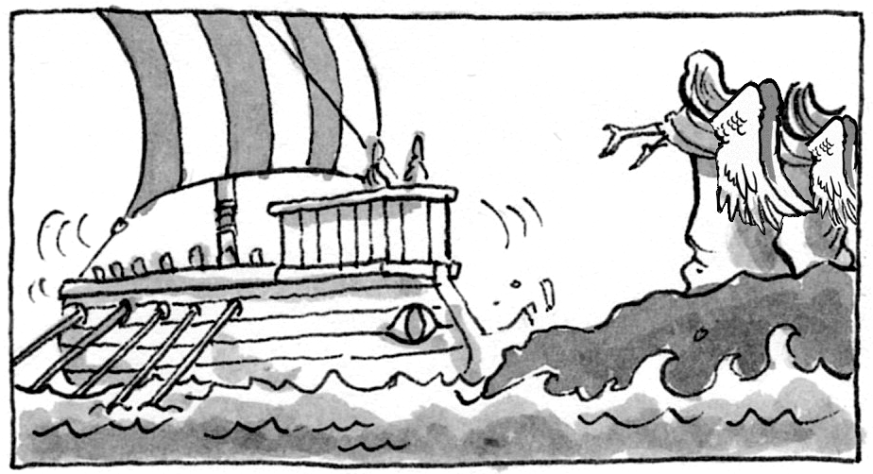
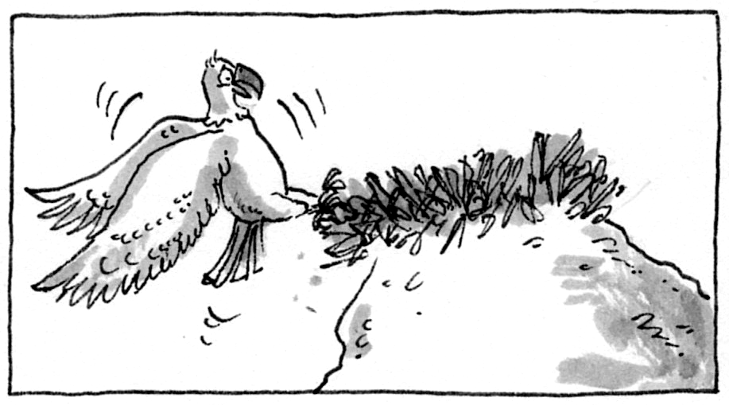
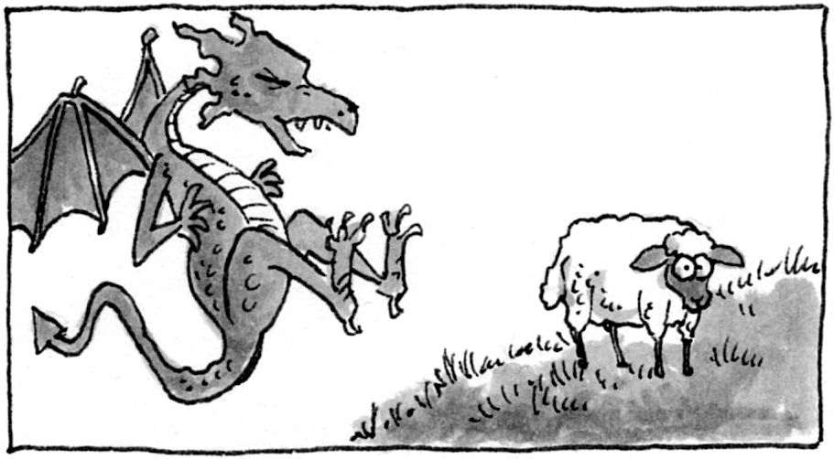

❻ What’s the best picture for the story? _________________.

②Read and match. Mark / 5

❶ The astronaut will fly c a) him homework today.
❷ His teacher is not going to give _ b) to school tomorrow.
❸ She is going to visit _ c) to the moon next month.
❹ One day she will study _ d) on Mars in the future.
❺ They won’t come _ e) Paris in spring.
❻ People won’t live _ f) English at university.

Total review mark / 15

