Name: | Class:

①Complete the story. Mark / 10

going yet was Nothing anything everywhere already
might because bought will enough

Next Saturday is Tom’s birthday and he is (1) going to have a big
party. He has (2) ________ invited everyone. Yesterday, his friend

Sam went shopping because he wanted to find the perfect present for Tom.
In the morning, Sam looked (3) ________ but he couldn’t find anything. At four o’clock in the afternoon Sam (4) ________ looking in the sports shop

when he found something perfect for Tom: a skateboard. ‘Tom is going to love

this!’ Sam thought.

When Sam was going out of the shop he met Tom, who was very excited.
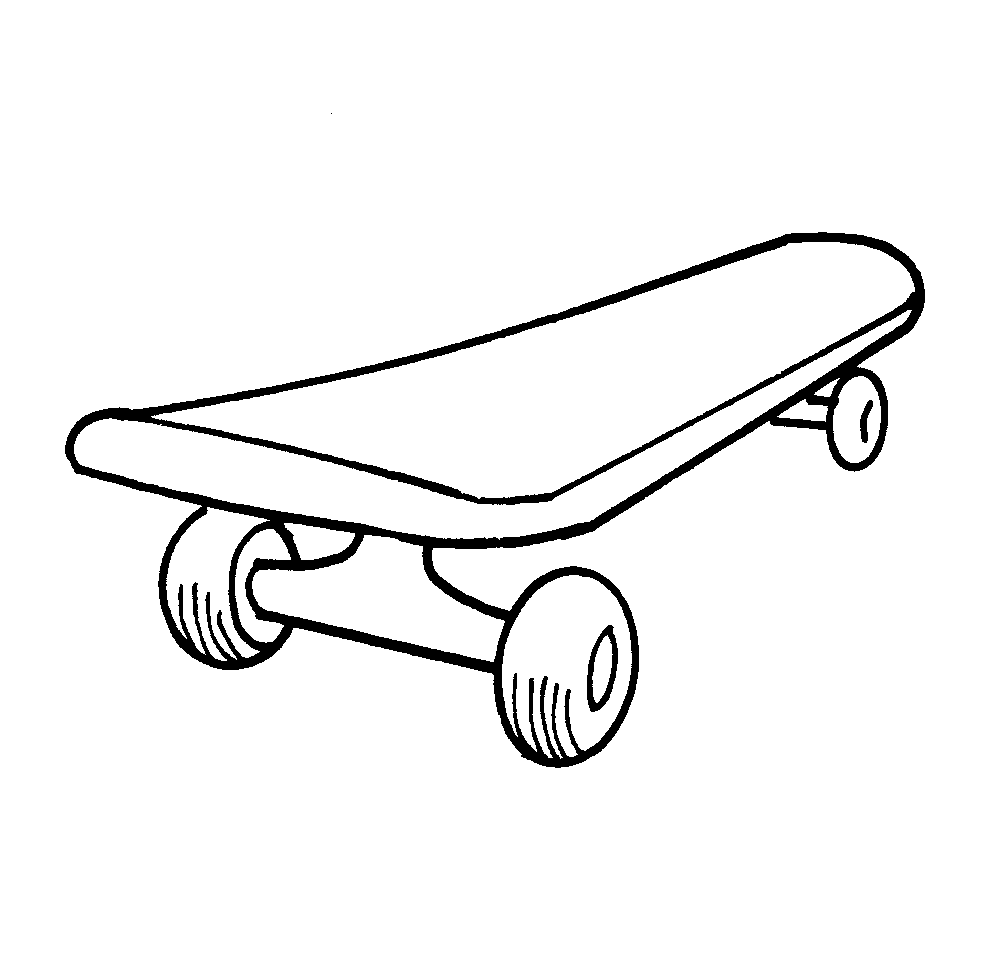
‘Look!’ Tom said, ‘I’ve (5) ________ a new skateboard – I love it!’ Tom saw

Sam’s shopping bag. ‘What did you buy? He asked.
‘(6) ________ ’ said Sam, and put the bag behind his back.

②Complete the table. Mark / 10

unicorn rocket jellyfish griffin coral chopsticks centaur
plankton peanut butter recipe engineer satellite

under the sea

_____________

_____________

_____________

beasts

unicorn

_____________

_____________

space

rocket

_____________

_____________

food

_____________

_____________

_____________

③Read and match. Mark / 10

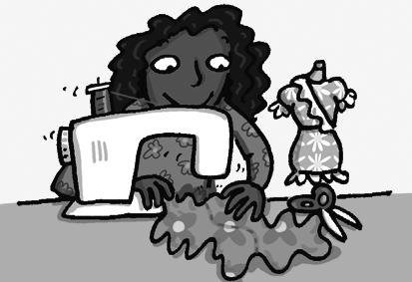
Teacher: Hi Debbie. Are you still going
A: No, I’m not. I wanted to do something more interesting.

B: No, I think I will be an art teacher.

C: Something light. Not wool. I might use cotton.

D: Yes. I’ve just started designing clothes.

E: Yes, I do. I’m going to start making it tomorrow.

F: No, but I’m going to make a skirt for the school disco. I’ve just finished the design. Look!
to chess club?
Debbie: (1) A

Teacher: Oh. Have you got a new hobby?
Debbie: (2) __

Teacher: Great. Have you used your
designs to make any clothes yet?
Debbie: (3) __

Teacher: That’s fantastic! I really like
the pockets. What’s it going to be made of?
Debbie: (4) __

Teacher: Do you have enough time?
Debbie: (5) __

Teacher: Do you want to be a fashion
designer in the future?
Debbie: (6) __


④ Listen and circle. Mark / 5

❶ The boy is going to make spaghetti with squid and crab / octopus.
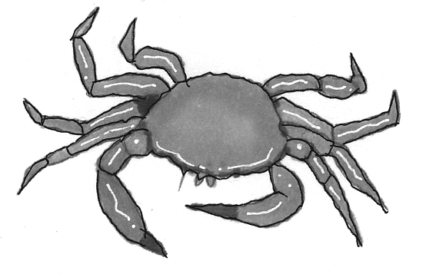
❷ The spaghetti / sauce is too hot.
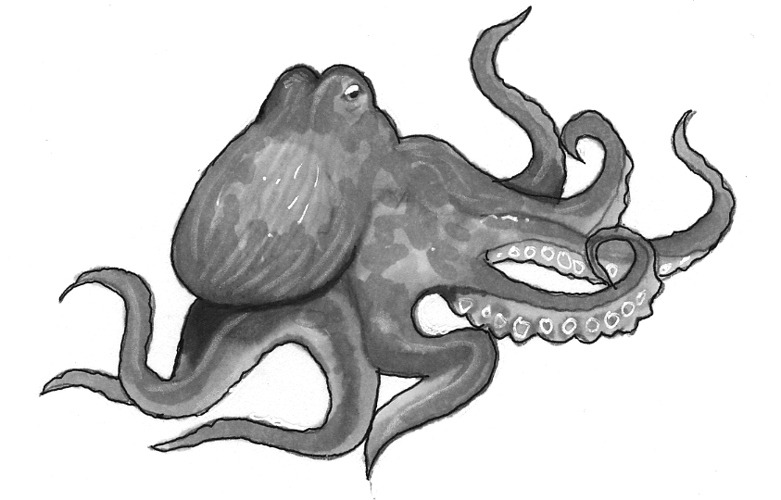
❸ They decide to invite someone / everyone for dinner.
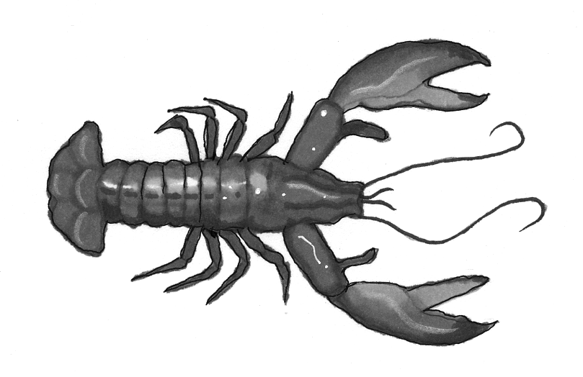
❹ Their friend Daisy will / won’t be busy.
❺ Tony might not / will like the food.
❻ Mary is / isn’t still in India.

Total end of level mark / 35

