Name: | Class:

①Look and the pictures and complete the words. Mark / 5


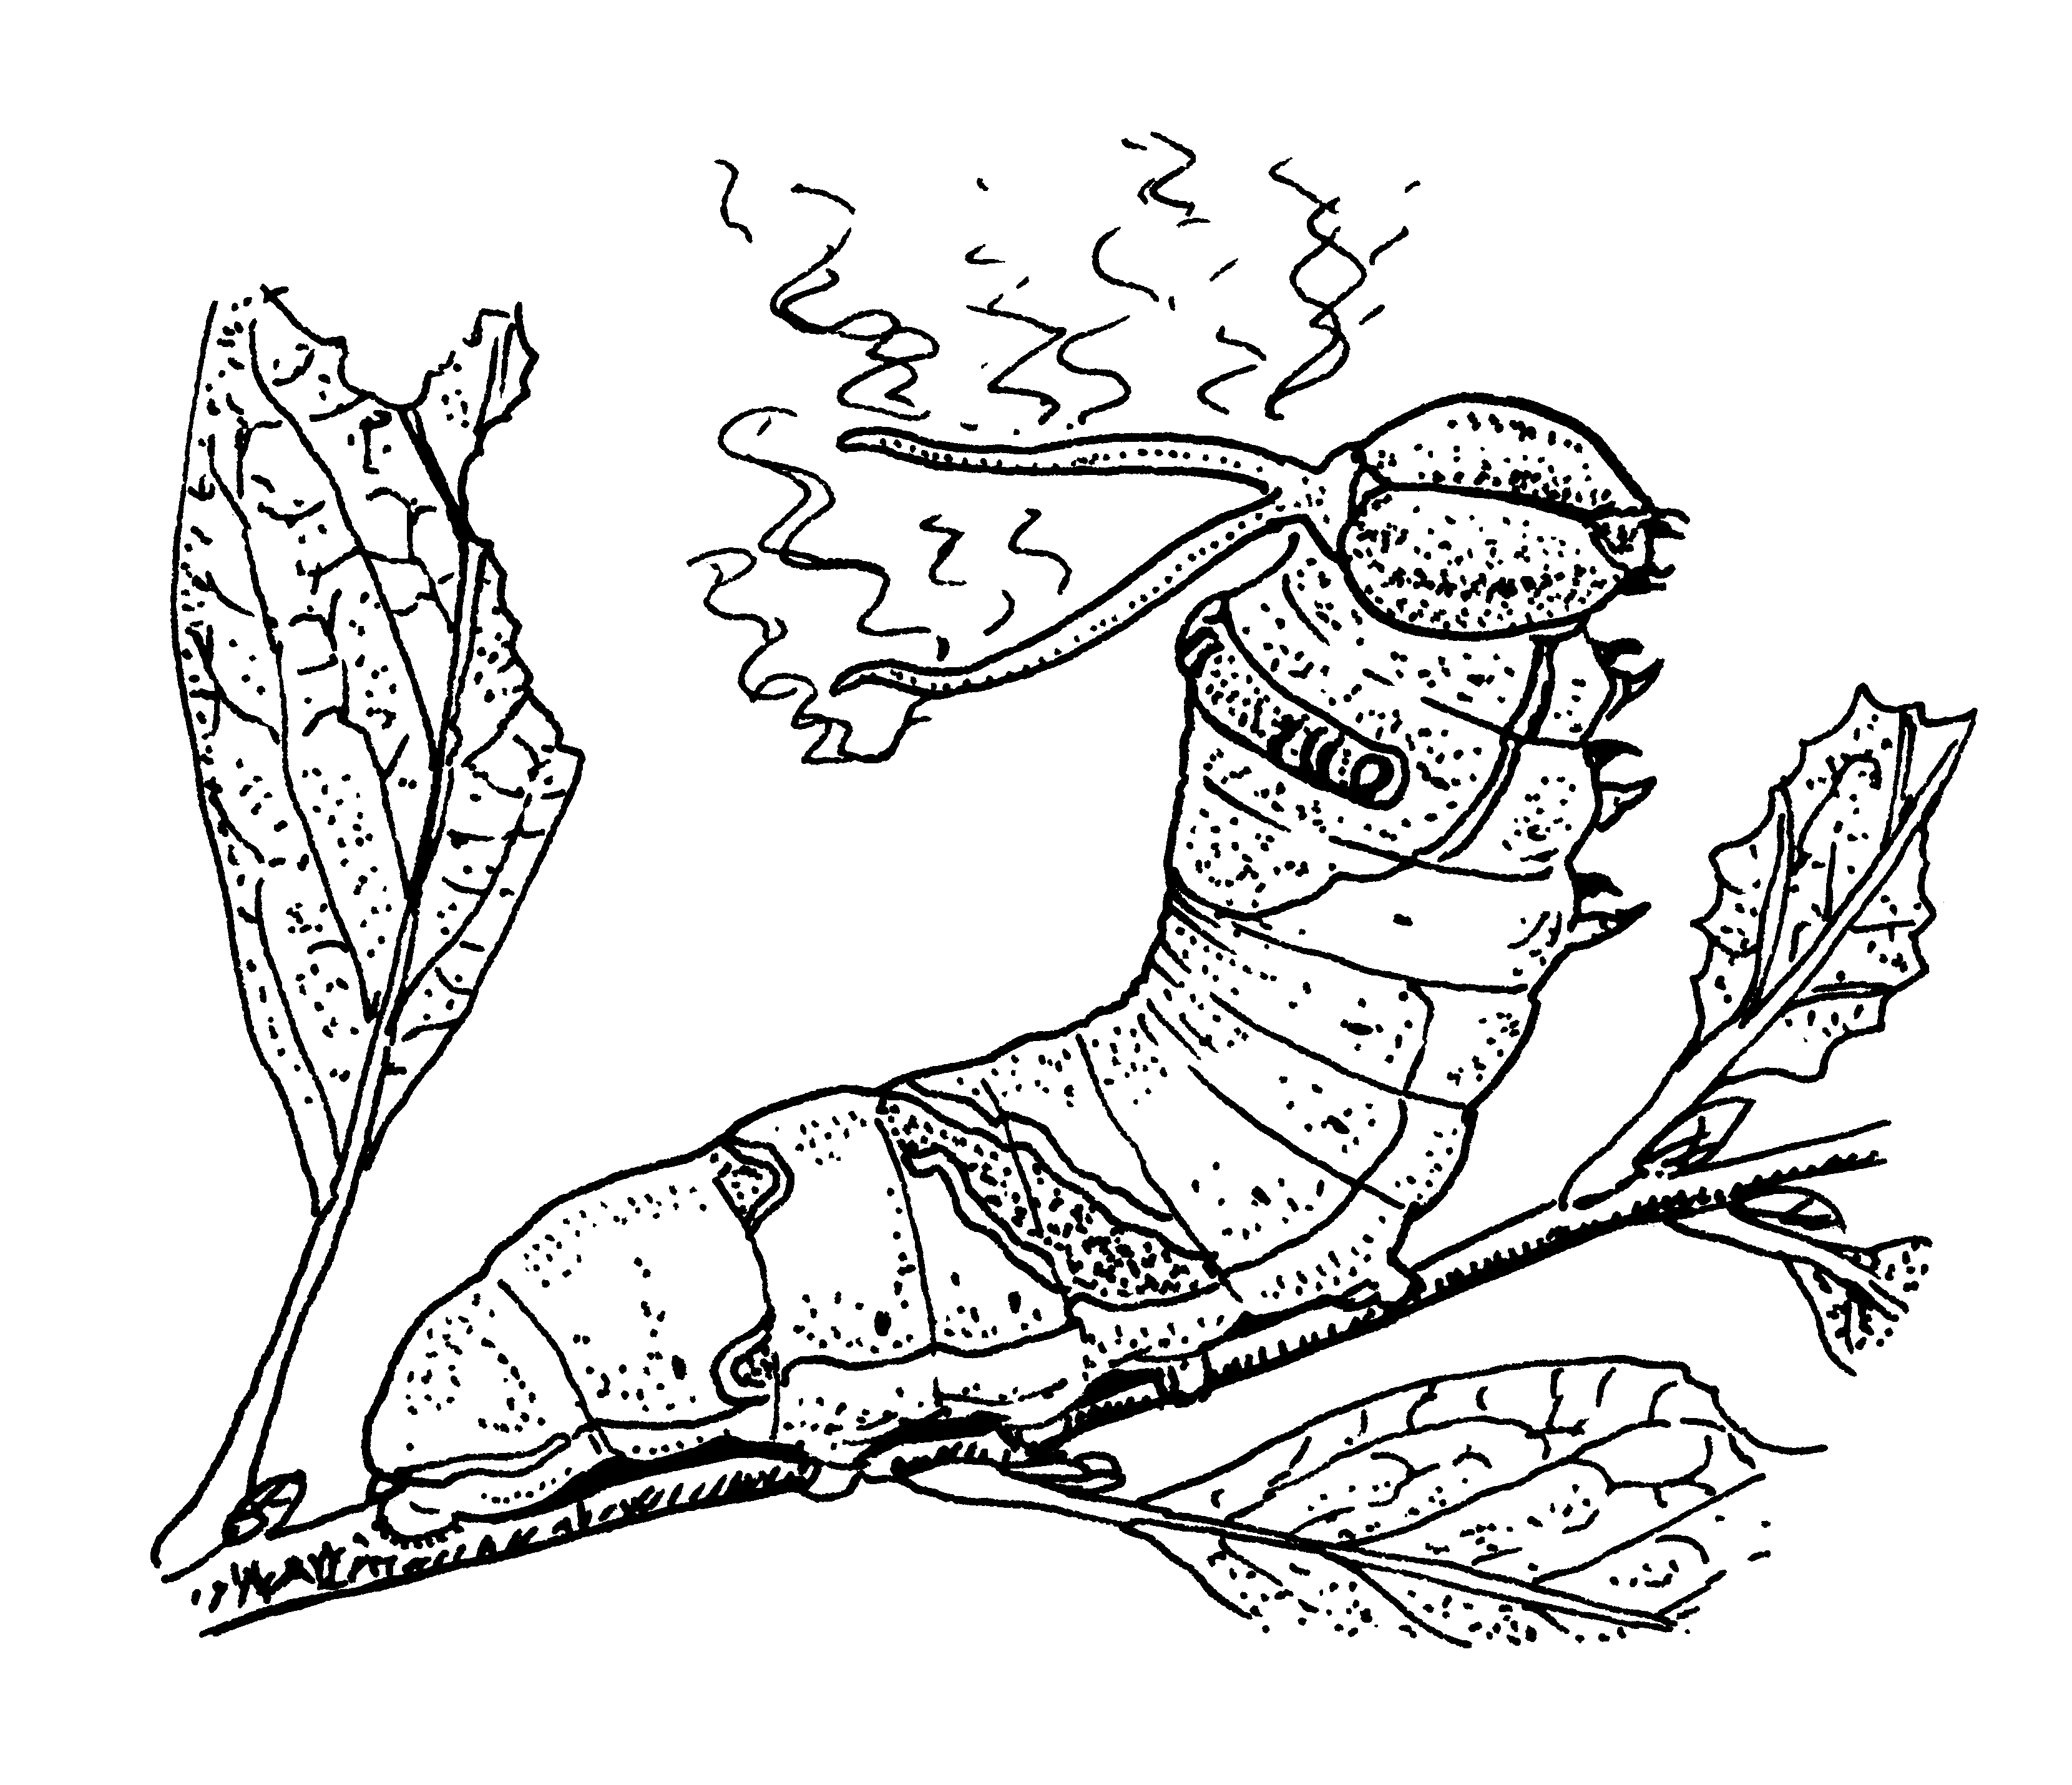
❶ secre t a r y ❷ cat _ _ _ _ _ _ _ _

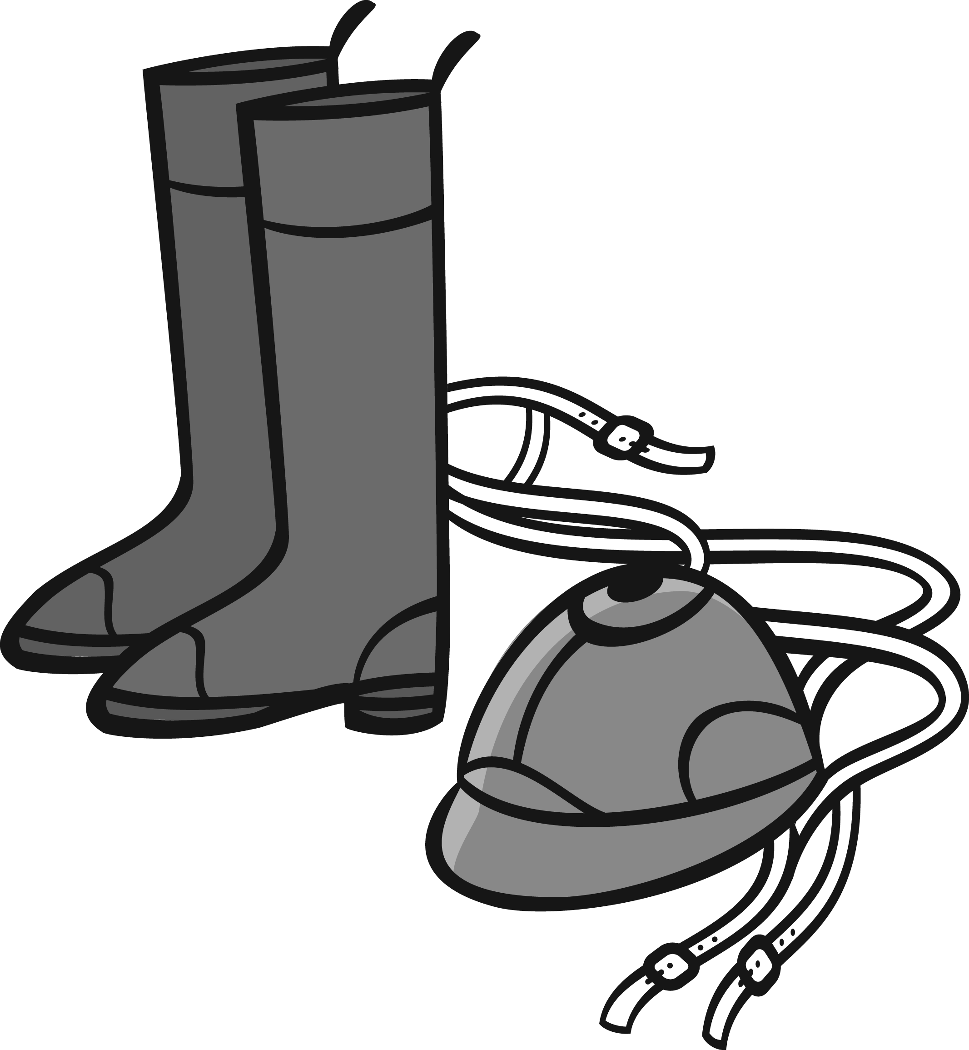
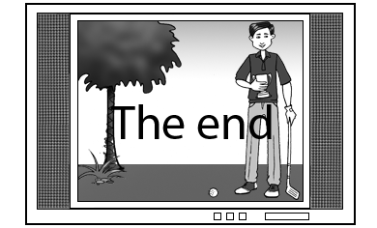
❸ on _ _ _ ❹ scr _ _ _

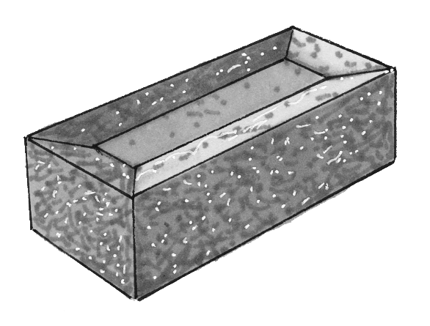
❺ horse _ _ _ _ _ _ ❻ br _ _ _

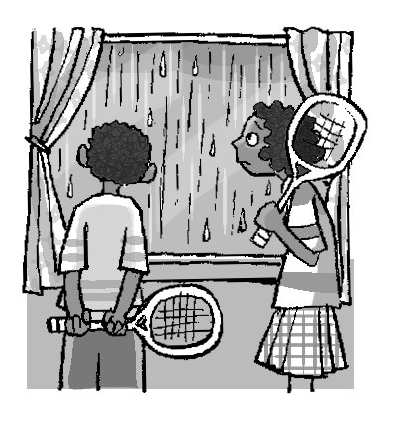
②Make negative sentences. Mark / 10

❶ They’re going to play tennis.
They aren’t going to play tennis.

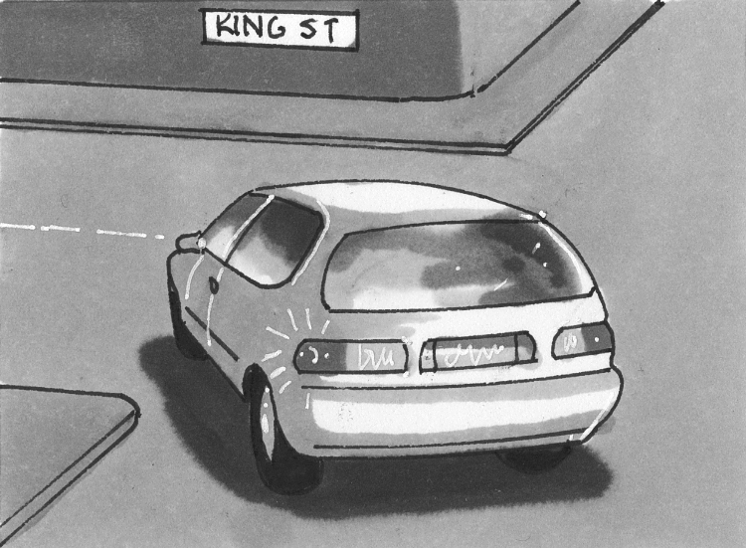
❷ The car is turning right.
________________________

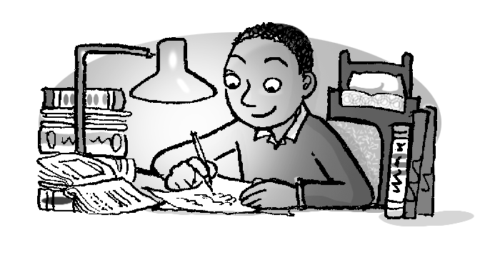

❸ He has finished his homework.
________________________

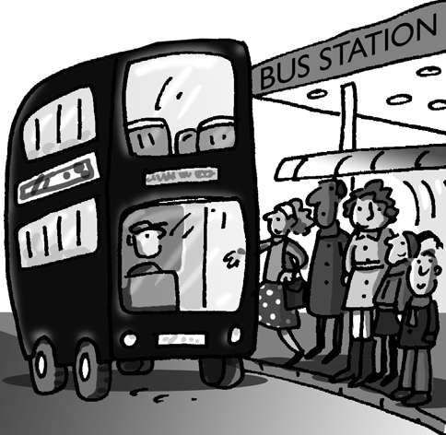
❹ It was raining when the bus arrived.
________________________
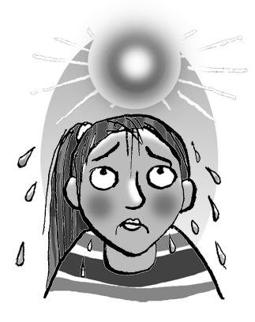

❺ She looks cold.
________________________
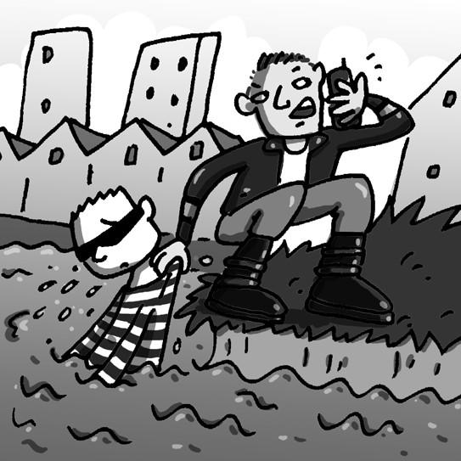

❻ The thief escaped.
________________________

③Complete the table. Mark / 10

uniform episode journalist rubber medal turn on
bus driver hurricane stone athletics lightning

TV | work | weather | materials | sport
___________ | uniform | ___________ | ___________ | ___________
___________ | ___________ | ___________ | ___________ | ___________
 | ___________

④Order the questions. Look, write and answer. Mark / 10

work in the kitchen brushing his teeth on the corner
a doctor a snowman of wood

❶ What / she / to / is / going / do / ? ❷ chairs / of / are / What / the
What is she going to do? / made / ? ____________
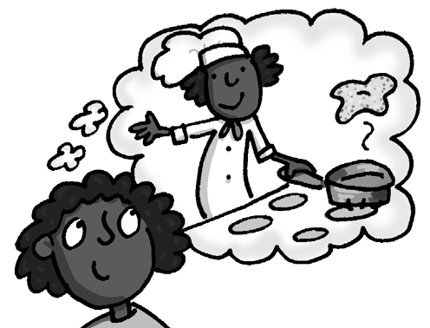
She’s going to work in the kitchen. They are made ___________.
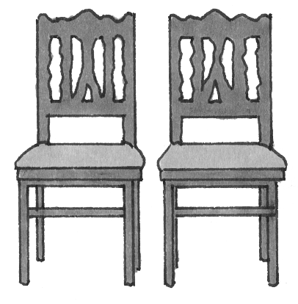

❸ have / What / done / children / the / ? ❹ ten / doing / at / was / ten /
__________________ What / he / past / ?
They’ve made ___________. __________________
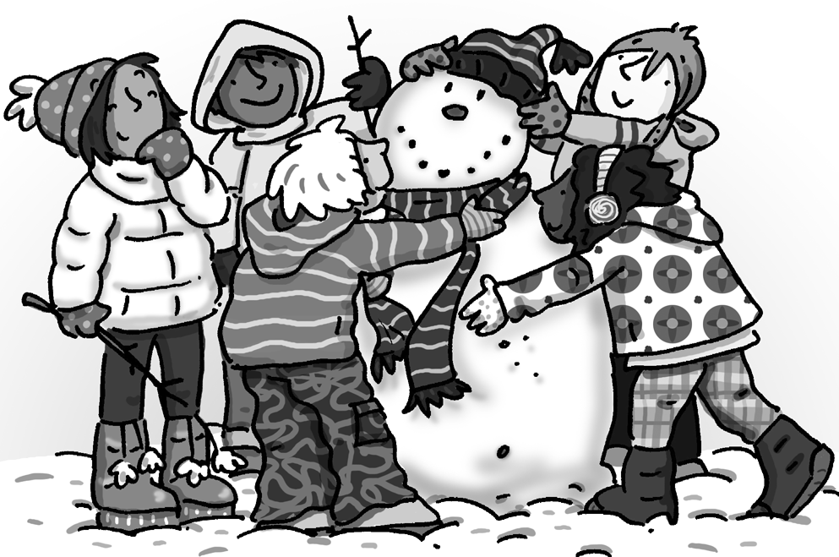
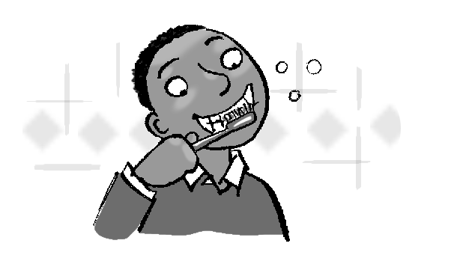
He was ___________.
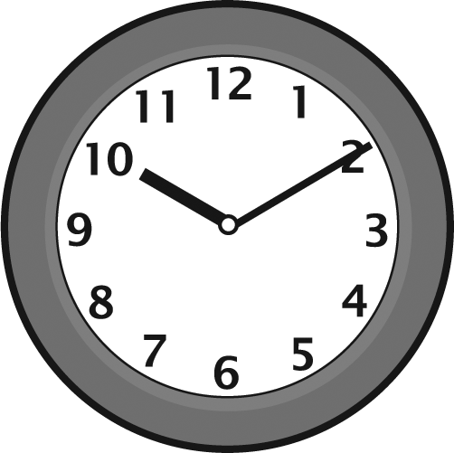

❺ should / do / he / What / ? ❻ Where / he / waiting / is / ?
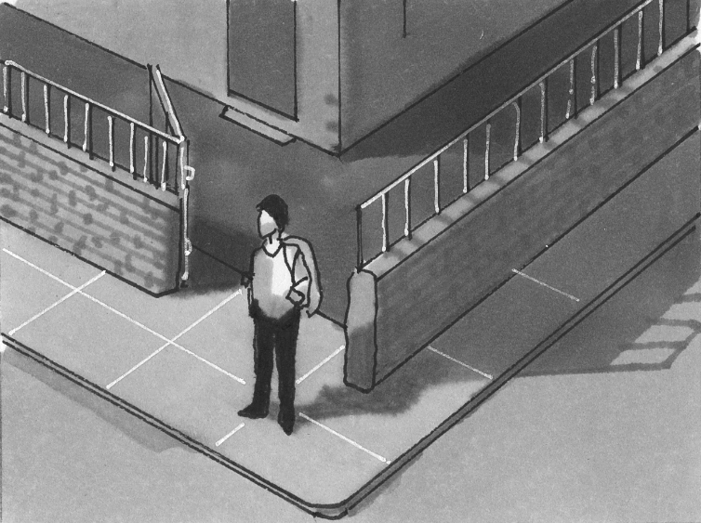
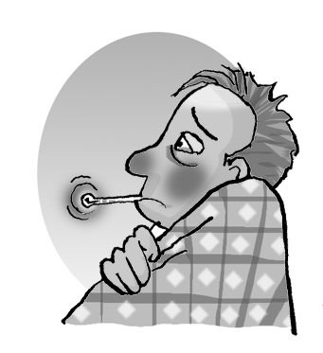
__________________ _______________
He should see _________. He’s He’s waiting ________.

Total end of level mark / 35

