Name: | Class:

①Complete the sentences. Mark / 5

on the floor in the countryside after meals
near a busy road before meals the habitat where you live
❶ You shouldn’t throw rubbish on the floor.
❷ You should brush you teeth ______________.
❸ You shouldn’t play football ______________.
❹ You should help protect ________________.
❺ You should wash your hands _____________.
❻ You should clean up after a picnic ____________.
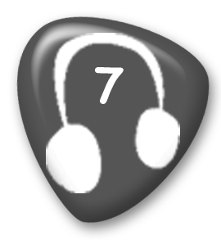
② Listen and tick () or cross (). Mark / 10

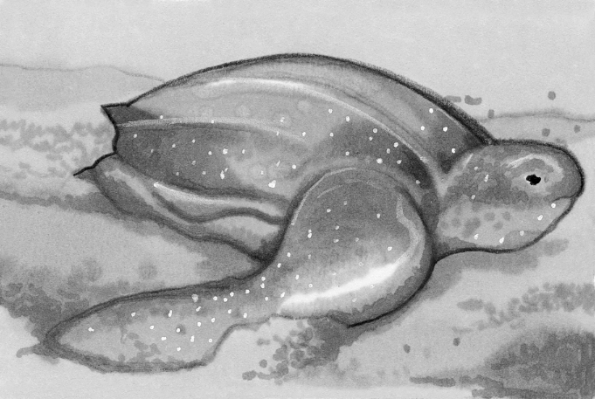
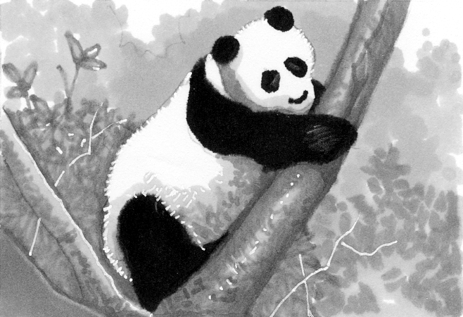
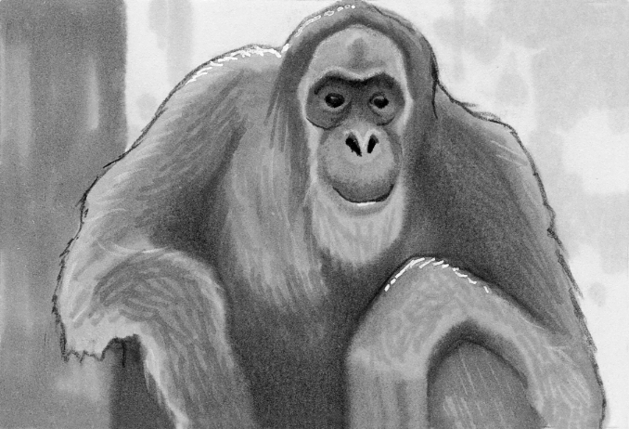



1 2 3 4 5 6

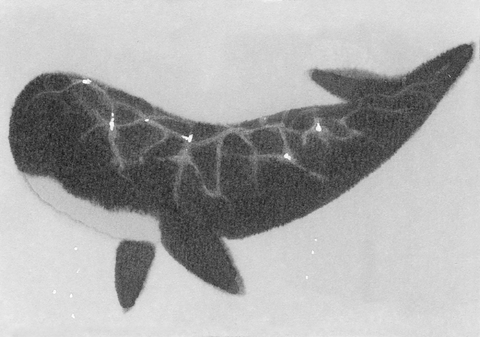
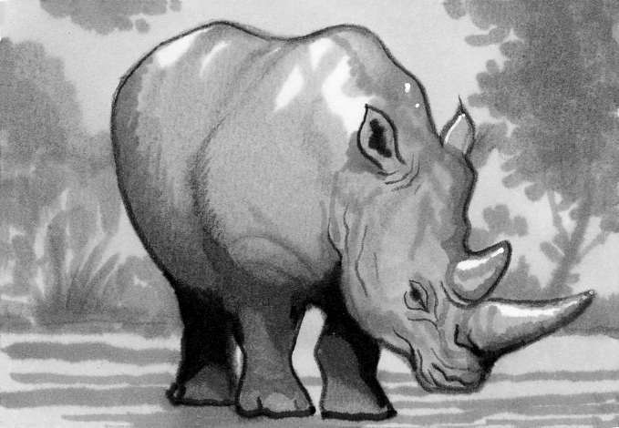
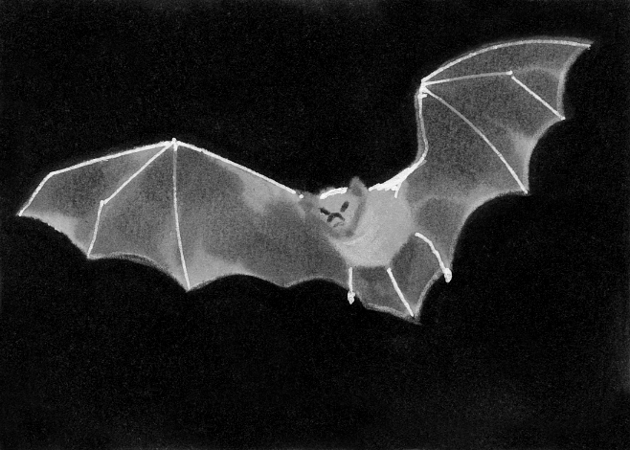

7 8 9 10 11

Total unit mark / 15

