Name: | Class:

①Look at the picture. Read and tick () or cross (). Mark / 5
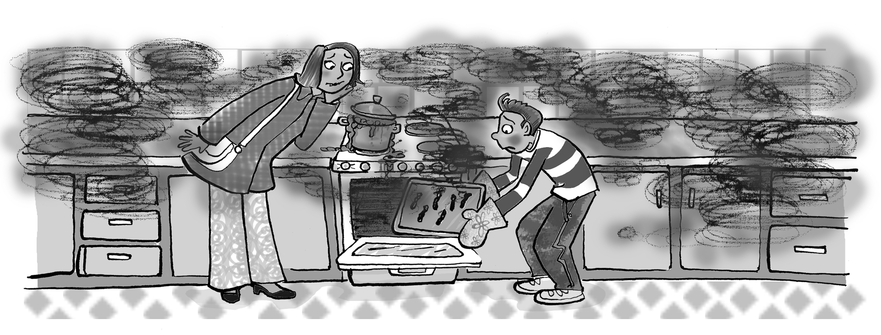

❶ The boy feels excited.
❷ His mum looks worried.
❸ The sausages look thin and black.
❹ The sausages are going to taste delicious.
❺ The kitchen smells clean.
❻ The cooker feels very hot.

②Read and complete. Mark / 10

Polly loved pizza. She loved the smell of pizza and the taste of pizza.
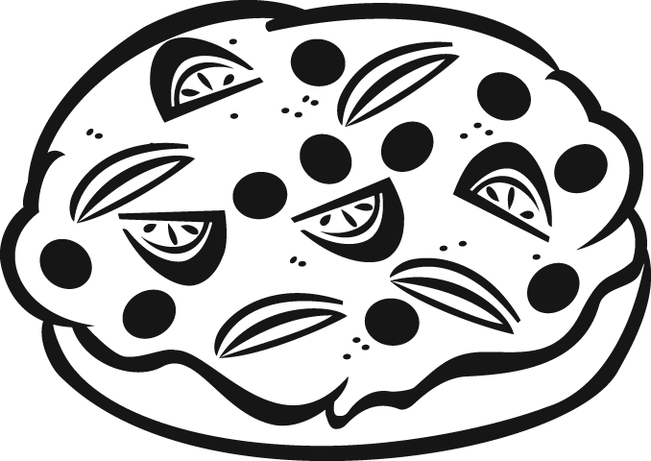
She loved the sound of pizza when it was cooking. But Polly had a
problem. Her parents never changed the toppings on their pizzas. They
always had tomato, cheese and onion.
So, Polly decided to make a ‘P pizza’. First she looked in the fridge. There
were lots of tomatoes but she couldn’t put tomatoes on a P pizza. She didn’t
take the tomatoes but she took some potatoes. In the cupboard there was
some pasta and in the fruit bowl she found pears, plums and a pineapple.
‘Perfect!’ Polly said. She cut the toppings and put them on the pizza. Then
she put the pizza in the oven. She was excited!
Later, when the family was sitting at the kitchen table, her parents
asked, ‘What has this pizza got on it?’
‘It’s got food beginning with the letter P on it,’ Polly said. ‘It’s Polly’s perfect
P Pizza!’
Then Polly tasted the pizza. Do you think it was perfect?

❶ Polly’s favourite food was pizza.
❷ Polly’s parents always put the same _________ on their pizzas.
❸ Polly didn’t use the __________ she found in the fridge.
❹ She found some pasta in the __________ .
❺ Polly _______ the ingredients before she put them on the pizza.
❻ How many ingredients with the letter P did Polly use? _______ .

Total unit mark / 15

