Name: | Class:

① Listen and write the number. Mark / 5

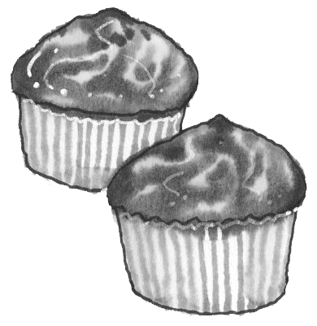



_ _ _ _ _ _
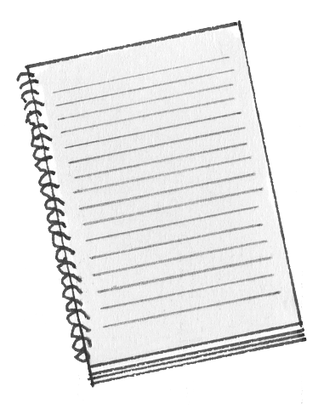



_ _ _ _ _1_

②Circle the correct answer. Mark / 10

❶ A lion sound / sounds like a tiger.
❷ You use a fork / knife to cut your food.
❸ Lemonade looks / tastes like water.
❹ Our house is / are made of stone.
❺ We’ve got four / five senses.
❻ My ice cream tastes / taste like strawberries.
❼ He knows / nose the answer.
❽ Their / There jumpers are made of wool.
❾ Metal / Glass can break easily.
❿ Sweets are made of salt / sugar.


Pizza is a famous Italian / English food.

Total review mark / 15

