Name: | Class:

①Read and tick () or cross (). Mark / 5
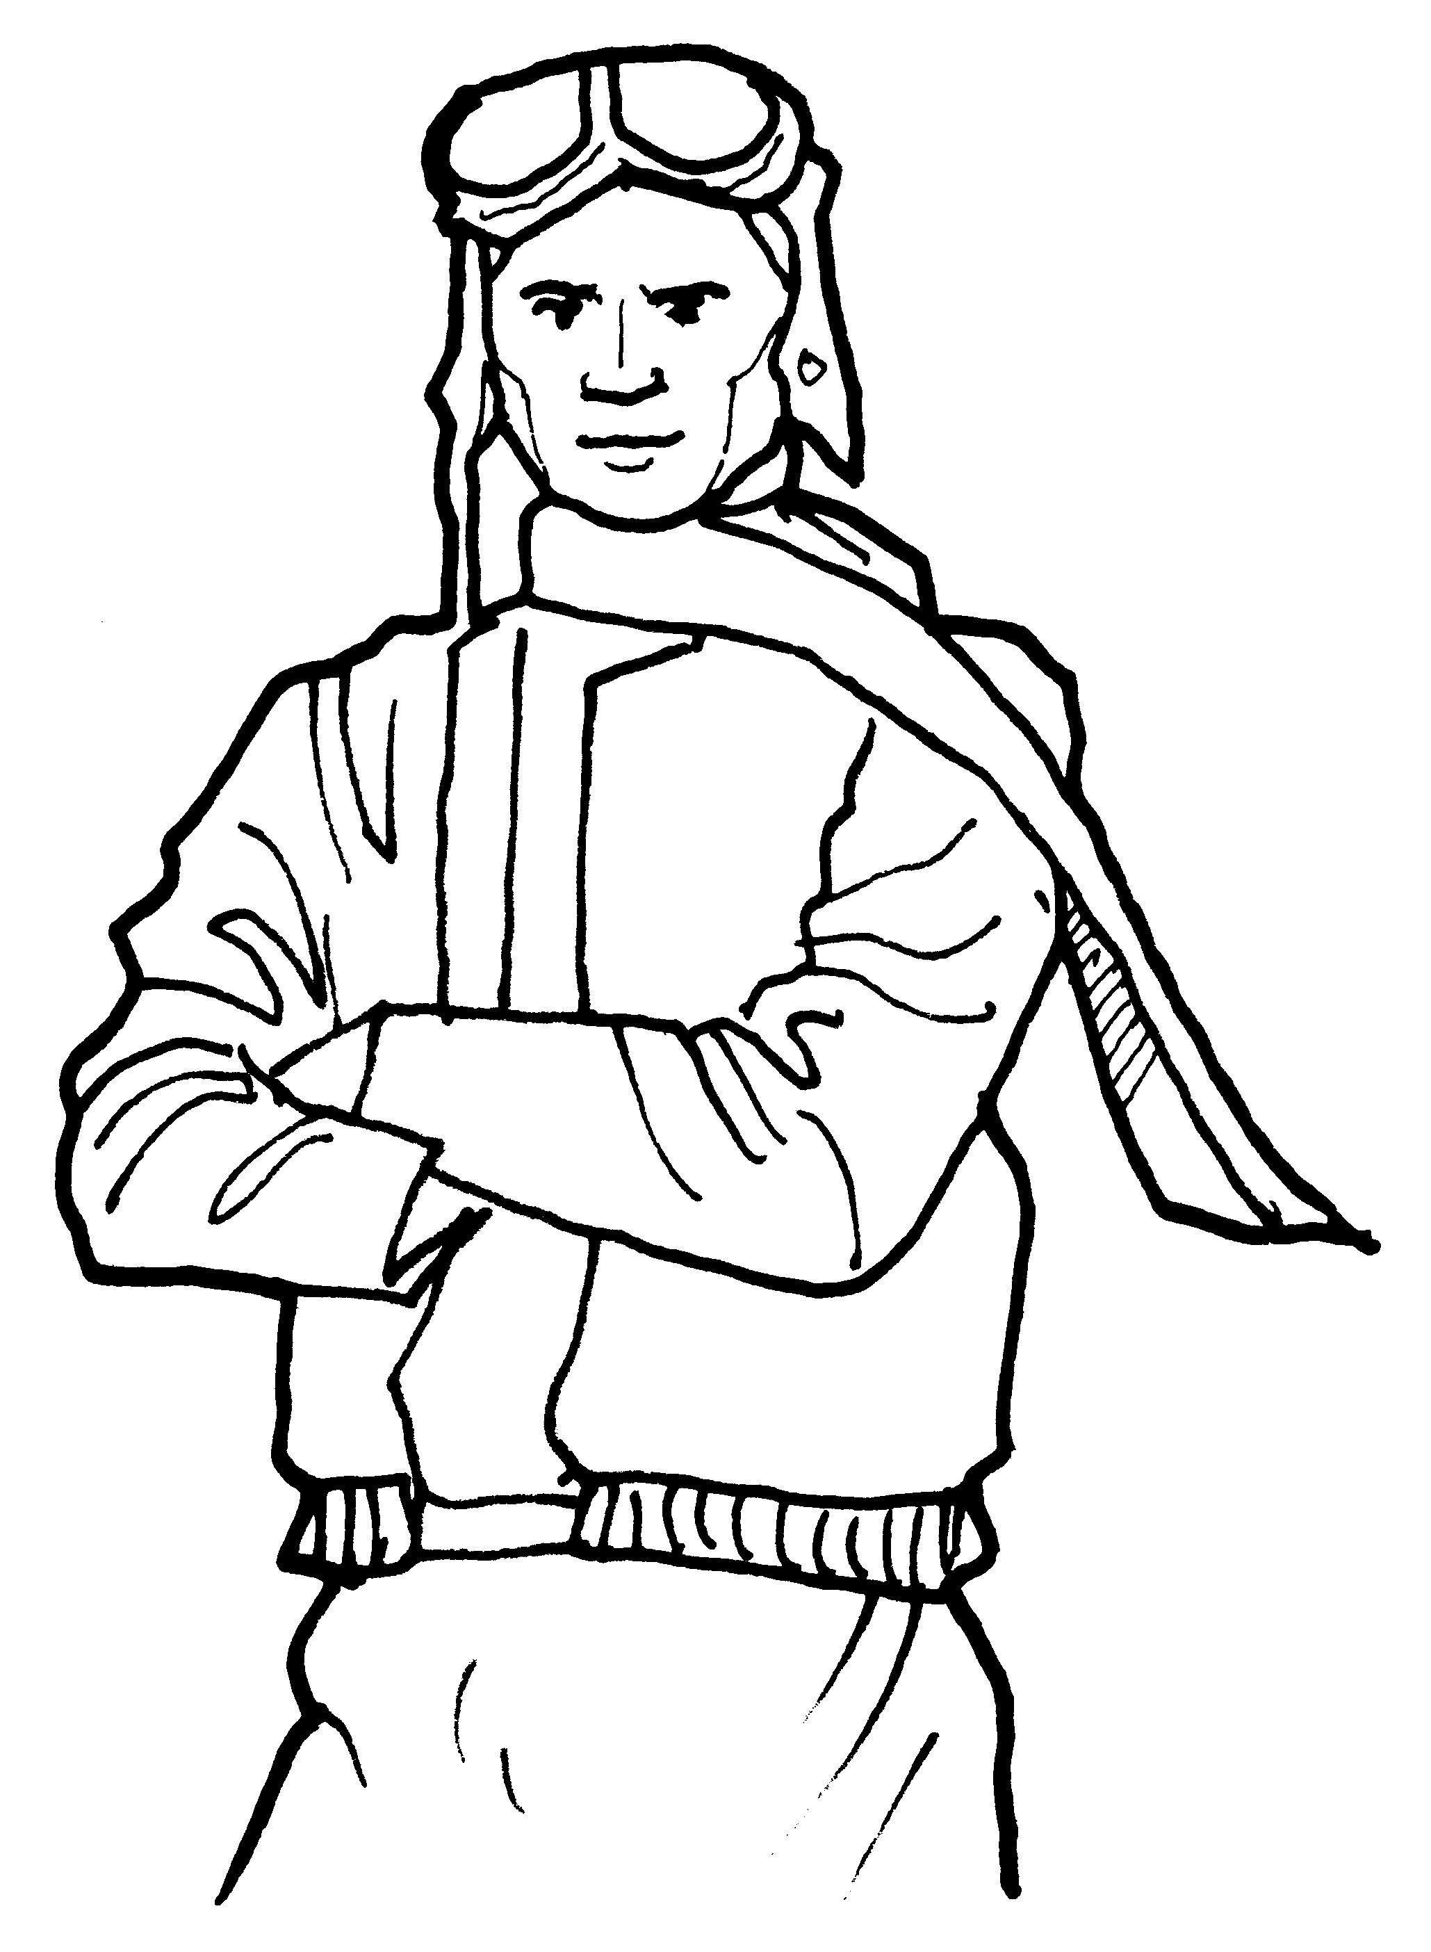
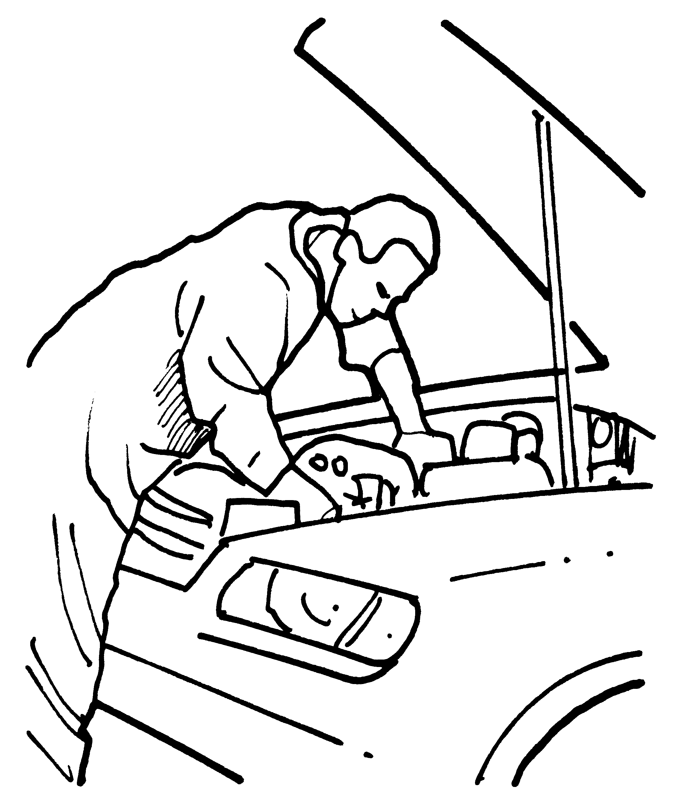



❶ a He drives a car. ❷ a He gets dirty.

b He travels a lot. b He works in a kitchen.

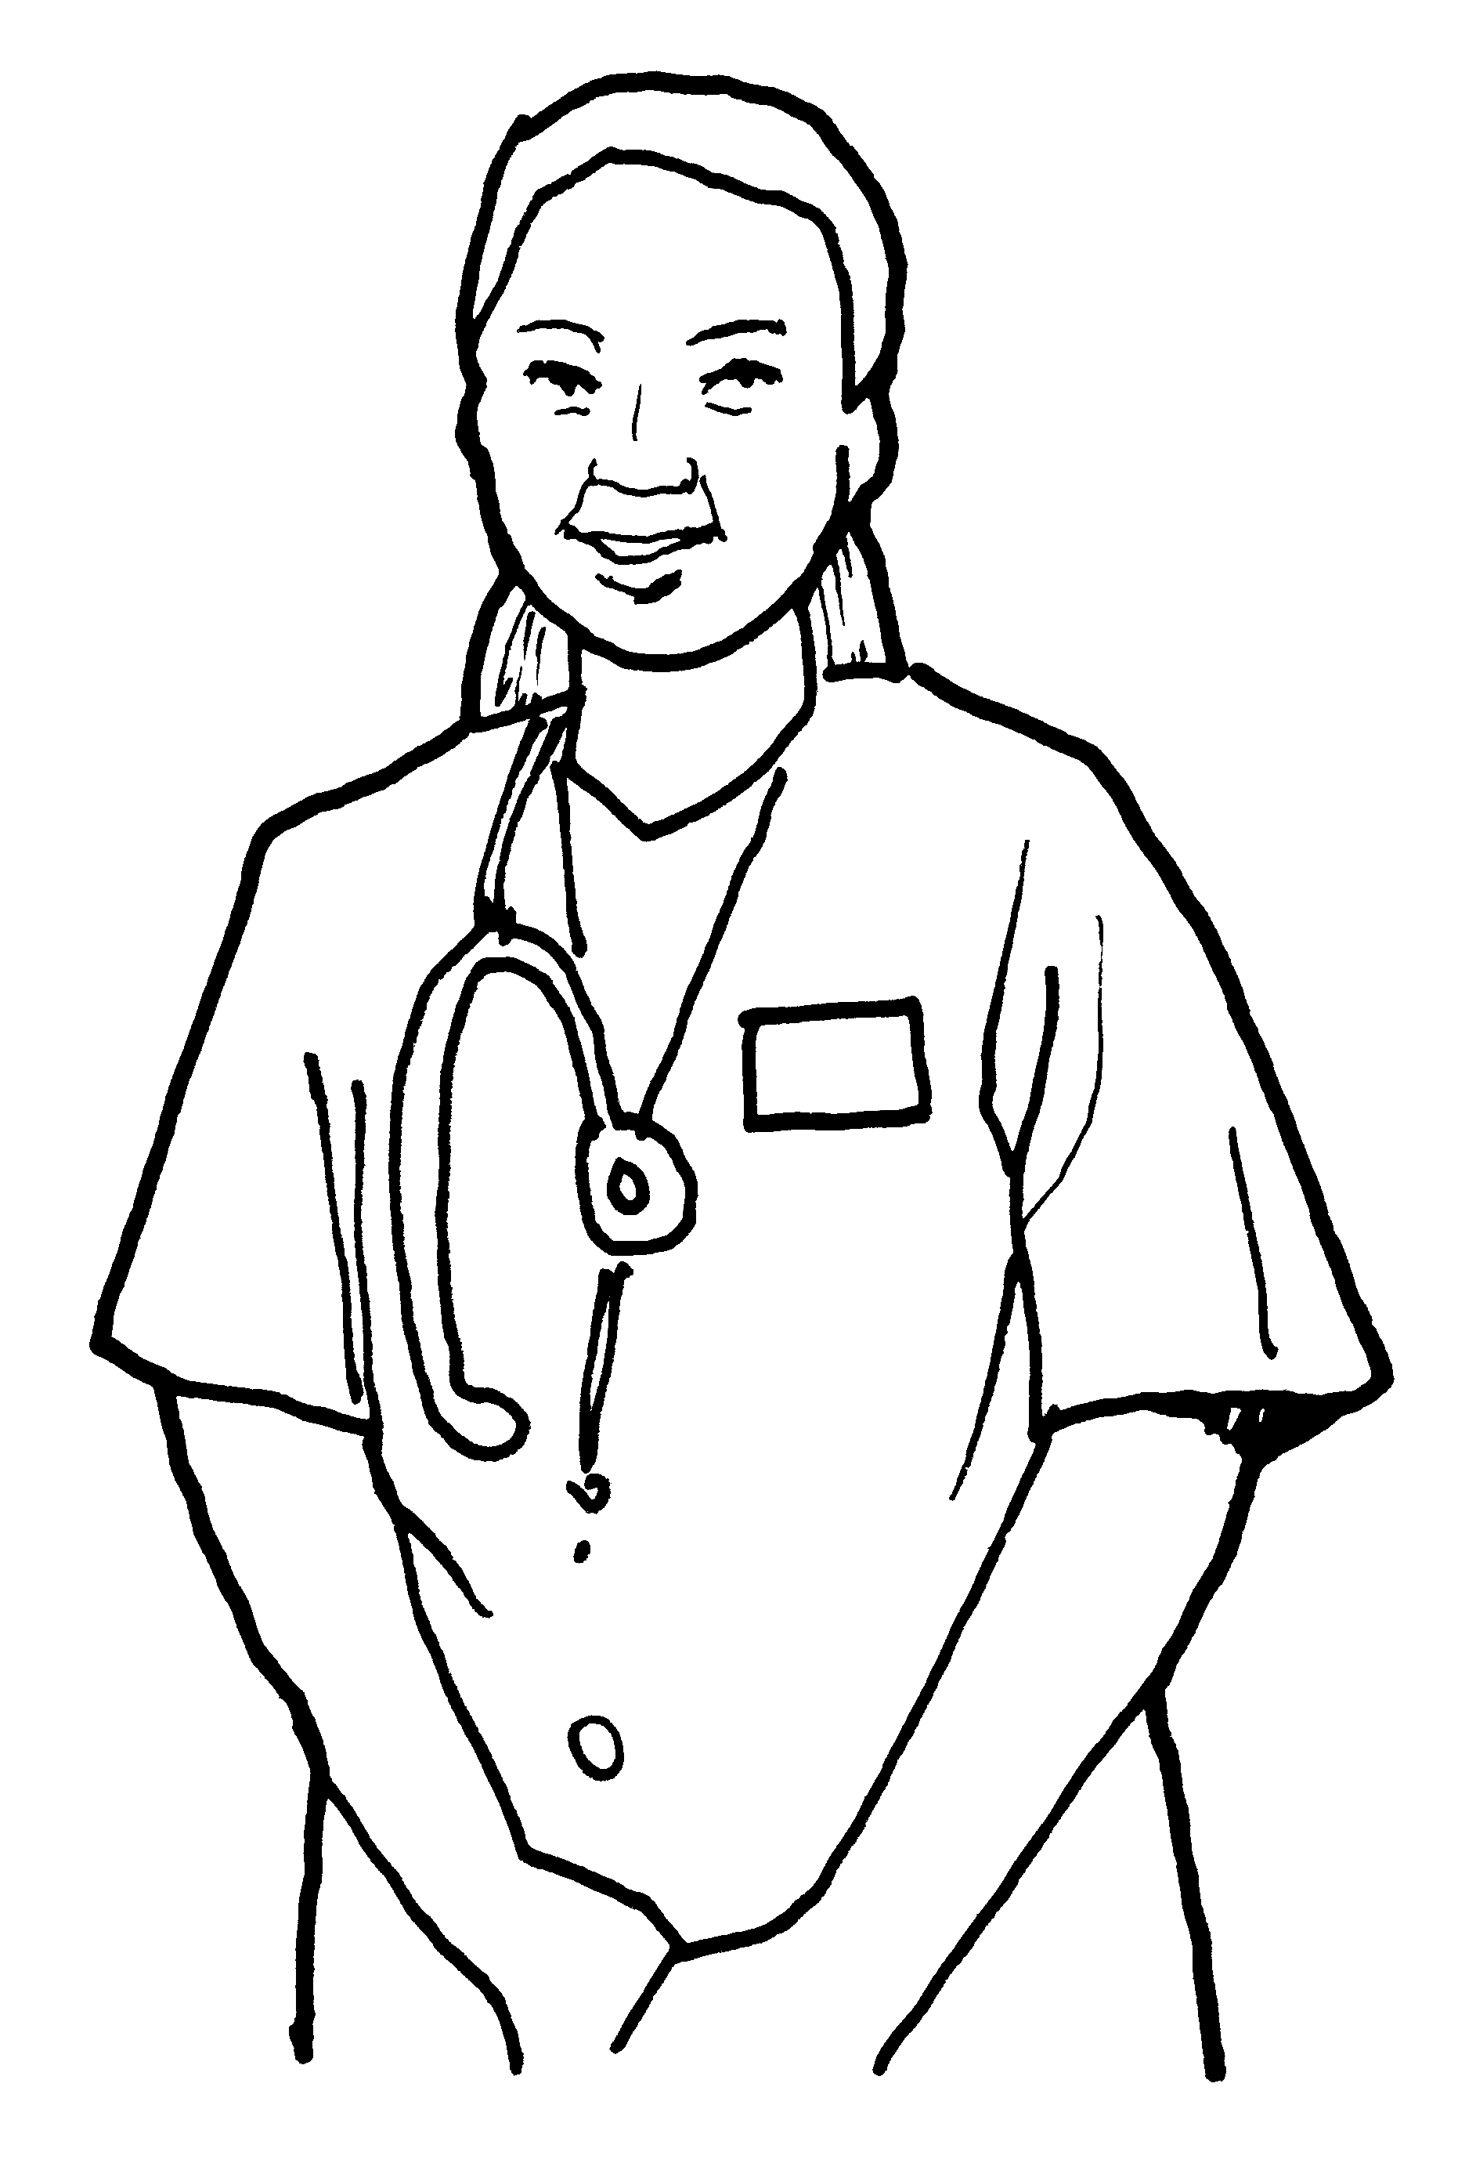
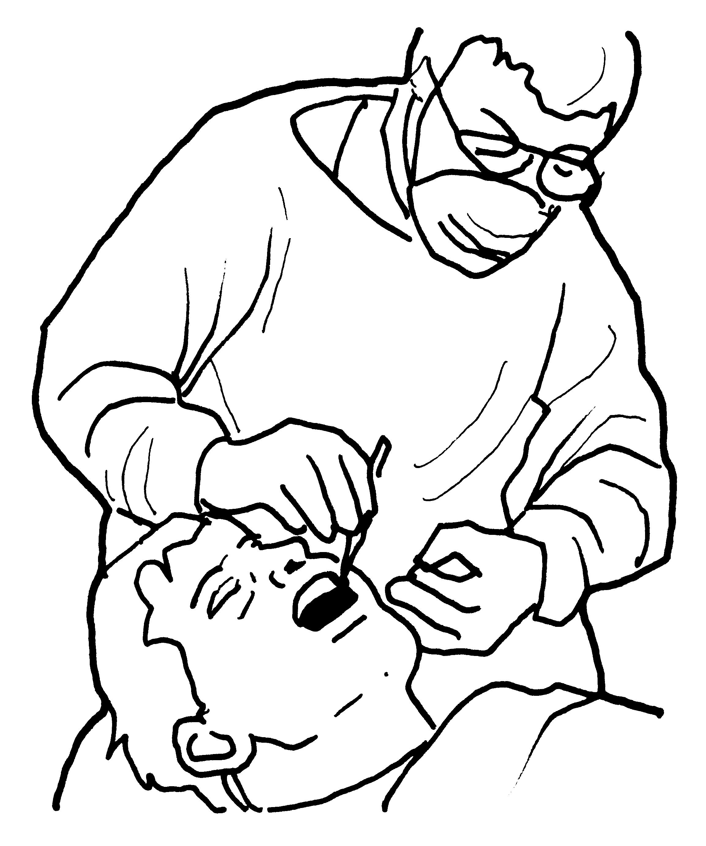
❸ a She looks after ❹ a He works at a school.
people. b He wears gloves and
b She repairs cars. a mask.

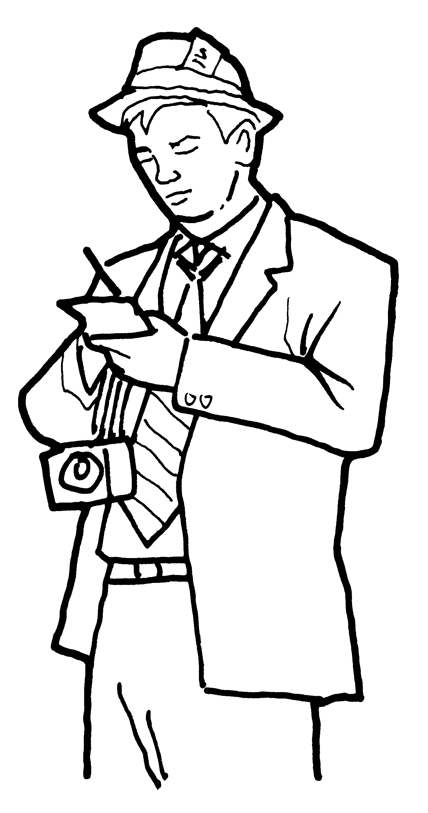

❺ a She visits lots of ❻ a He takes lots of photos.
airports. b He has to wear a
b She types very fast. special uniform.

②Read look and write. Mark / 10

1 | cook | scientist | artist |  | 2 | work | working | works
3 | quarter | half | clock |  | 4 | goes | go | going
5 | is | isn’t | aren’t |  | 6 | are | aren’t | they

Tommy is a (1) cook at a very good hotel. He (2)________ in the week and sometimes at the weekends. He usually gets up at (3)________ to six

because he starts work at seven. Today, he’s cooking soup in the kitchen. He’s
(4)________ to have a busy day because lots of people are going to eat at the hotel. Tommy likes having lots of things to do but he (5)________ going to do everything today. There are three chefs who (6)________ going

to help him.

Total unit mark / 15

