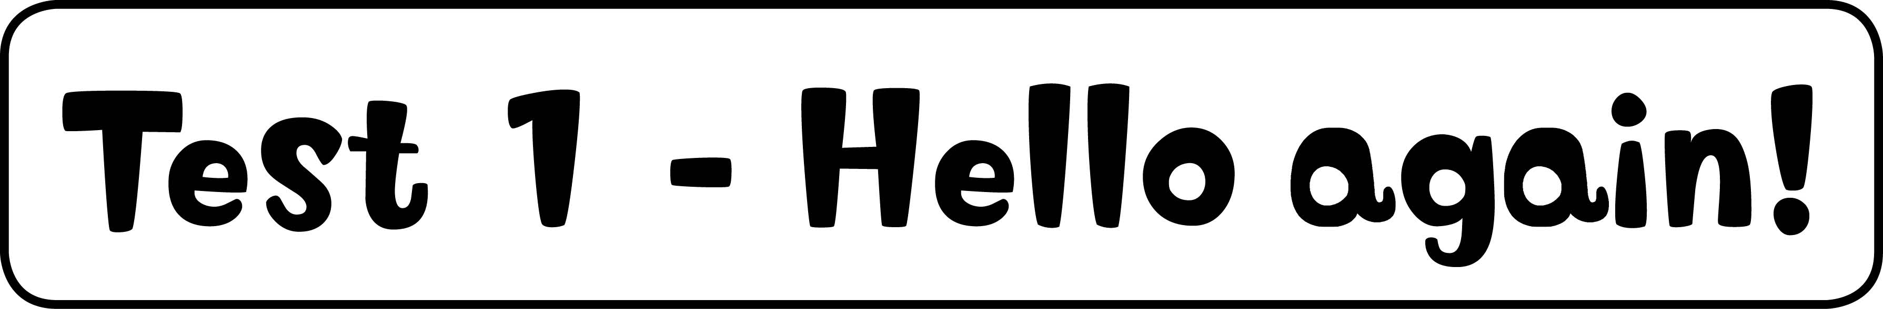

1 Look and write. (10 marks)
d, G, j, K, N, Q, t, V, v, y

2 Circle and write. (5 marks)
2 He’s Simon. 3 He’s Mr Star. 4 She’s Marie. 5 She’s Suzy. 6 He’s Maskman.



1 Look and write. (5 marks)
15, 20, eighteen, fourteen, 12

2 Read and circle. (5 marks)
2 There isn’t, 3 There isn’t, 4 There’s, 5 There’s, 6 There’s



1 Look and write the words. (5 marks)
2 kite, 3 camera, 4 watch, 5 robot, 6 computer game

2 Listen and draw lines. (5 marks)
computer game – Jill, watch – Ann, robot – Sam, lorry – Rick, camera – Ann

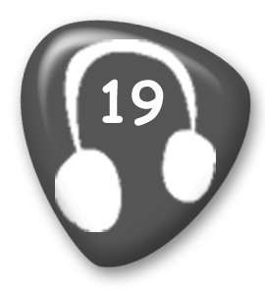
Whose is the kite? It’s Rick’s.
Whose is the camera? It’s Ann’s.
Whose is the robot? It’s Sam’s.
Whose is the computer game? It’s Jill’s.
Whose is the watch? It’s Ann’s.
Whose is the lorry? It’s Rick’s.

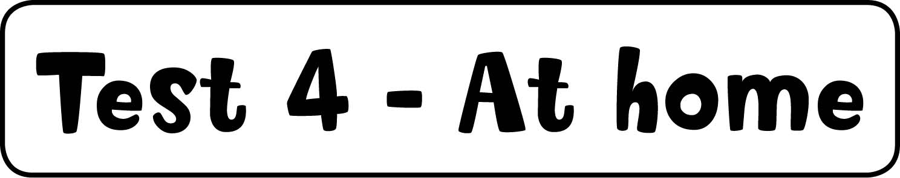

1 Look and write the words. (5 marks)
2 phone, 3 sofa, 4 mirror, 5 mat, 6 lamp

2 Listen, match and colour. (5 marks)
John – green watch, purple kite;
Sue – red camera, yellow trousers, red socks


Man: Which shoes are John’s?
Woman: The white ones are his.
Man: Which camera is Sue’s?
Woman: The red one is hers.
Man: Which watch is John’s?
Woman: The green one is his.
Man: Which trousers are Sue’s?
Woman: The yellow ones are hers.
Man: Which kite is John’s?
Woman: The purple one is his.
Man: Which socks are Sue’s?
Woman: The red ones are hers.



1 Order and write. (5 marks)
2 Is there a teacher? 3 There is a whiteboard. 4 Are there eighteen desks?
5 Are there six rulers? 6 Is there a bookcase?

2 Look and write. (5 marks)
2 on, 3 next to, 4 under, 5 on, 6 in

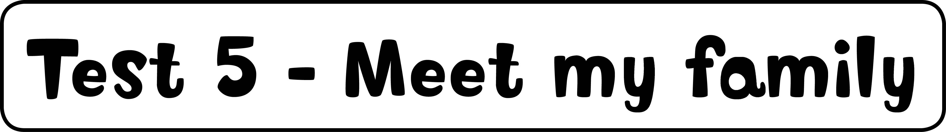

1 Look and write. (5 marks)
2 grandpa, 3 Frank’s, 4 mummy, 5 Lenny’s/Sam’s, 6 Frank’s

2 Listen and write yes or no. (5 marks)
2 no, 3 yes, 4 no, 5 no, 6 yes

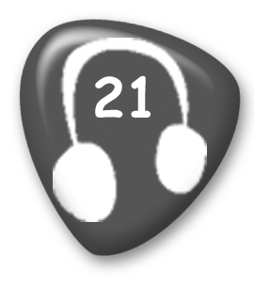
1 He’s hitting a ball.
2 He’s reading a book.
3 She’s jumping.
4 She’s kicking a ball.
5 He’s throwing a ball.
6 She’s running.

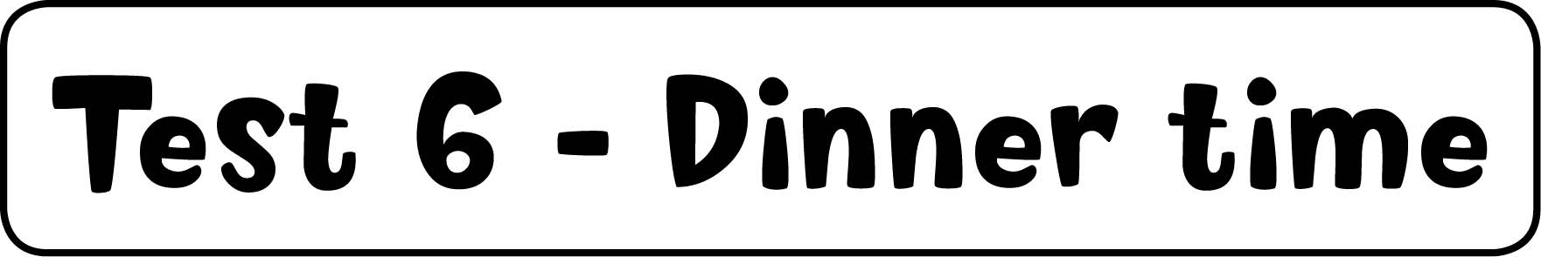

1 Write the words. (5 marks)
2 eggs, 3 water, 4 juice, 5 chicken, 6 milk

2 Order and write. (5 marks)
2 Can I have some chicken, please? 3 What’s his favourite breakfast?
4 Can I have an egg, please? 5 Can I have some rice, please?
6 His favourite breakfast is bananas.

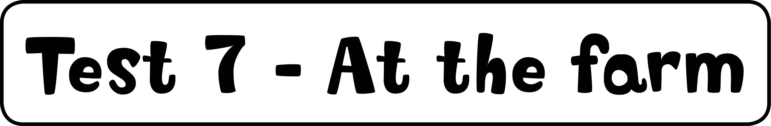

1 Read and write. (5 marks)
fish, birds, sheep, goats, spiders

2 Listen and tick or cross. (5 marks)
cow , lizard , spider , goat , sheep 

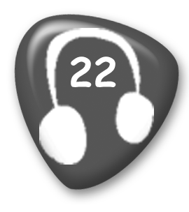
Girl: I like ducks. Boy: I don’t.
Girl: I like frogs. Boy: So do I.
Girl: I like cows. Boy: I don’t.
Girl: I like lizards. Boy: So do I.
Girl: I like spiders. Boy: I don’t.
Girl: I like goats. Boy: So do I.
Girl: I like sheep. Boy: I don’t.

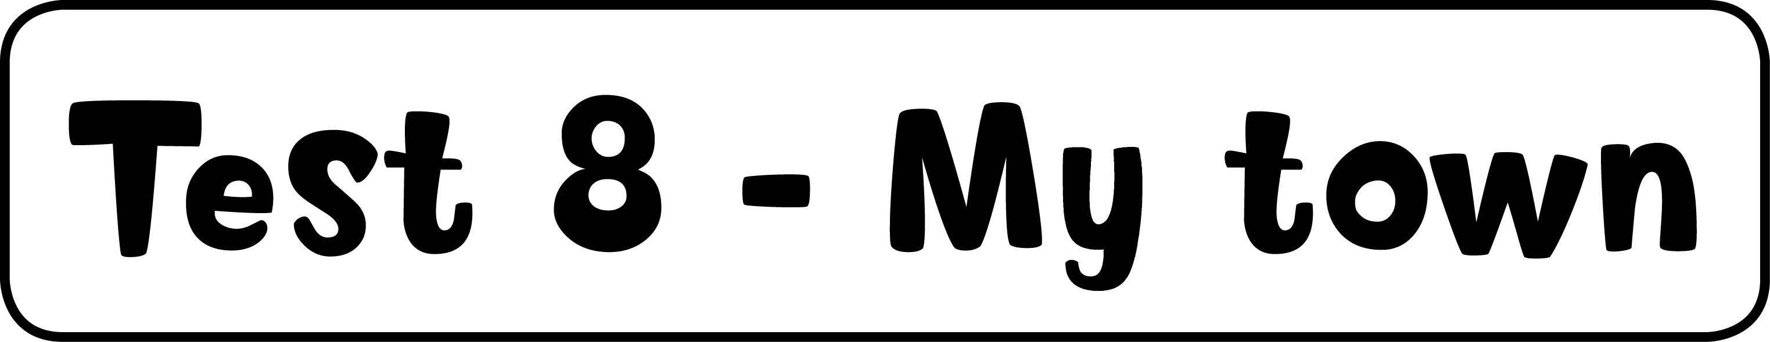

1 Match. (5 marks)
shop – top right, park – right centre, street – left centre, café – bottom left,
hospital – bottom right

2 Look and tick or cross. (5 marks)
2 , 3 , 4 , 5 , 6 



1 Listen and write the number. (5 marks)
She’s eating bread – 3, She’s eating cake – 5, He’s drinking juice – 4,
He’s playing – 6, She’s eating a banana – 2

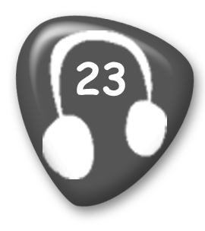
1 He’s sleeping.
2 She’s eating a banana.
3 She’s eating bread.
4 He’s drinking juice.
5 She’s eating cake.
6 He’s playing.

2 Look and write. (5 marks)
babies – one, women – two, men – two, kites – one, bikes – one

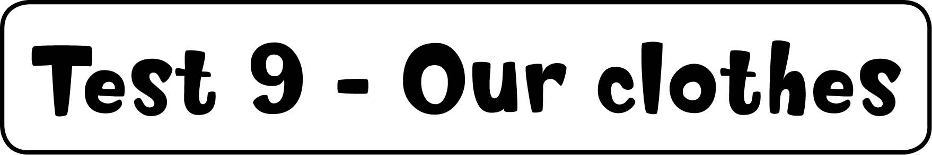

1 Listen and colour. (5 marks)
handbag – red, glasses – black, shirt – yellow, hat – purple, jeans – blue

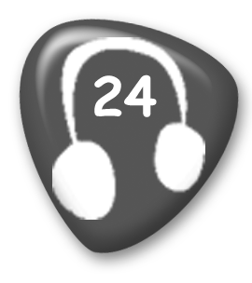
I’m wearing a grey dress.
I’ve got a red handbag.
I’m wearing black glasses.
I’m wearing a yellow shirt.
I’m wearing a purple hat.
I’m wearing blue jeans.

2 Follow the lines. Write. (5 marks)
3 No, he hasn’t. 4 Yes, she has. 5 No, he hasn’t. 6 Yes, she has. 7 No, he hasn’t.

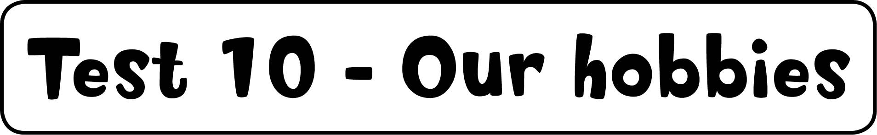

1 Match and write. (5 marks)
2 hockey, 3 baseball, 4 table tennis, 5 football, 6 basketball

2 Read and circle. (5 marks)
2 don’t, 3 like, 4 like, 5 taking, 6 eating



1 Listen and number. (5 marks)
cake – 2, orange – 6, sausage – 4, lemonade – 3, watermelon – 5

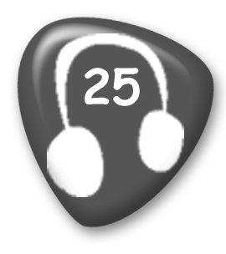
1 burger
2 cake
3 lemonade
4 sausage
5 watermelon
6 orange

2 Write the questions and answers. (5 marks)
2 Yes, I’d love one. 3 Can I have some lemonade? 4 Here you are.
5 Would you like some watermelon? 6 No thank you.



1 Write the words. (5 marks)
2 shell, 3 sea, 4 beach, 5 sun, 6 city

2 Listen and draw lines. (5 marks)
1 beach – shell, 2 city – café, 3 mountains – bird

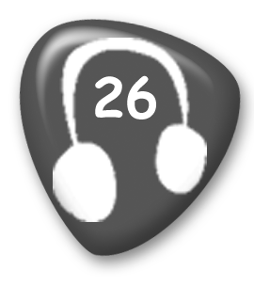
1 Girl: Let’s go to the beach. I love picking up shells!
2 Boy: Let’s go to the city. I like sitting in cafés!
3 Girl: Let’s go to the mountains. I like looking at the birds!



1 Write the questions and answers. (5 marks)
2 Yes, she does. 3 Do you like going to the beach? 4 Yes, I do. 5 Does Rick like fishing? 6 No, he doesn’t.

2 Look and write. (5 marks)
2 us, 3 me, 4 them, 5 him, 6 you



1 Read and answer. (5 marks)
2 It’s rice. 3 They’re bananas. 4 It’s a cake. 5 They’re eggs. 6 They’re burgers.

2 Write. (5 marks)
2 She’s reading. 3 He’s playing hockey. 4 She’s painting. 5 He’s fishing.
6 We’re playing badminton.

3 Match and write. (5 marks)
2 Jill’s, 3 Rick’s, 4 Kim’s, 5 Tony’s, 6 Lucy’s

4 Listen and colour. (5 marks)
Girl’s hat – green, Mummy’s T-shirt – yellow, Daddy’s T-shirt – purple, shells – blue,
tree – brown and green

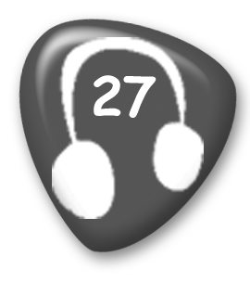
1 The bird is grey.
2 The girl’s hat is green.
3 Mummy’s T-shirt is yellow.
4 Daddy’s wearing a purple T-shirt.
5 The shells are blue.
6 The tree is brown and green.

