Name: | Class:

①Look and write. Mark / 5

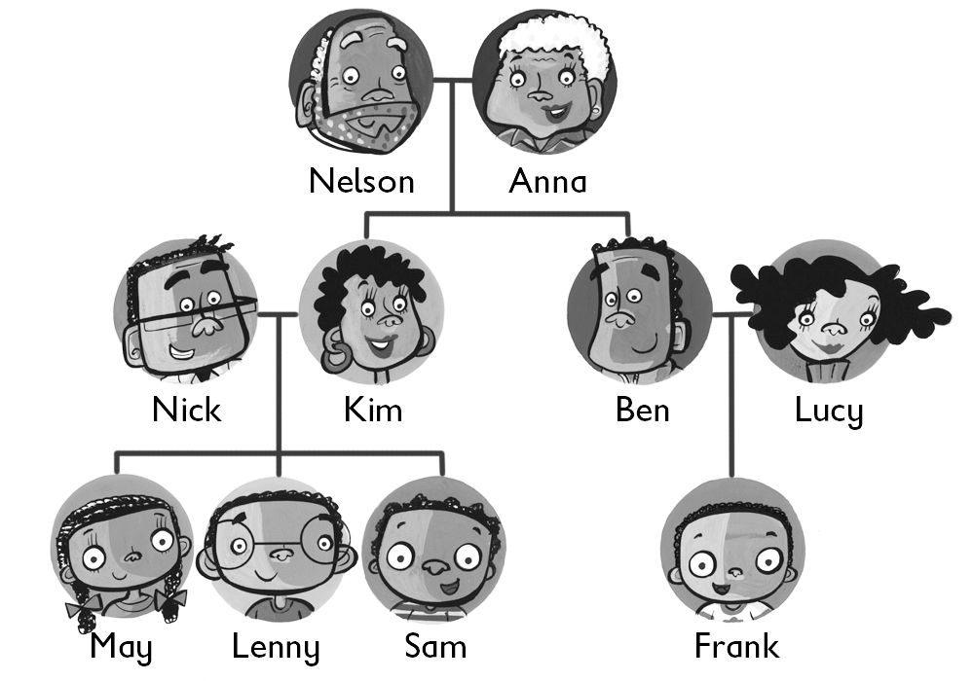
❶ Ben is Frank’s daddy.

❷ Nelson is Sam’s ________.

❸ Lenny is ________ cousin.

❹ Kim is May’s ________.

❺ May is ________ sister.

❻ Lucy is ________ mummy.

② Listen and write ‘yes’ or ‘no’. Mark / 5

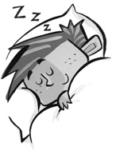

❶ He’s hitting a ball. ❷ He’s reading a book.

yes ________
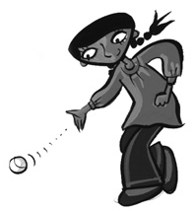
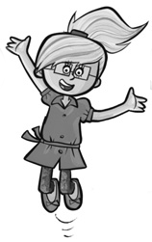
❸ She’s jumping. ❹ She’s kicking a ball.

________ ________

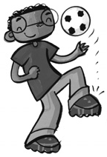

❺ He’s throwing a ball. ❻ She’s running.

________ ________
Total unit mark / 10

