Name: | Class:

①Order and write. Mark /10

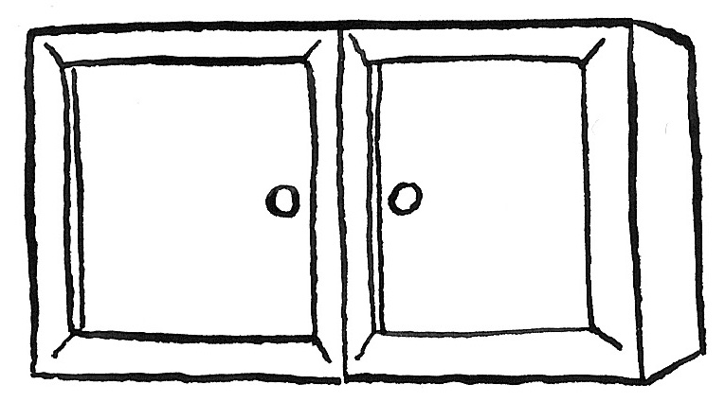
❶ cupboards / are / there? / How / many
How many cupboards are there?
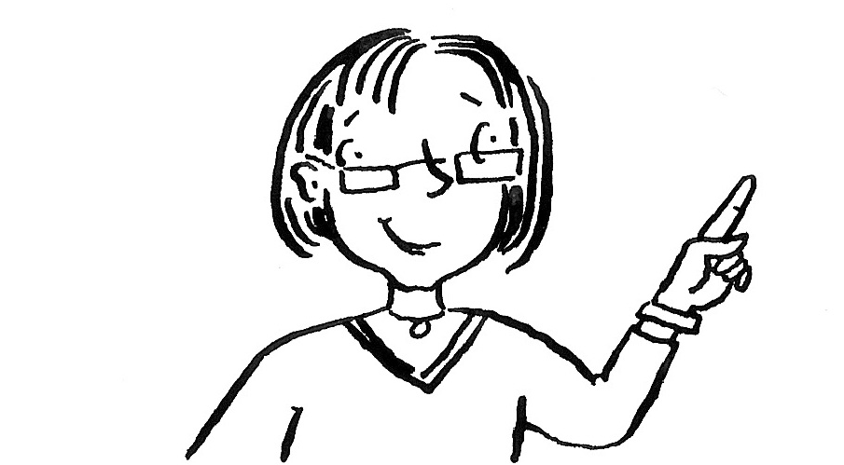
❷ Is / teacher? / there / a
________________________
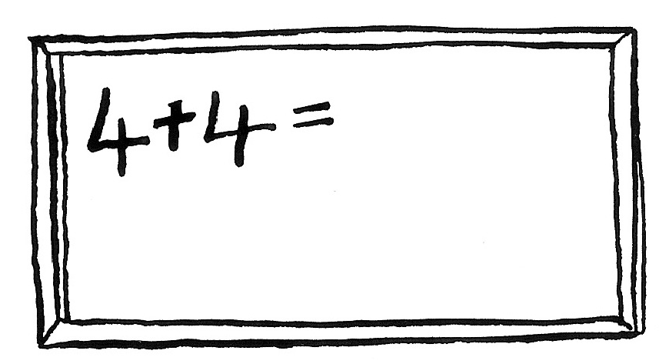
❸ whiteboard. / There / a / is
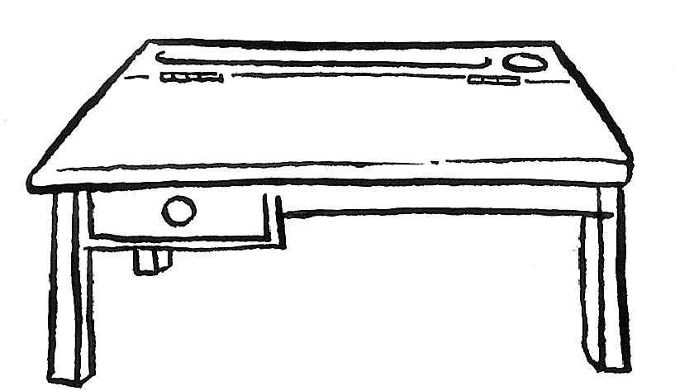
________________________
❹ desks? / there / Are / eighteen
________________________
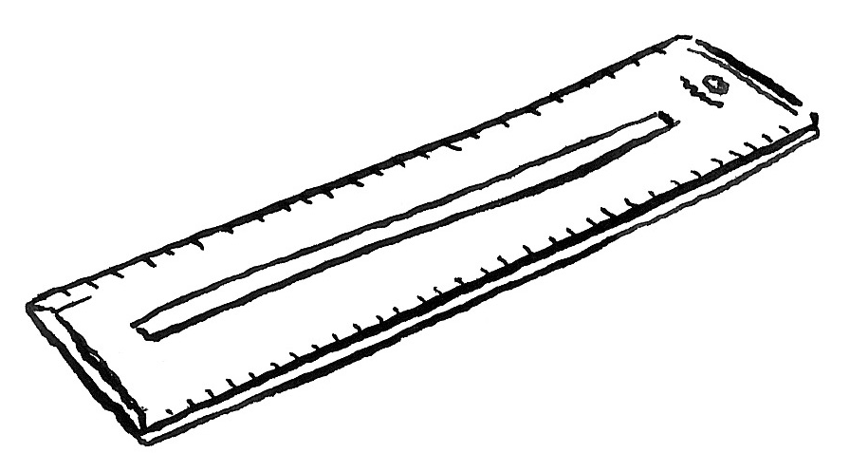
❺ six / Are / there / rulers?
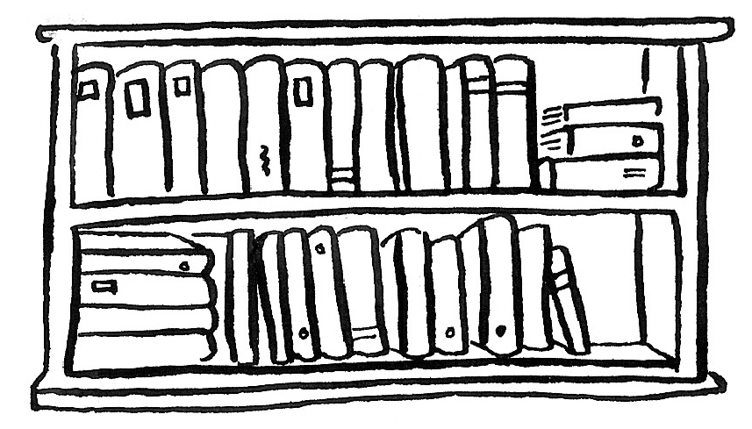
________________________
❻ there / bookcase? / Is / a
________________________
②Look and write. Mark / 5

next to under on in on next to

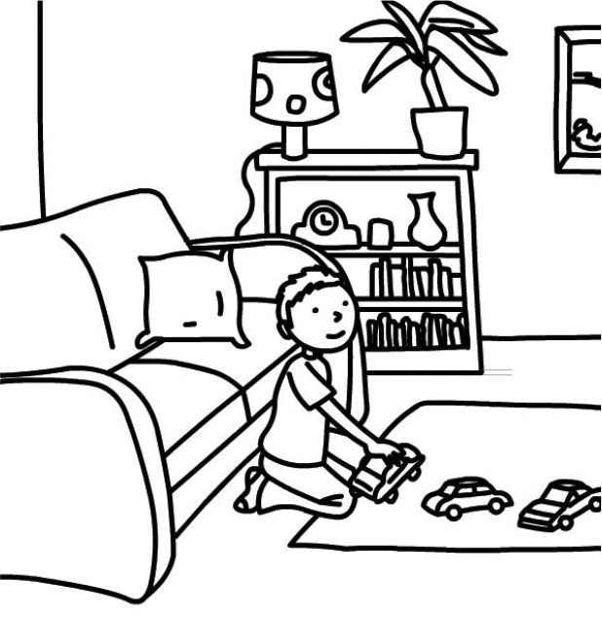
❶ The boy is next to the sofa.
❷ The cars are ____________ the mat.
❸ The sofa is ____________ the bookcase.
❹ The clock is ____________ the lamp.
❺ The lamp is ____________ the bookcase.
❻ The books are ____________ the bookcase.

Total review mark / 15

