Unit 6 Test Name: ______________________________
page 1
See instructions on pp. 126–127

  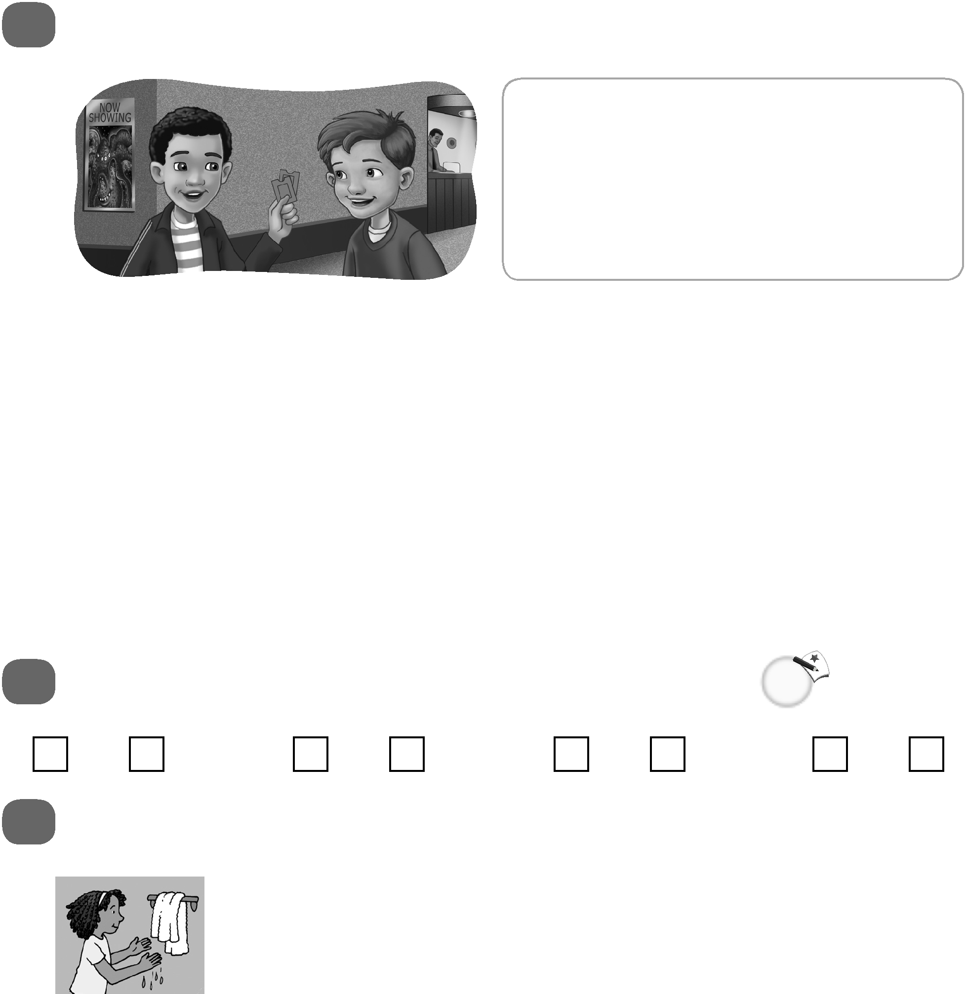 | Complete the conversation. Use the sentences.  I’ve heard it’s scary  I’m excited to see this movie  Wow, thanks  Have you already bought  your ticket

Scott: _________________________________________________?
Andy: Yes, I have, and I bought your ticket, too!
Scott: _________________________!
Andy: _________________________________________________!
Scott: Me, too. I’ve heard it’s funny.
Andy: Really? ____________________________.
Scott: Oh. Maybe it’s scary and funny.
 | Do you hear ar or ir? Listen and check.
1. ar ir |  | 2. ar ir | 3. ar ir | 4. ar ir

 |  | Make a sentence.
1. |  |  | washed her hands / already  _________________________________________
2. | 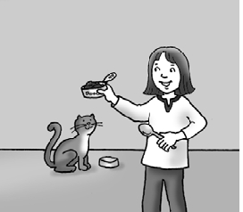 |  | fed the cat / yet  _________________________________________
3. | 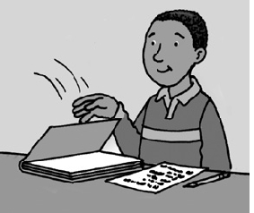 |  | done his homework / already  _________________________________________

Unit 6 Test Name: ______________________________
page 2
See instructions on pp. 126–127

 | Write the question and answer.

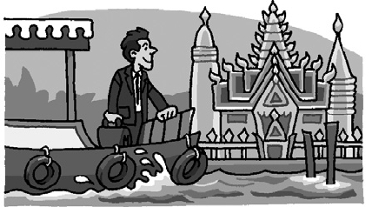  1. | (visiting Bangkok / last week) How long  ______________________________________?  ______________________________________
  2. | (lived in New York / eight months) How long  ______________________________________?  ______________________________________
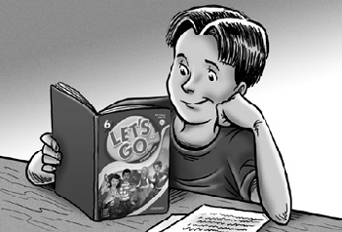  3. | (studied English / three years) How long  ______________________________________?  ______________________________________
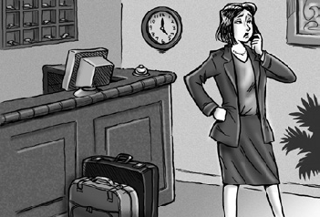  4. | (been at the hotel / yesterday evening) How long  ______________________________________?  ______________________________________
 | Listen and match.

1. ______ | 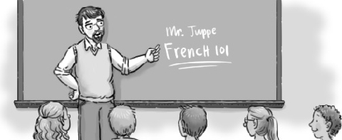  A.
2. ______ | 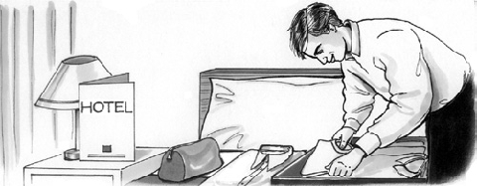  B.
3. ______ | 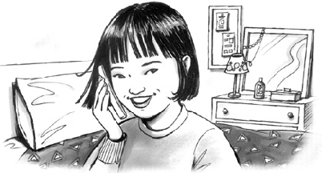  C.
4. ______ | 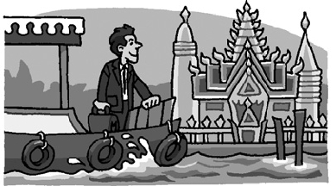  D.

