Unit 5 Test Name: ______________________________
page 1
See instructions on pp. 126–127

 | 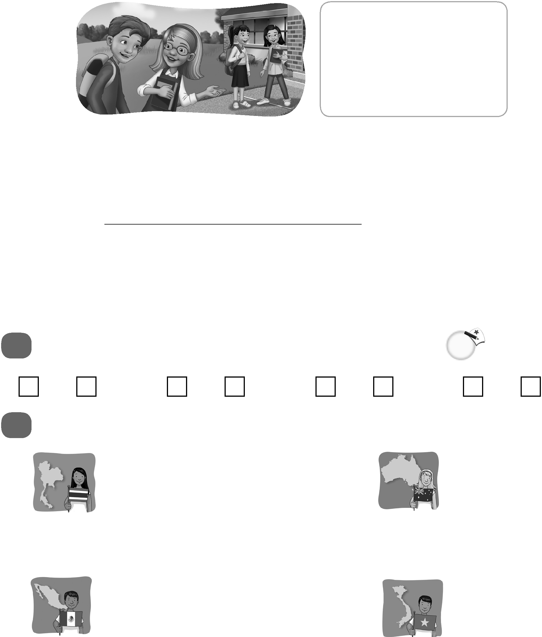  Complete the conversation. Use the sentences.
Where is she from
Yes, she is
Does Ahn speak English
Have you met Anh

Kate: ___________________? She’s the girl who is talking to Jenny.
Andy: No, I haven’t. Is she here on a homestay?
Kate: ____________________. She’s staying with Jenny’s family.
Andy: Really? ____________________?
Kate: She’s from Vietnam.
Andy: ____________________?
Kate: Yes, she does. She speaks Vietnamese and English too.
 | Do you hear ea or ou? Listen and check.
1. ea ou |  | 2. ea ou | 3. ea ou | 4. ea ou

 |  | Look and write.
1. | She’s from Thailand.  She’s ________________. |  | 2. | She’s from Australia.  She’s ________________.
3. | He’s from Mexico.  He’s ________________. |  | 4. | He’s from Vietnam.  He’s ________________.
Unit 5 Test Name: ______________________________
page 2
See instructions on pp. 126–127

 | Write the answer.
  Thailand | France | Mexico | Brazil
  Thai | French | Spanish | Portuguese
  noodles | croissants | burritos | black beans

1. What language is spoken in Thailand?
__________________________________________.

2. Where are croissants eaten?
__________________________________________.

3. What language is spoken in Mexico?
__________________________________________.

4. Where are black beans eaten?
__________________________________________.

Listen and check.

1. | 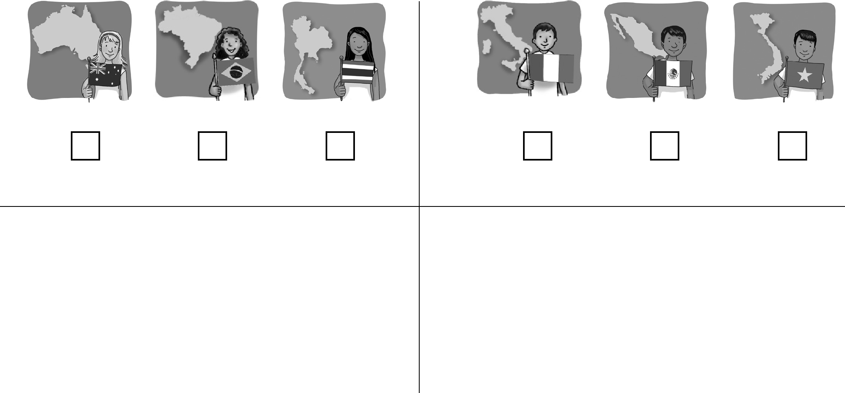  A. B. C. | 2. | A. B. C.
3. | 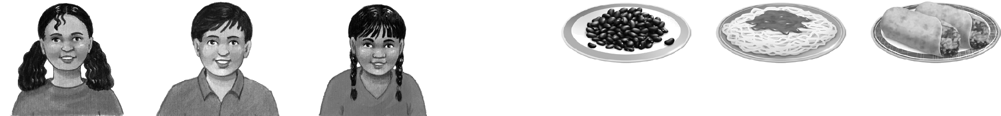  A. B. C. | 4. | A. B. C.

