Unit 4 Test Name: ______________________________
page 1
See instructions on pp. 126–127

 | Complete the conversation. Use the sentences.
It’s across from the music store
No, I don’t
We’re here
Do you know

Kate: Where’s the food court? ____________________?
Jenny: ____________________. Let’s look at the map.
Kate: Here it is. ______________________________________.
Jenny: Where are we now?
Kate: ____________________. We should go this way.
 | Do you hear ow or or? Listen and check.

1. ow or | 2. ow or | 3. ow or | 4. ow or | 5. ow or

 | Look and write.

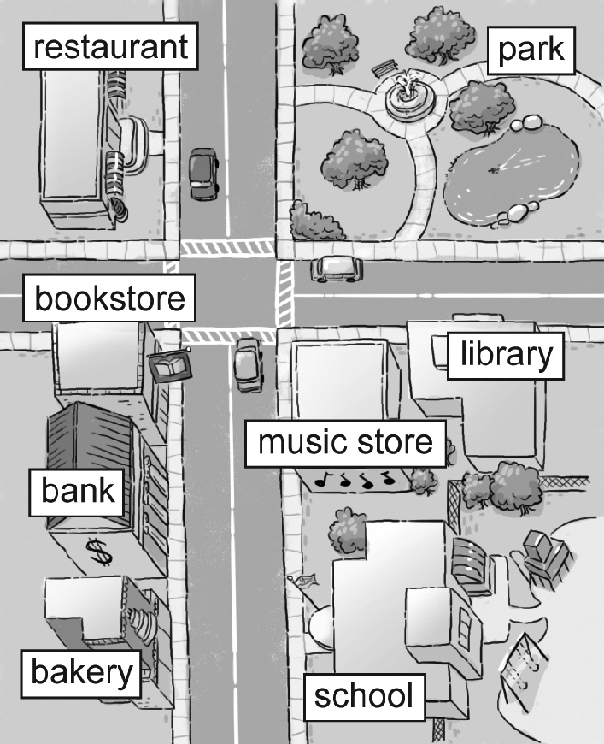
1. Where’s the library?
It’s _______________the music store.
2. Where’s the bank?
It’s _______________ the bookstore and
the bakery.
3. Where’s the school?
It’s _______________ from the library.
4. Where’s the restaurant?
It’s _______________ from the park.
Unit 4 Test Name: ______________________________
page 2
See instructions on pp. 126–127

 | Write and connect.
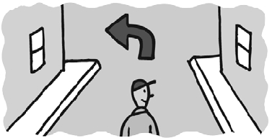
1. ________ left. | ● | ● A.
2. ________ the street. | ● | 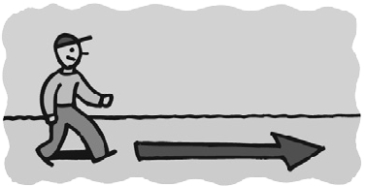  ● B.
3. ________ two blocks. | ● | 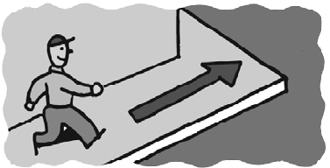  ● C.
4. Turn ________. | ● | 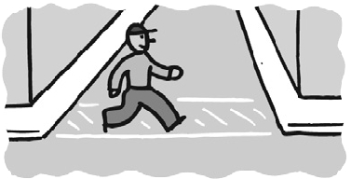  ● D.
5. Go to the ________. | ● | 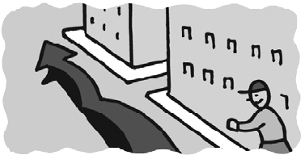  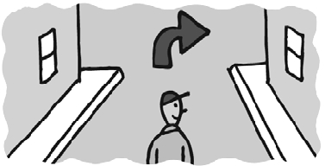  ● E.
6. Go ________. | ● | ● F.

 | Look and write.

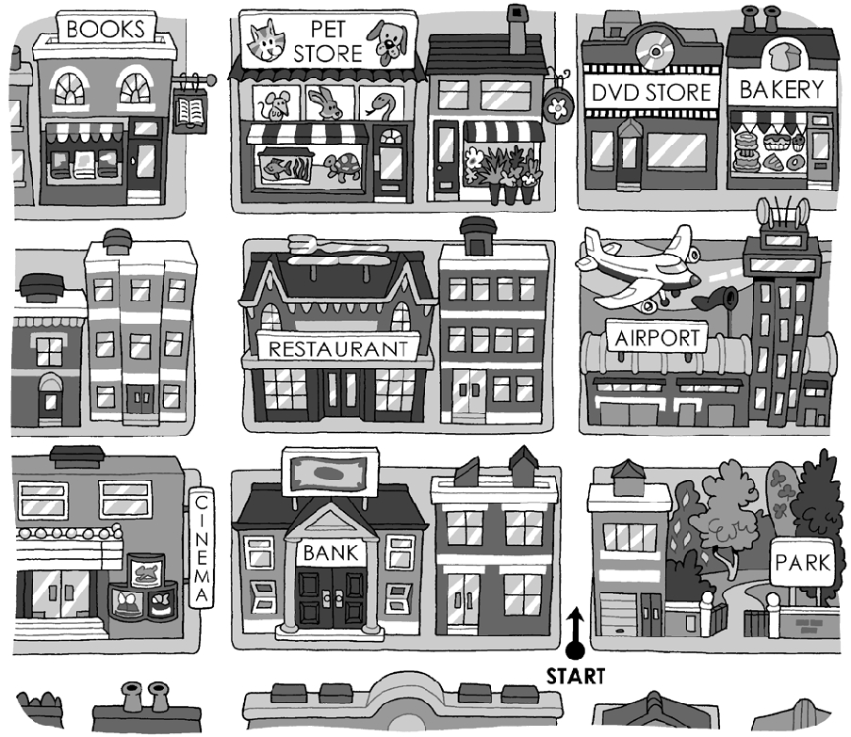
1. How do I get to the ________________?
Go one block and turn right.

2. How do I get to the ________________?
Go two blocks and turn left.

3. Go one block and turn left. Where are you?
I’m at the ________________________.

4. Go two blocks and turn left. Then go one block.
Where are you?
I’m at the ________________________.

