Unit 3 Test Name: ______________________________
page 1
See instructions on pp. 126–127

 | 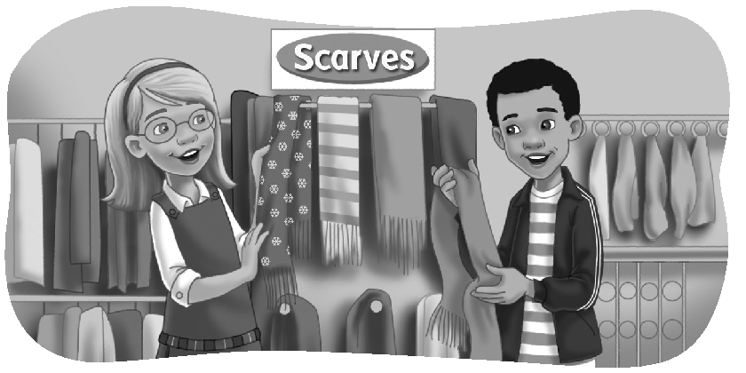  Complete the conversation. Use the sentences.
That’s a great idea
You could get her a cookbook
What should I get her
What are you doing here

Kate: Hi, Andy. ______________________?
Andy: I need a present for my mother. ____________________?
Kate: _____________________________.
Andy: She already has a lot of cookbooks.
Kate: How about a scarf?
Andy: ________________________!
 | Do you hear au or oo? Listen and check.

1. au oo | 2. au oo | 3. au oo | 4. au oo | 5. au oo

 |  | Look and connect.
1. | What should she get her mother? ●  She should get her a bracelet. |  | 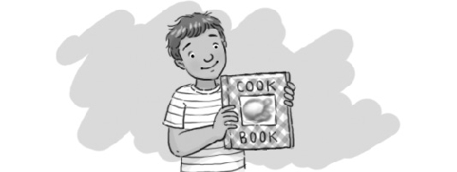  ● A.
2. | What should he get his grandfather? ●  He should get him a DVD. |  | 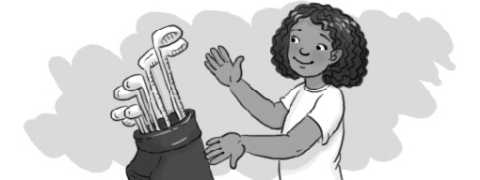  ● B.
3. | What should she get her father? ●  She should get him golf clubs. |  | 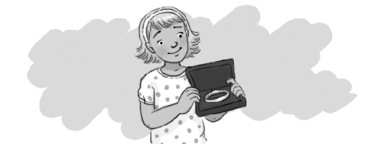  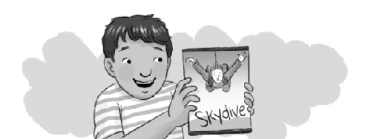  ● C.
4. | What should he get his grandmother? ●  He should get her a cookbook. |  | ● D.
Unit 3 Test Name: ______________________________
page 2
See instructions on pp. 126–127

 | Look and write.

1. Should I get my father a scarf or a DVD?

You should get

2. Should I get my sister a box of chocolates or a cookbook?
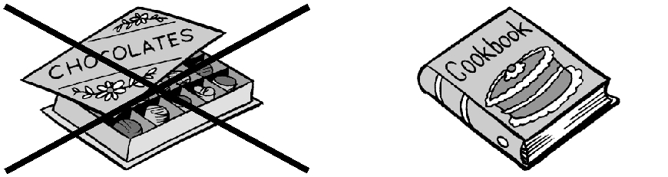
You

3. Should he get his mother a bracelet or a necklace?
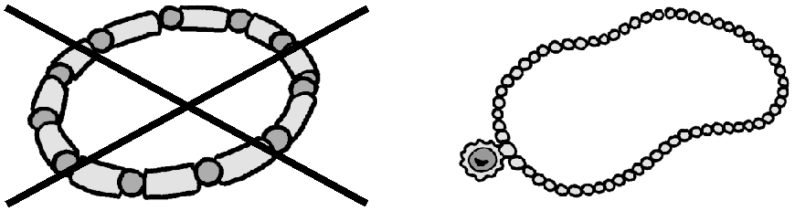
He

 | Listen and check.
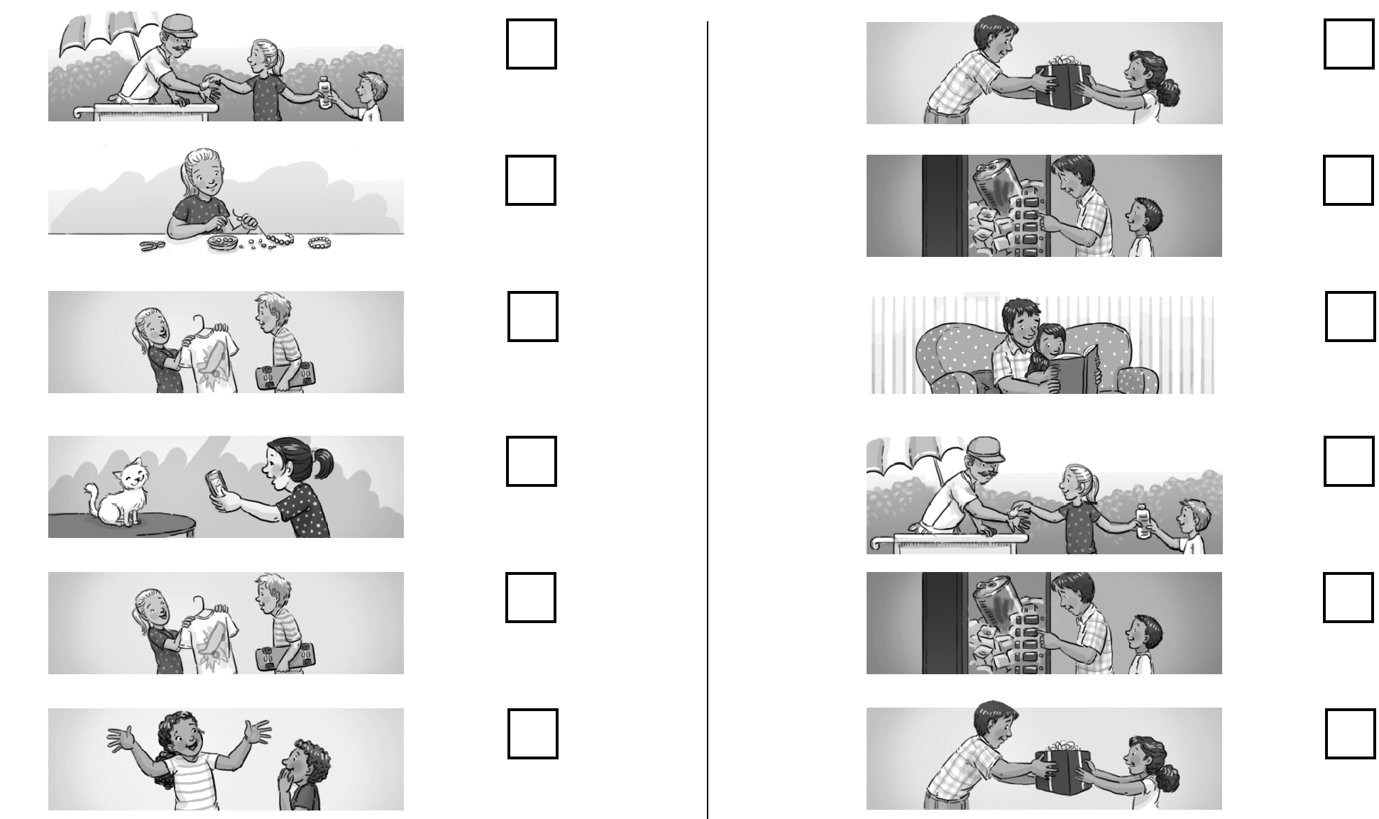
1. A. 2. A.

B. B.

C. C.

3. A. 4. A.

B. B.

C. C.

