Unit 2 Test Name: ______________________________
page 1
See instructions on pp. 126–127

 | 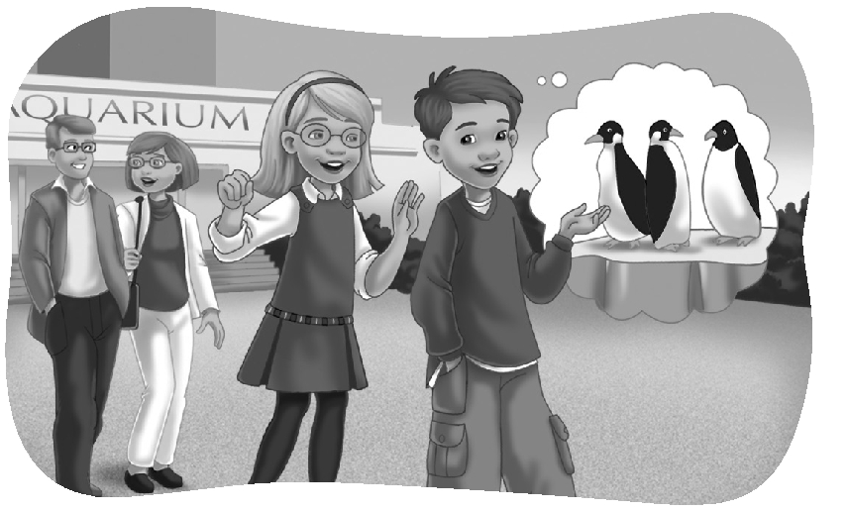  Complete the conversation. Use the sentences.
They were amazing
But I’m tired now
I liked the sharks
What a great day
What did you like best

Scott: _________________________________!
Kate: It sure was! _____________________________.
Scott: Me, too. We really walked a lot.
Kate: _________________________________?
Scott: I think I liked the penguins best.
Kate: _________________________________.
Scott: What about you?
Kate: __________________________________.
Scott: They were scary!
 | Do you hear oi or oo? Listen and check.

1. oi oo | 2. oi oo | 3. oi oo | 4. oi oo | 5. oi oo

 | Write the answer.

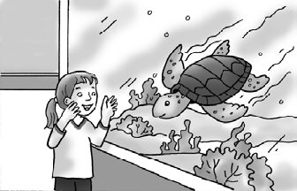  1. |  | What did she say?  _______________________________________.
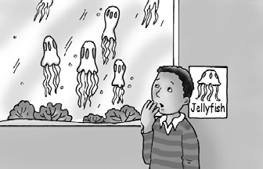  2. |  | What did he say?  _______________________________________.

Unit 2 Test Name: ______________________________
page 2
See instructions on pp. 126–127

 | Look and write.

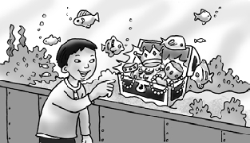  1. | The exhibit was ________________.  He was amazed.
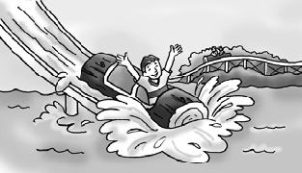  2. | The ride was exciting.  He was ________________.
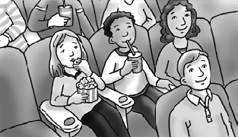  3. | The movie was ________________.  She was bored.
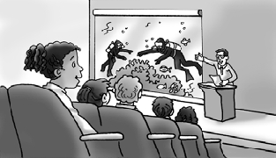  4. | The lecture was interesting.  She was ________________.
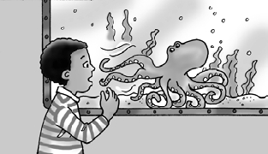  5. | The octopus was ________________.  He was scared.
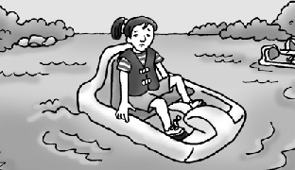  6. | The pedal boat was tiring.  She was ________________.

 | Connect and write the sentence.

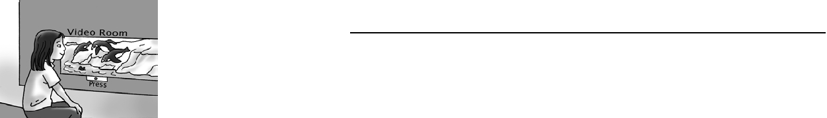 | She said _________________ ● | ● A. the tour / tiring
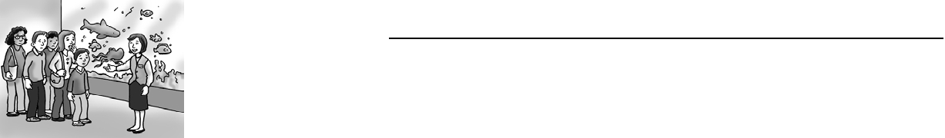 | He said __________________ ● | ● B. the aquarium /  interesting
 | They said ________________ ● | ● C. the video /  exciting

