Unit 1 Test Name: ______________________________
page 1
See instructions on pp. 126–127

  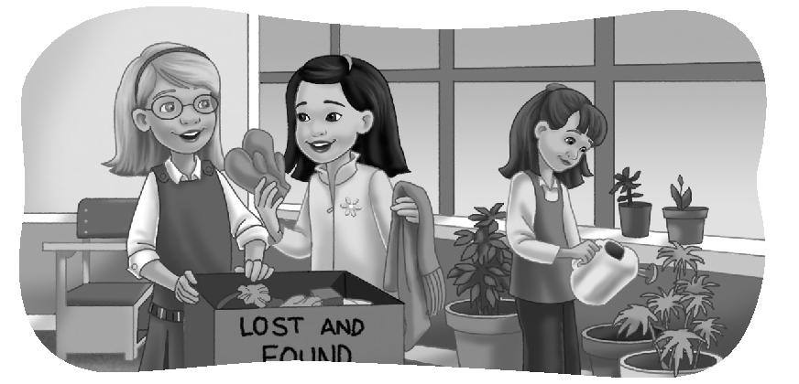 | Complete the conversation. Use the sentences.
He’s the boy over there
They’re hers, too
I think it’s Jim’s glove
It’s Anna’s scarf

Kate: Whose scarf is that?
Jenny: ______________________________________.
Kate: Whose mittens are those?
Jenny: _____________________________________.
Kate: Is that her glove, too?
Jenny: No, it isn’t. _________________________________.
Kate: Which boy is Jim?
Jenny: _____________________________________.
 | Do you hear aw or ow? Listen and check.
1. aw ow |  | 2. aw ow | 3. aw ow | 4. aw ow

 |  | Look and connect.
1. | Which girl is Lucy? ●  She’s the girl who is watering the plants. |  | 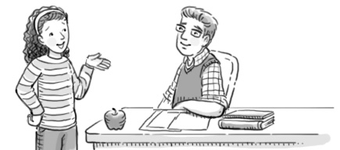  ● A.
2. | Which boy is Bill? ●  He’s the boy who is writing an essay. |  | 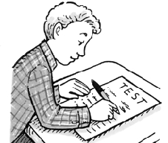  ● B.
3. | Which girl is Tina? ●  She’s the girl who is talking to the teacher. |  | 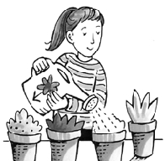  ● C.
4. | Which boy is Doug? ●  He’s the boy who is feeding the fish. |  | 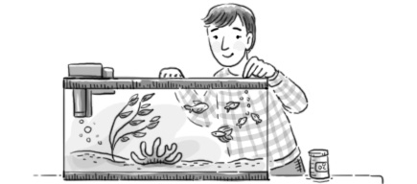  ● D.

Unit 1 Test Name: ______________________________
page 2
See instructions on pp. 126–127

 | Unscramble, write, and connect.

1. was talking / it started to rain / He / when / on his cell phone
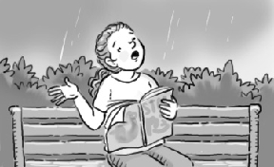
__________________________________
__________________________________ ● ● A.
2. it started to rain / was walking / when / in the park / She
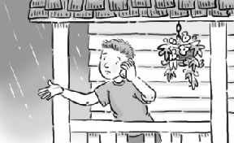
__________________________________
__________________________________ ● ● B.
3. She / a magazine / when / was reading / it started to rain
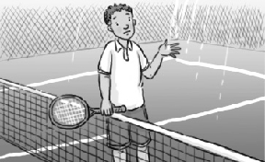
__________________________________
__________________________________ ● ● C.
4. a game / it started to rain / was playing / He / when
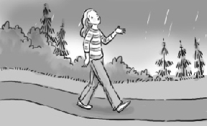
__________________________________
__________________________________ ● ● D.
 | Listen and check.
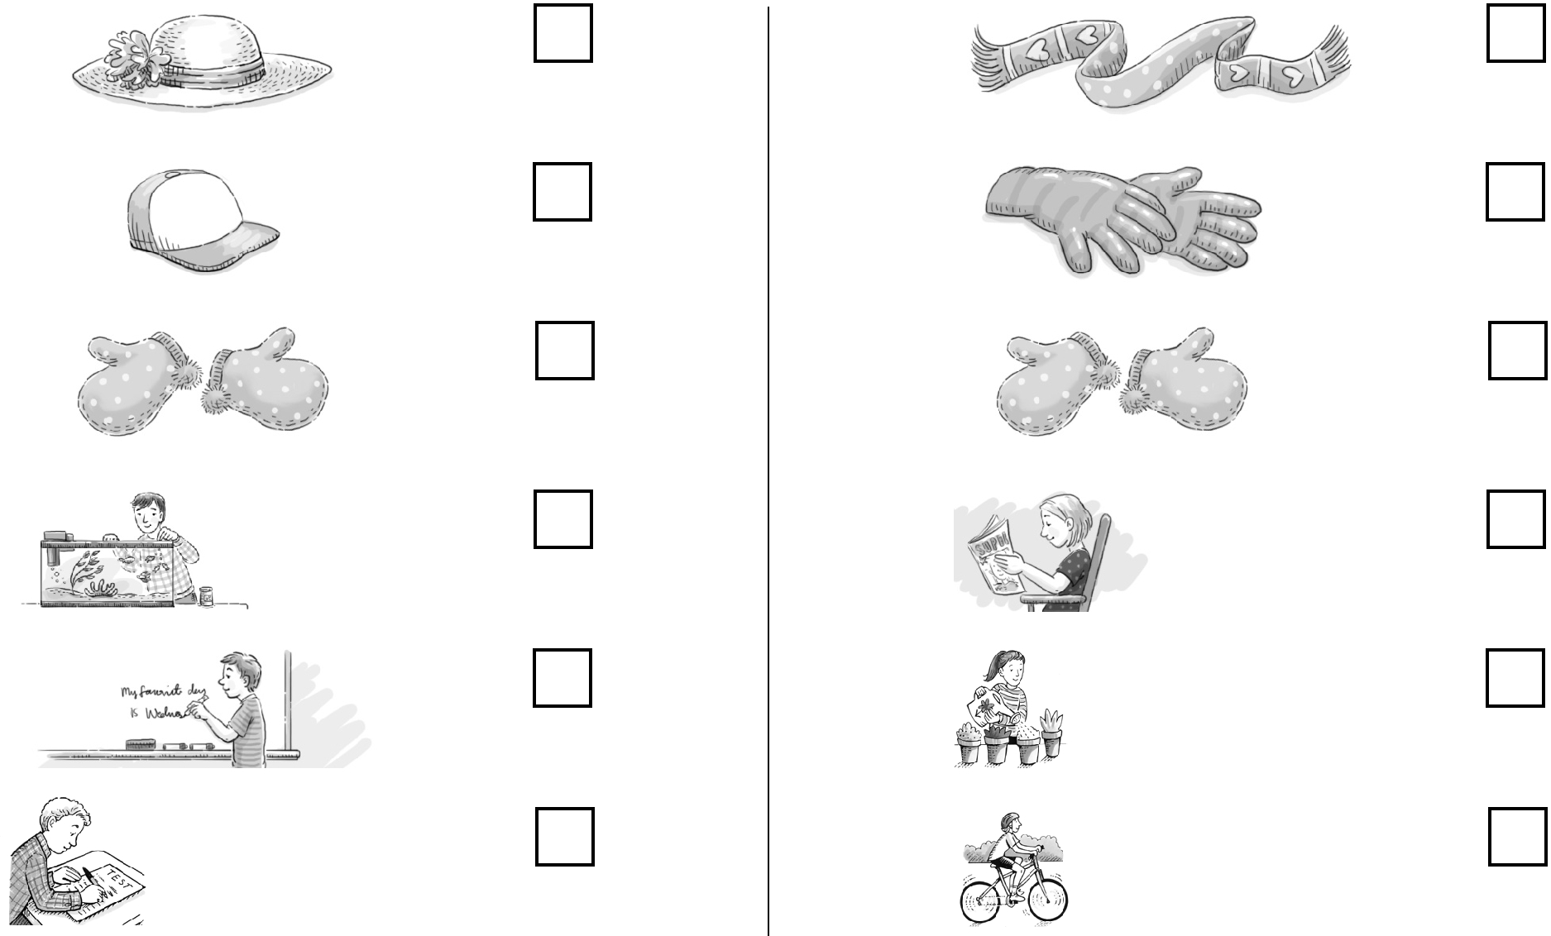
1. A. 2. A.

B. B.

C. C.

3. A. 4. A.

B. B.

C. C.

