Midterm Test Name: ______________________________
(Units 1–4) page 1
See instructions on pp. 126–127

 | Write.

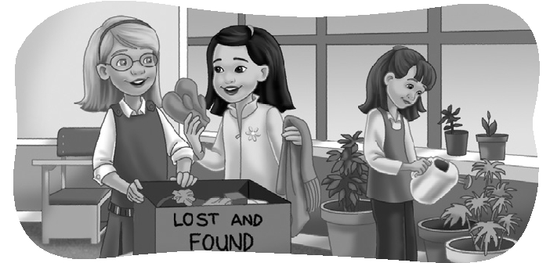
1. Kate: Whose scarf it that?

Jenny: ___________________________.

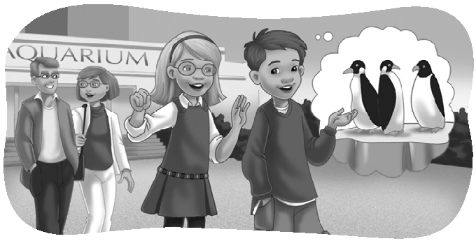
2. Kate: What did you like best?

Scott: ____________________________.

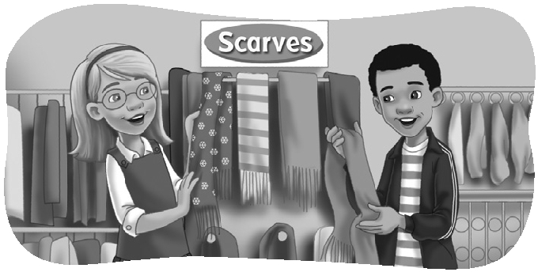
3. Kate: How about a scarf?

Andy: _____________________________!

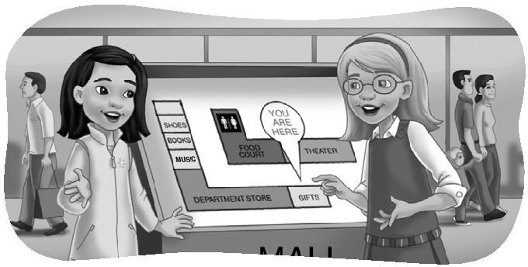
4. Jenny: ___________________________?

Kate: We’re here. We should go this way.


 | Listen and number.

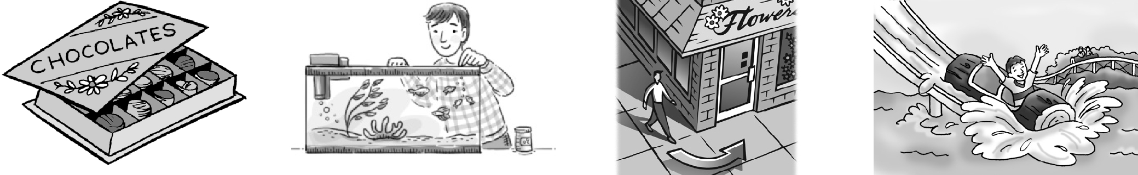  1. _____ | 2. _____ | 3. _____ | 4. _____
1. | 2. | 3. | 4.
Midterm Test Name: ______________________________
(Units 1–4) page 2
See instructions on pp. 126–127

 | Look and connect.

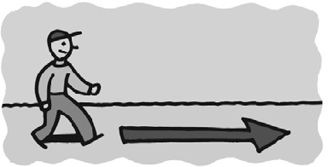  1.  ● | ● buy a drink ●  ● scary ● | 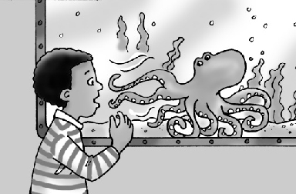  2.  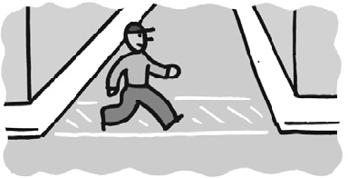  ●
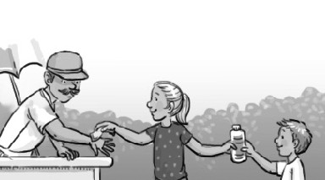  3.  ● | ● tell a story ●  ● go straight ● | 4.  ●
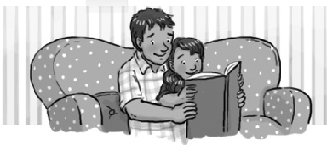  5.  ● | ● tired ●  ● cross the street ● | 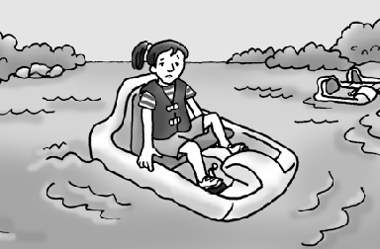  6.  ●

 | Listen, circle, and write.

1. A. | 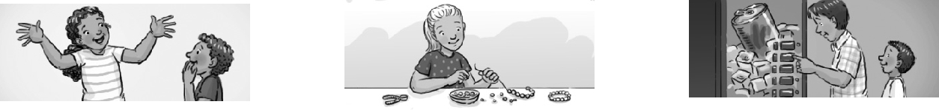 | B. | C. | ___________
2. A. |  | 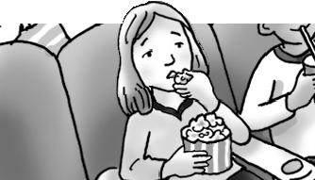  B. | 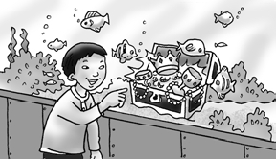  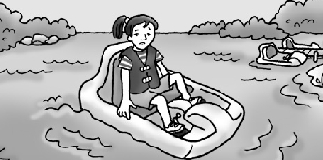  C. | ___________
3. A. | 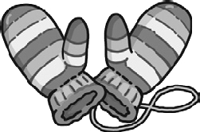  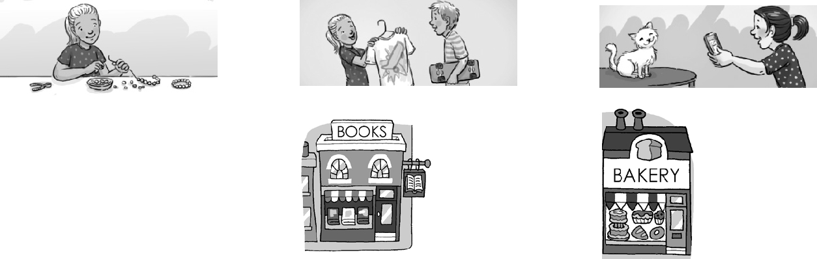 |   B. |   C. | ___________
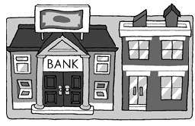  4. A. |  | B. | C. | ___________
5. A. |  | B. | C. | ___________
6. A. | 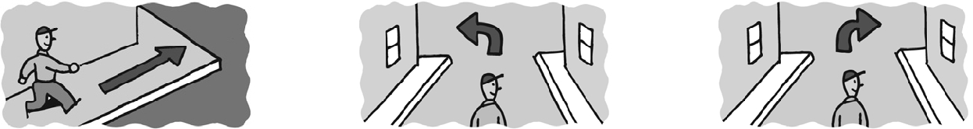 | B. | C. | ___________

Midterm Test Name: ______________________________
(Units 1–4) page 3
See instructions on pp. 126–127

Read and match.

1. Whose boots are those? ______ | A. He was talking on his cell  phone when it started to rain.  B. He said the sea turtles were  amazing.  C. She’s the girl who is  feeding the fish.  D. He was bored.  E. It’s on the corner.  F. They’re Eric’s boots.  G. She showed him a T-shirt.
2. The lecture was boring. ______
3. What did she show him? ______
4. What did he say? ______
5. What was he doing when it
started to rain? ______
6. Where’s the bakery? ______
7. Which girl is Louise? ______

 | Look and write.
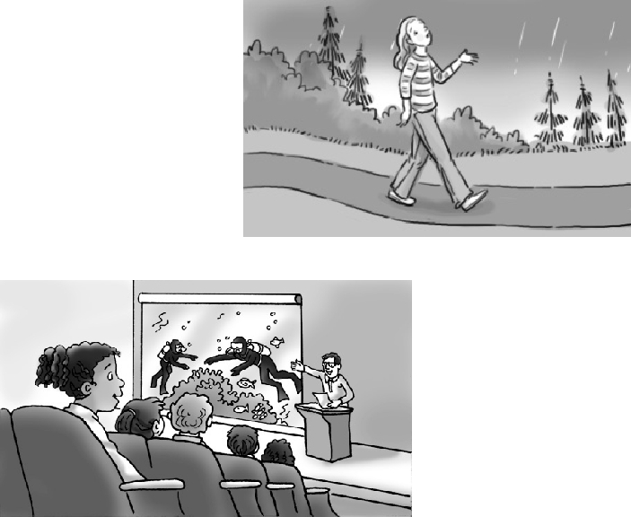
1. _________________ when it started to rain?
_________________ when it started to rain.
2. She was _________. The lecture was
_________.
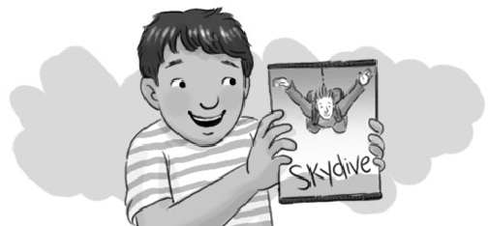
3. What ______________________?
He should get him ______________________.
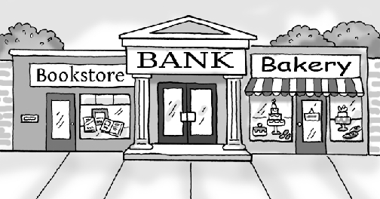
4. _________ the bank? It’s _________
______________________________.

Midterm Test Name: ______________________________
(Units 1–4) page 4
See instructions on pp. 126–127

Write the question or answer.

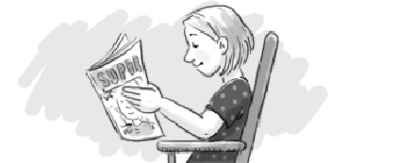  1. | Which girl is Lisa?  _______________________________________.
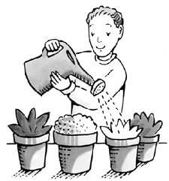  2. | Which boy is Bill?  _______________________________________.
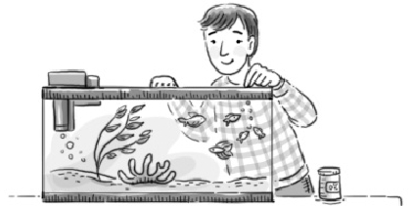  3. | ______________________________ Bill?  He’s the boy who is feeding the fish.
  4. | ______________________________ Mia?  She’s the girl who is talking to the teacher.

Listen and check.
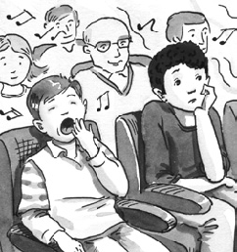
1.  A. The movie was boring.  B. The music was boring. | 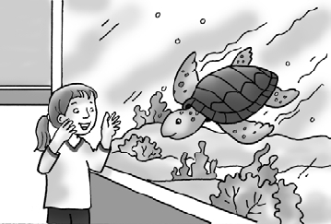  2.  A. The sea turtles were amazing.  B. She said she was amazed.
  3.  A. They should get him golf clubs.  B. They should get him a DVD. | 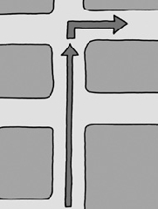  4.  A. Go two blocks and turn right.  B. Go two blocks and turn left.

