Unit 4 Test Name: ______________________________
page 1
See instructions on pp. 126–127

 | Choose and write.
forgot it put ready sunscreen take off Wait
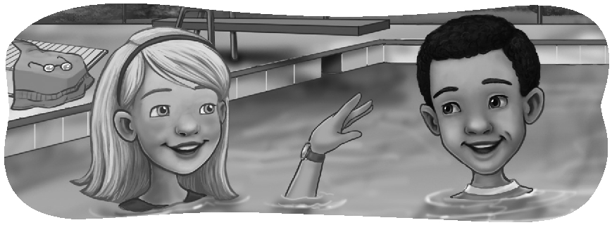

Andy: Are you _______? | Kate: Yes, I turned _______ off.
Kate: Not yet. _______ a minute. | Andy: OK. You’re ready.
Andy: Why? | Kate: Oh, no! Now I remember.
Kate: I think I _______ to do something. | Andy: What?
Andy: Did you put on _______? | Kate: I forgot to _______ my  watch.
Kate: Yes, I did. I _______ it on. | Andy: I hope it’s waterproof.
Andy: Did you turn off the radio?

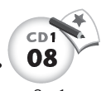
 | Listen and number.

1. ____  2. ____ | 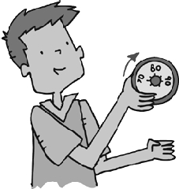  1.  Yes, I did. | 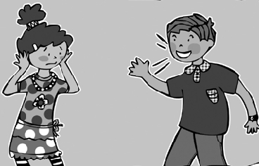  2.  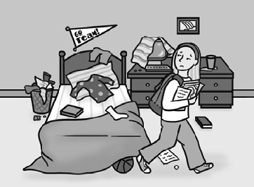  No, he doesn’t.
3. ____  4. ____ | 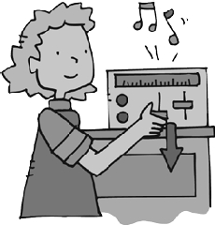  3.  Yes, she did. | 4.  No, she didn’t.
Unit 4 Test Name: ______________________________
page 2
See instructions on pp. 126–127

 | Read and match.

1. You can make a model tornado _____ | A. on the mouth of the bottle.
2. Put water in _____ | 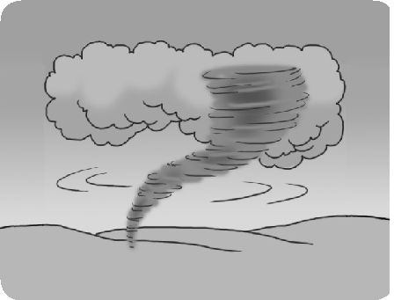  B. swirl the water in a circle.
3. Put tape _____ | C. the bottles.
4. Make a hole and tape _____ | D. in a bottle.
5. Turn over _____ | E. one of the bottles.
6. Tilt the bottles and _____ | F. the necks of the bottles tightly together.

 | Write the question or answer.

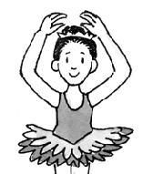  1.  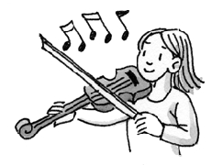 | How does she dance?  (graceful) _________________________________.  _________________________________________?
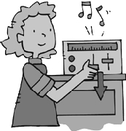  2. | She plays beautifully.  __________________________________________?
3. | No, she didn’t. She turned it on.
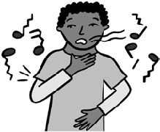  4. | Does he sing well?  __________________________________________.

 | Do you hear It or Id? Listen and check.

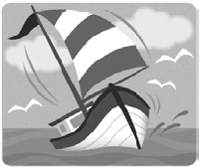 | 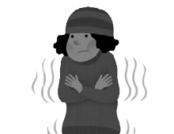 | 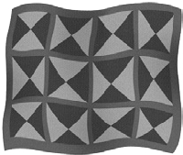 | 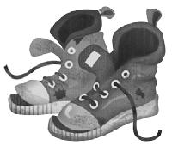 | 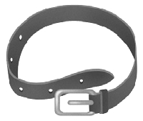
1.  lt Id | 2. lt Id | 3. lt Id | 4. lt Id | 5. lt Id

