Unit 2 Test Name: ______________________________
page 1
See instructions on pp. 126–127

 | Choose and write.
didn’t fast faster know probably sure Which

Andy: Did you ____________ that a zebra is slower than a gazelle?

Scott: Really? I ____________ know that.

Andy: ____________ animal is faster? A cat or a polar bear?

Scott: I’m not sure. I think a polar bear is ____________ faster.

Andy: No! A cat is as ____________ as a polar bear.
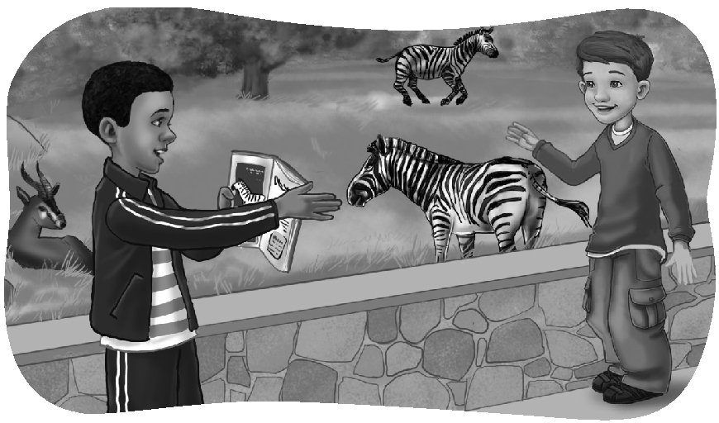
Scott: Wow! Are you sure? That’s interesting!

Andy: A man is ____________ than a skunk.

Scott: Are you ____________?

Andy: Yes, I’m sure. Look!

Scott: That’s good! He can run away!

 | Listen and check.
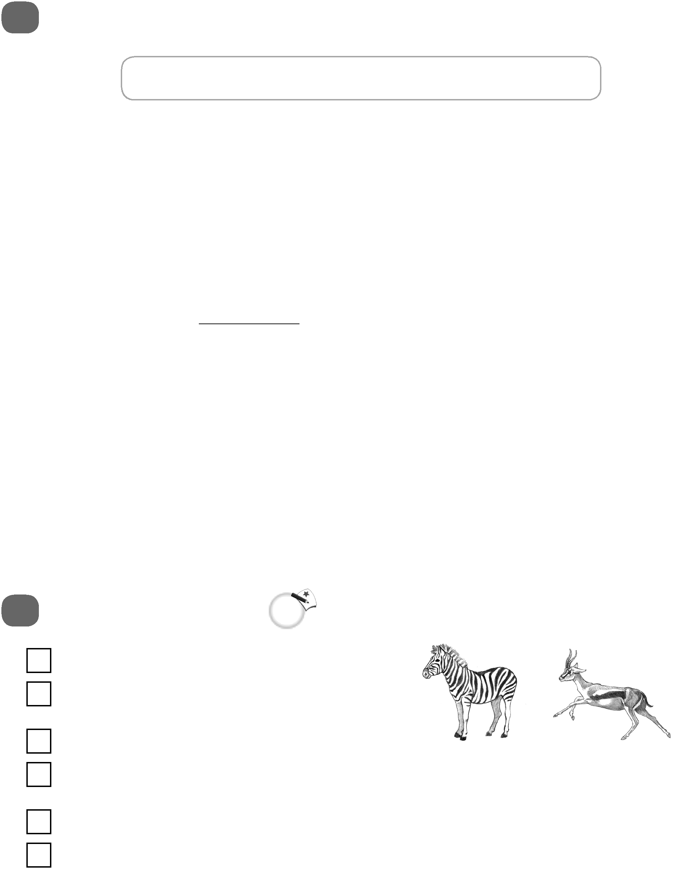
1. A. Yes, it is.
B. No, it isn’t. It’s slower.

2. A. The jaguar is the most graceful.
B. The gazelle is the most graceful.
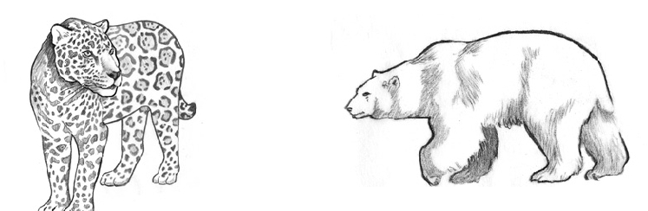
3. A. Yes, it is.
B. No, it isn’t.

Unit 2 Test Name: ______________________________
page 2
See instructions on pp. 126–127

 | Read and match.
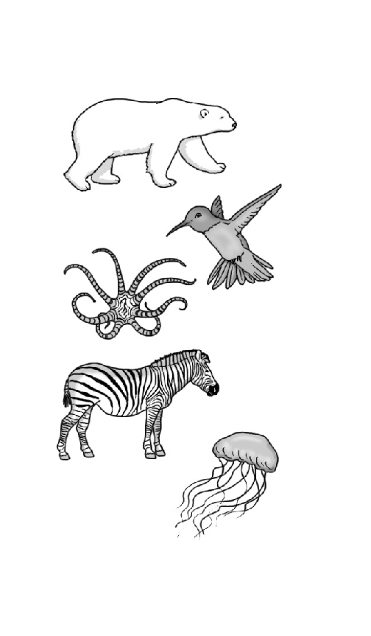
1. Polar bears have _____ | A. fly backward.
2. They can _____ | B. different.
3. A hummingbird can _____ | C. 24 eyes.
4. The mimic octopus can _____ | D. a good sense of smell.
5. Every zebra’s stripes are _____ | E. smell fish under the ice.
6. A box jellyfish has _____ | F. change its color and shape.

 | Write the question or answer.

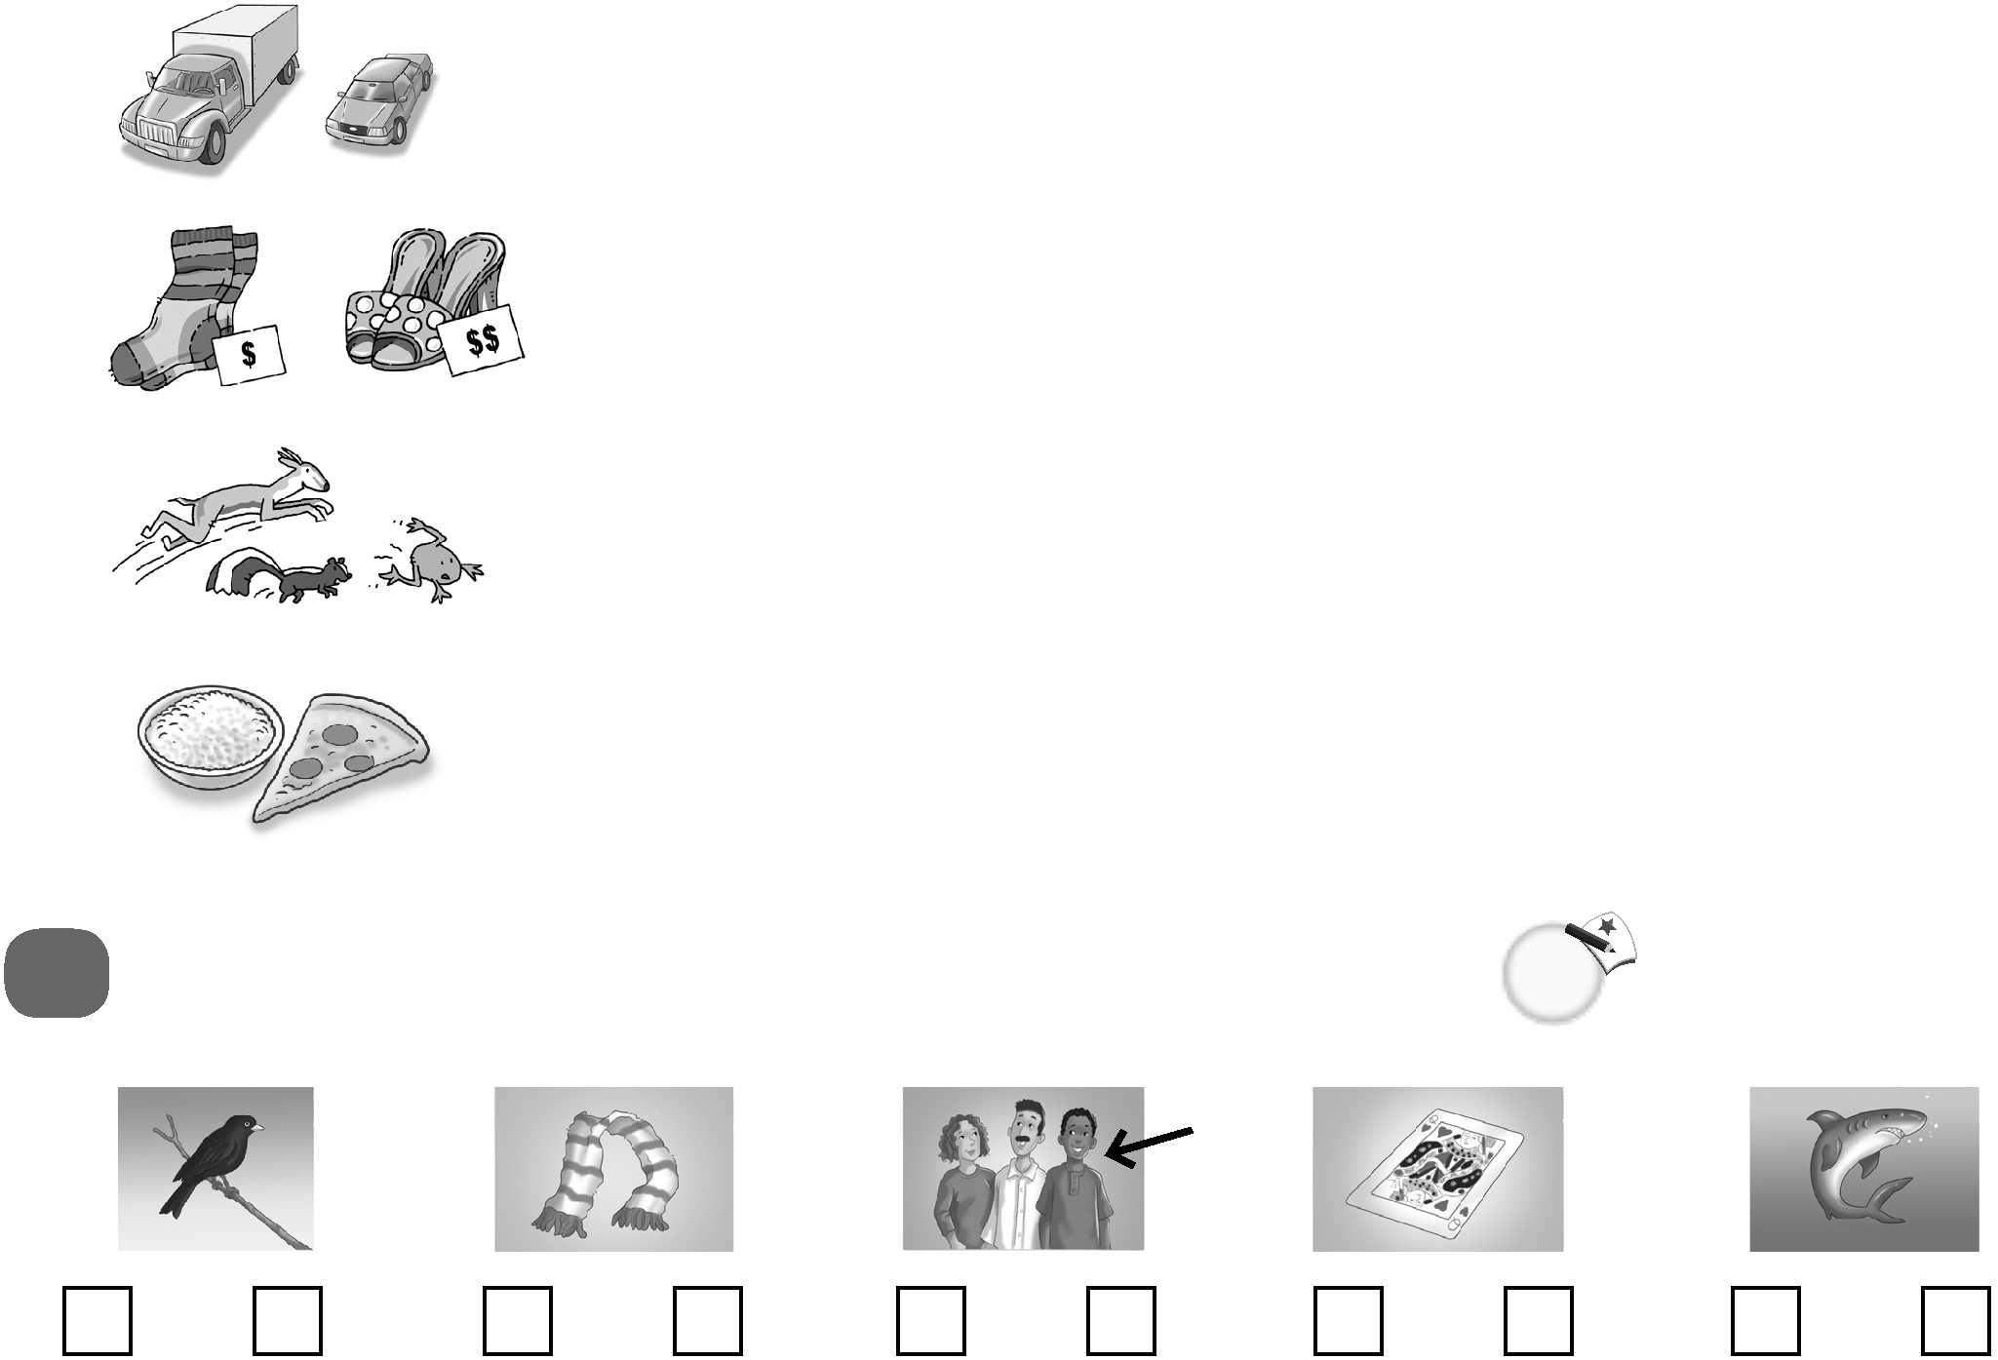  1. | Which one is heavier?  __________________________________________.
2. | Which ones are less expensive?  __________________________________________.  __________________________________________?
3. | The frog is the least graceful.  __________________________________________?
4. | Pizza is more delicious than rice.
 | Do you hear ar or ir? Listen and check.

1. ar ir | 2. ar ir | 3. ar ir | 4. ar ir | 5. ar ir

