Final Test Name: ______________________________
(Units 1–8) Page 1
See instructions on pp. 126–127

 | Choose and write.
one many there
Maybe What be

1. How ____ cans of soda are ____?  There’s only ____ can of soda. | 2. ____ do you think I’ll ____?  Hmm. ____ you’ll be an engineer.
sure think faster | season What’s Winter
3. Which animal is ____? A cat or a polar bear?  I’m not ____. I ____ a polar bear is probably faster. | 4. ____ your favorite ____?  ____.  smells doing cookies
5. How was your ____?  great yours weekend | 6. Something ____ good. What are you ____?  I’m baking ____.
It was ____. How was ____?  something put forgot | 8. Have you ____ to France ____?  before first been
7. I think I ____ to do ____.  Did you ____ on sunscreen? | No. It’s my ____ time.
 | Listen and number.
1. ______ | 2. ______ | 1.  3.  5.  7. | 2.  4.  6.  8.
3. ______ | 4. ______
5. ______ | 6. ______
7. ______ | 8. ______

Final Test Name: ______________________________
(Units 1–8) Page 2
See instructions on pp. 126–127

 | 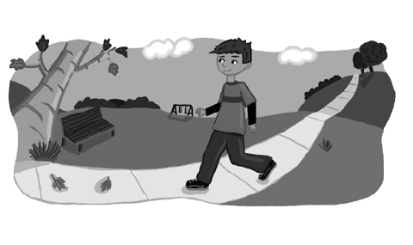  Read and connect.
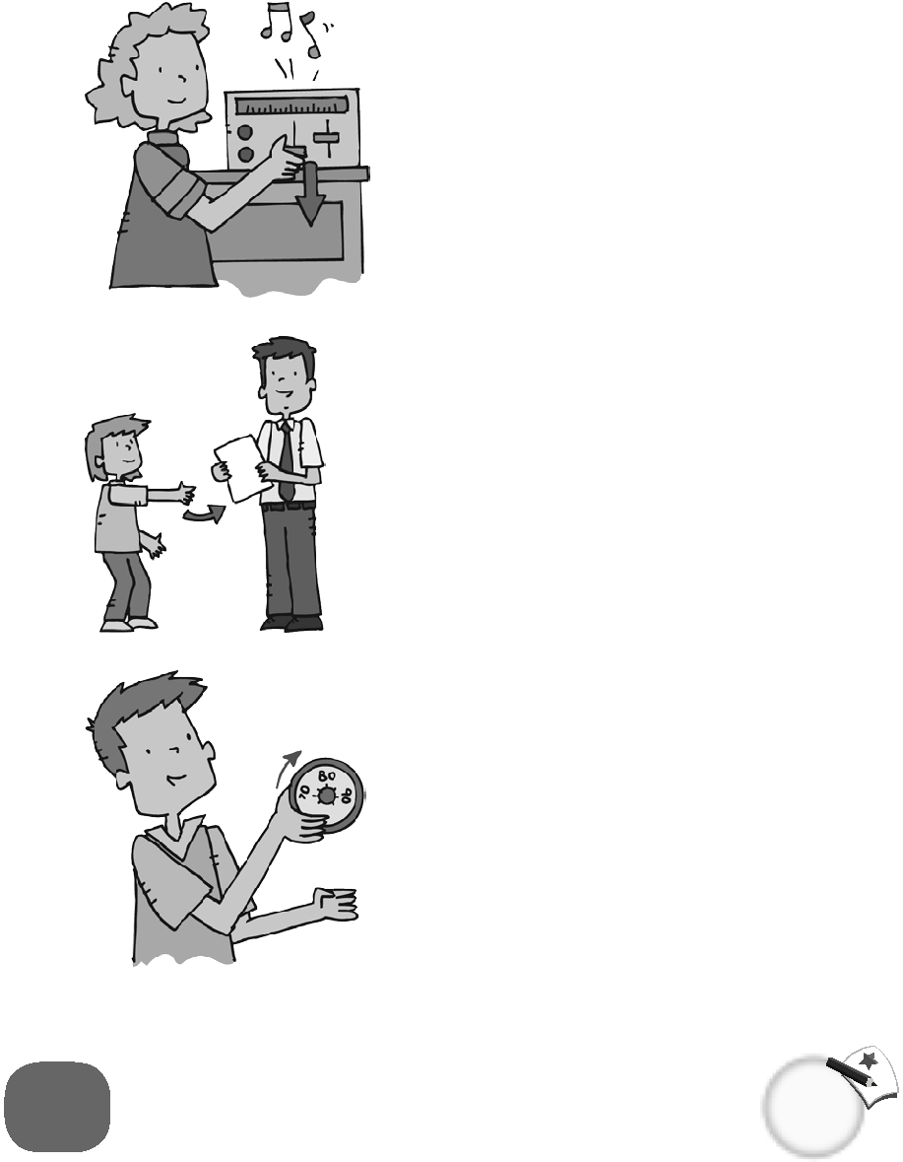
1.  ● | ● go for a walk ●  ● turn up the heat ● | 4.  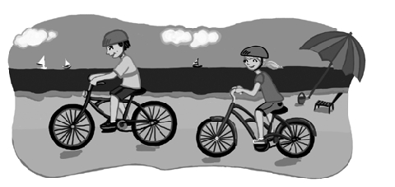  ●
2.  ● | ● turn in my homework ●  ● go for a swim ● | 5.  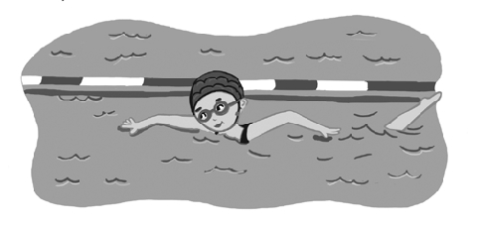  ●
3.  ● | ● go for a bike ride ●  ● turn down the music ● | 6.  ●

 | Listen and check.
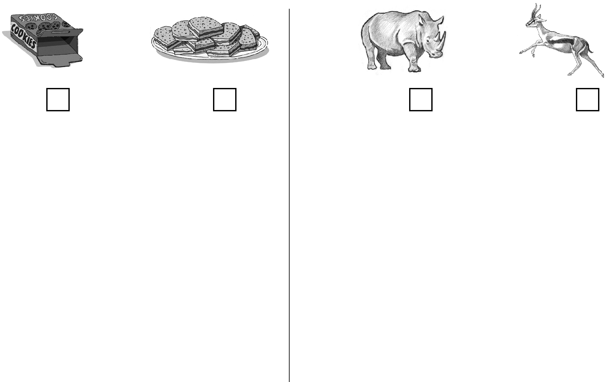
1. |  | 2.
3. |  | 4.
5. |   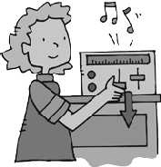 | 6. | 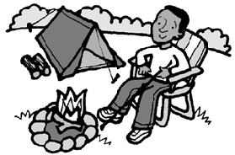  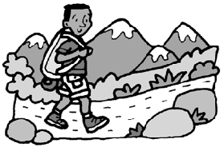
Final Test Name: ______________________________
(Units 1–8) Page 3
See instructions on pp. 126–127

 | Read and match.

1. Why do you like summer? _____ | A. I think she’ll be a hair stylist.
2. What will she do next? _____ | B. They went waterskiing.
3. Did he turn up the heat? _____ | C. He was taking pictures.
4. How does the lemon taste? _____ | D. Yes, he turned it up.
5. What was he doing yesterday? _____ | E. Because I like waterskiing.
6. What is he going to do tonight? _____ | F. She’ll probably mop the floor.
7. What do you think she’ll be? _____ | G. He’s going to clean up his room.
8. What did they do last summer? _____ | H. It tastes sour.

 | Look and connect.

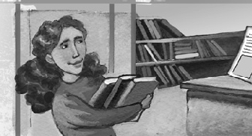  1. What will she do next? ● | ● A. She’ll wash the dishes.
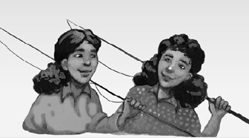  2. What will they do next? ● | ● B. She’ll do homework.
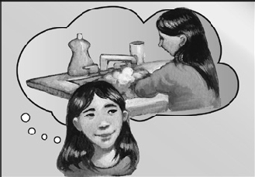  3. What will she do next? ● | ● C. He’ll clean up the desk.
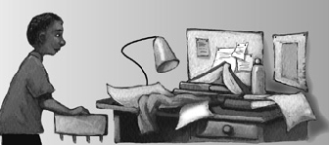  4. What will he do next? ● | ● D. They’ll go fishing.

Final Test Name: ______________________________
(Units 1–8) Page 4
See instructions on pp. 126–127

Read, connect, and circle.

1. Are there a lot of sandwiches? ● | 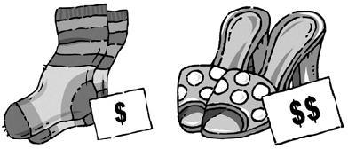  ● | A. Yes, they are.  No, they aren’t.
2. Are the shoes more expensive ● than the socks? | 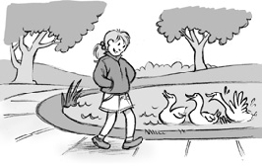  ● | B. Yes, she does.  No, she doesn’t.
3. Does she usually walk slowly? ● | 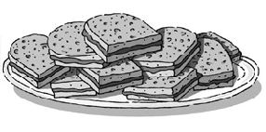  ●  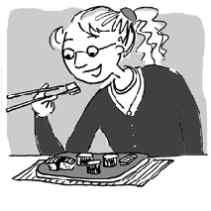 | C. Yes, there are.  No, there aren’t.
4. Has she ever eaten sushi? ● | ● | D. Yes, she has.  No, she hasn’t.

Listen and write.

1. Many dinosaurs had big, _____ bones. They were _____.
Some dinosaurs had little, _____ bones. They _____ climb trees.
2. A hummingbird is one of the _____ and _____ birds.
It is _____ than a coin, and it can _____ backward.
3. A tornado is a _____ The wind moves very _____ in a circle.
Tornadoes can pick up _____, cars, and _____!
4. You need two things to _____ food: taste buds and a sense of _____.
Taste buds are on your _____. They _____ you taste each kind of flavor.


Which sound do you hear? Listen and check.

1.  ar ir | 2. st str | 3. wr wh | 4. spr sp | 5. nch ch

