Unit 7 Test Name: ______________________________
page 1
See instructions on pp. 126–127

 | Choose and write.
want Here thirsty hungry

Jenny: I’m ________. I want an apple. | 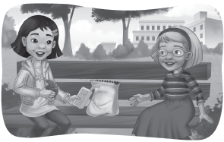
Kate: I’m ________. I ________ juice.
Jenny: ________ you are.
Kate: Thank you.
Jenny: You’re welcome.

 | Connect.

1. a banana ● |   ● A. | 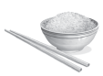  ● E.
2. a cookie ●
3. an egg ● | 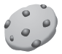  ● B. | 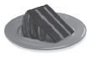  ● F.
4. an orange ●
5. cake ● | 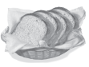  ● C. |   ● G.
6. rice ●
7. bread ● |   ● D. |   ● H.
8. milk ●

Unit 7 Test Name: ______________________________
page 2
See instructions on pp. 126–127
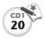
 | Listen and write A, B, C, or D.

1. ________  2. ________ | 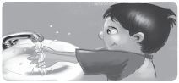 | 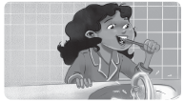
 | A. wash my hands | B. brush my teeth
3. ________ | 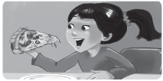 | 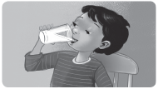
4. ________ | C. eat pizza | D. drink milk

 | Choose and write.  I don’t Yes I do I don’t
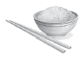
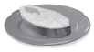  1. | 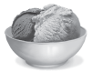  2. | 3. | 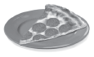  4.
Do you want fish? | Do you want cake? | Do you want rice? | Do you want chicken?
________, I do. | No, ______. I want ice cream. | Yes, ________. | No, ______. I want pizza.
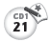
 | Listen for o as in pot and check.

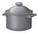  1. | pot | 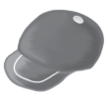  2. | cap | 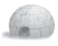  3. | igloo | 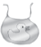  4. | dot
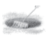 | pit |  | top |  | octopus | 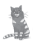 | dig

