Name: | Class:

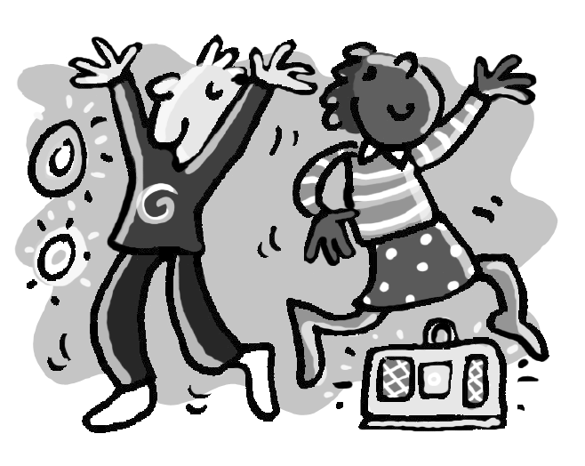
①Read and complete the text. Mark / 12

On Saturday it was Vicky’s birthday. She invited (invite) all her

friends to a party in her house. In the afternoon, Vicky
__________ (help) her mother to make a cake. They __________ (cook) burgers and there was a lot of food. The party was great. Vicky and her friends __________ (play) games and __________ (dance) to music all evening. They __________ (stop) when Jack and Sally __________ (jump)

on the sofa. Vicky’s mum wasn’t happy!

②Write the answers. Mark / 3

❶ Did Vicky invite all her friends to a party? Yes, she did.
❷ Did they have a lot of food? __________
❸ Did they dance all evening? __________
❹ Did Jack and Sally jump on the table? __________

Total unit mark / 15

